SuperLOTIS Pictures:

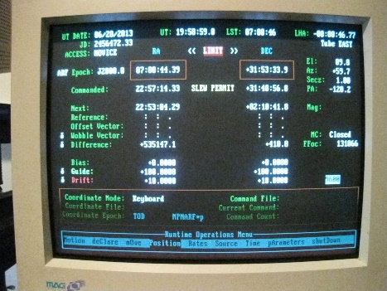Picture 1: SuperLOTIS Computer Rack and Monitor. Steps 2, 8, 9, 13, 16.

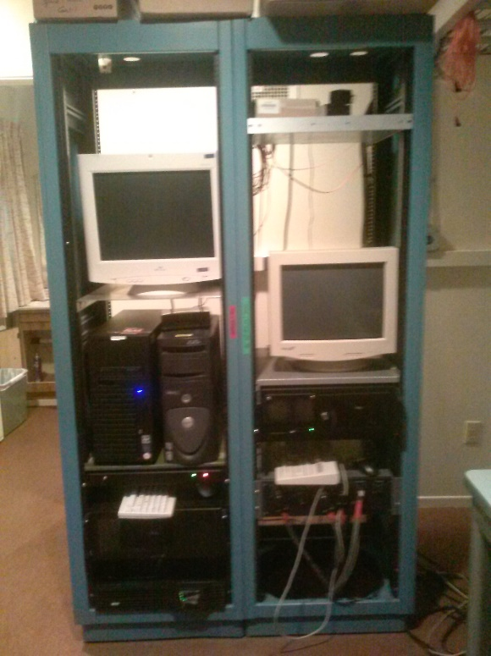

Picture 2: Dome control rack and Pulizzi switches. Step 2, 18.

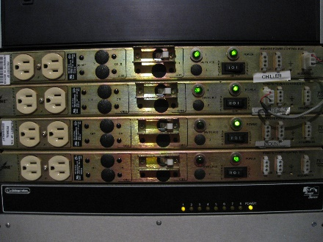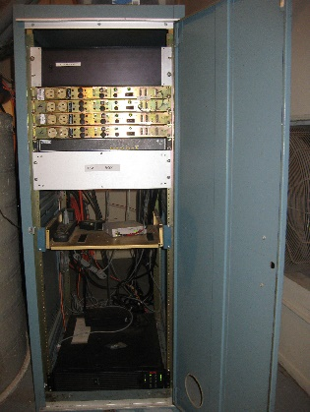

Picture 3: CCD Power Supply Box. Step 6

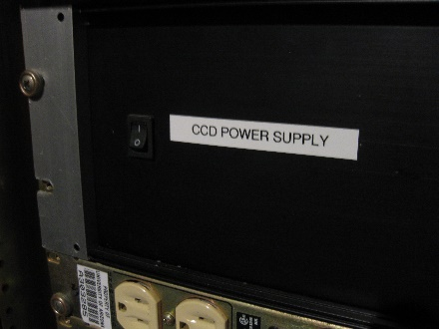

Picture 4: SLOTIS and EDDY workstations. Step 11, 13, 14, 16.

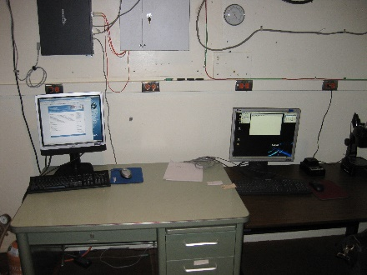

Picture 5: UPS power cord. Step 19

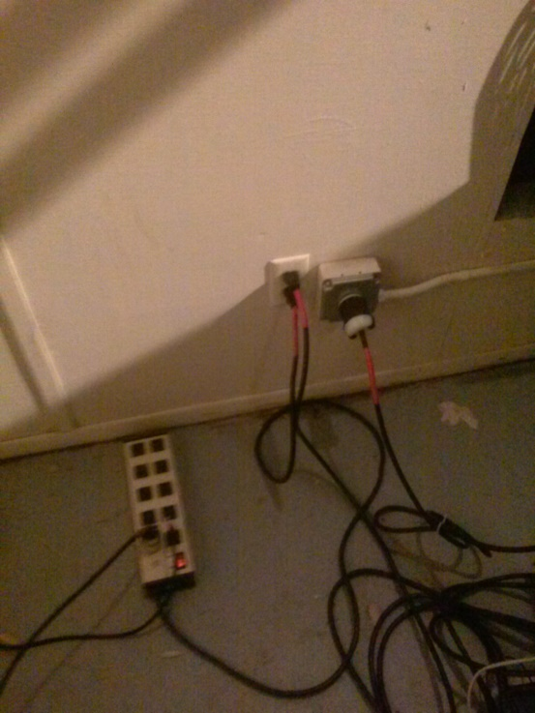

UPS Power cord

Picture 6: TCS PC interface box on back of telescope pier. Step 20.

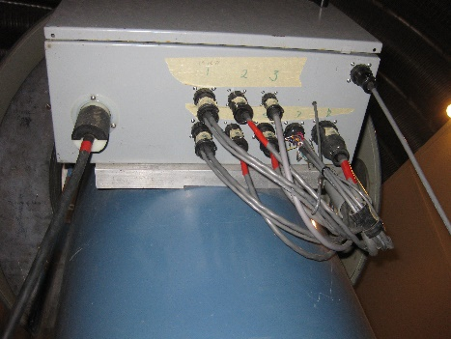

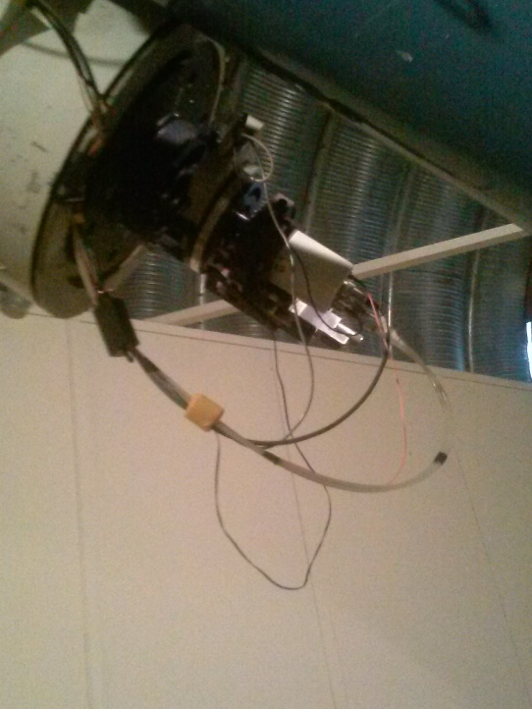Picture 7: Camera and filterwheel cabling. Steps 22, 23.

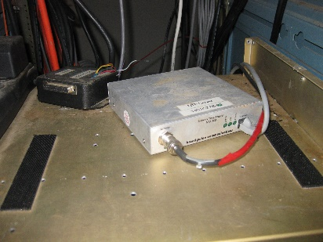Picture 8: Network Time adaptor NTA-100 box. Step 27.

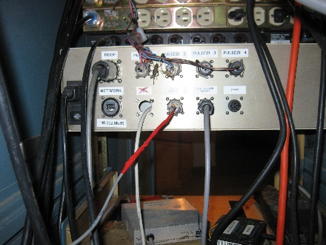Picture 9: Rain Sensor. Step 29

Picture 10: Lantronix connector. Step 30.

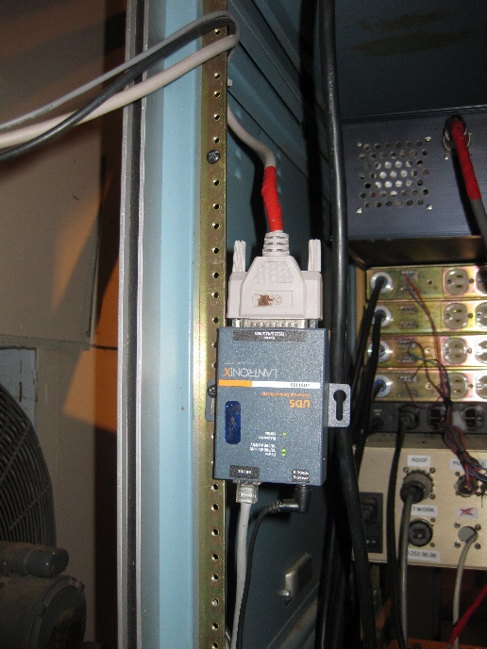

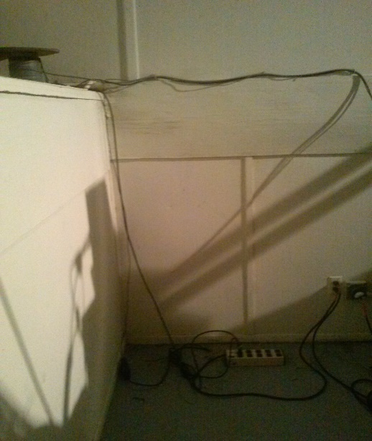Picture 11: Weather cables coming from outside the dome. Step 28.

Picture 12: UPS power cable location + chiller power cord. Step 32.



Chiller power cable

Picture 13: Tripp-Lite SmartOnline UPS. Step 34.

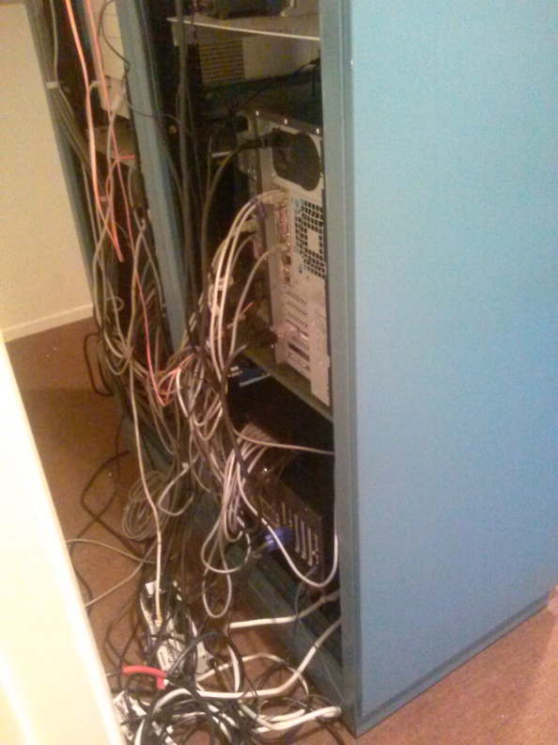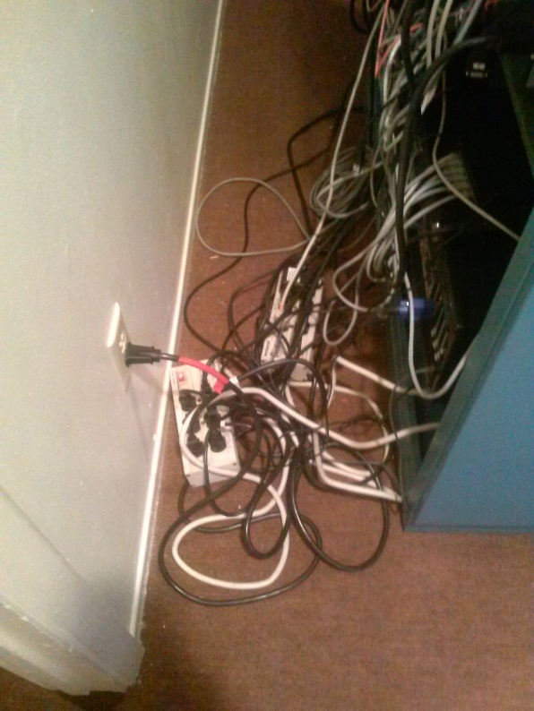

Picture 14: Leave Ethernet and APC backup on! Step 35.

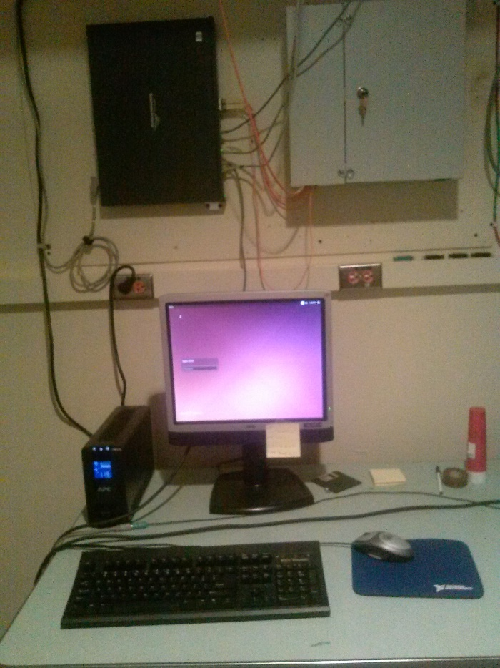

**Ethernet**

**APC UPS**

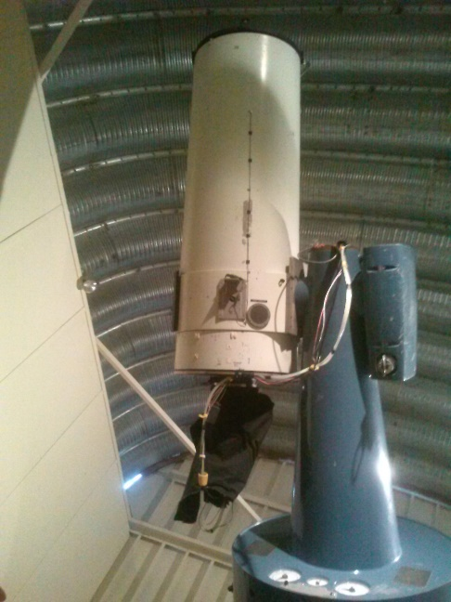Picture 15: Telescope Mount at Stow position. Step 2

Picture 16: Uncabled camera and filter wheel. Step 24

