VATTSpec Instructions 3/07/2013

Introduction

VATTSpec is a medium resolution CCD range spectrograph with a “skinny chip” having excellent cosmetics.

Wavelength range: 360 – 950 nm
Resolutions (with gratings and spectral coverages):
R= 4000 (1200 g/mm, 100nm), 2000 (600 g/mm, 200nm), 1000 (300 g/mm, 400nm)
Sensitivity: typical exp time for mag (TBD)

Setup for AzCam and VATT Spectrograph GUI

• Connect to instrument computer, and log in as ʻazcamʼ
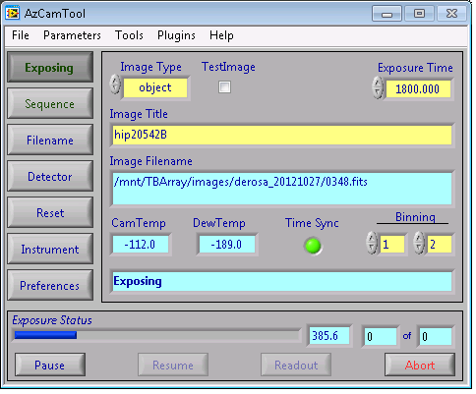• Open AzCam and the VATTSpec GUI
NB reload AzCam each day.

With TestImage checked - writes spectrum to test.fits, overwriting previous image

Monitor temperature here (-110 for camera, -190 for dewer), dewer lasts ~10 hours, and longer in winter.

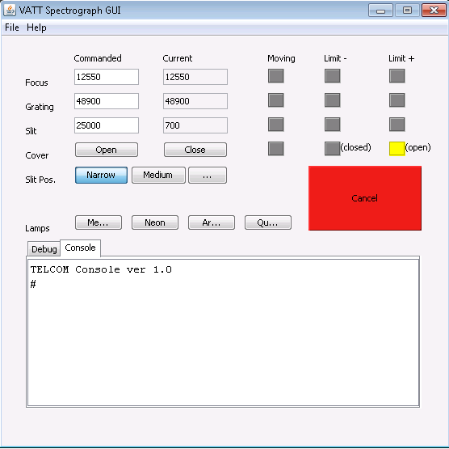

Focus value

Grating value - to select central wavelength of spectra see Appendix A

Open/close cover (close at end of night)
Slit width (narrow =1 arcsec,
medium=1.5 arcsec, wide=2 arcsec)

Calibration lamps and flat field lamp (Qu)

• Create a directory for your images using the IRAF terminal within (/mnt/TBArray/images)

• Click on ʻFilenameʼ in AzCam, enter the new directory name, the root name, and the sequence start number.

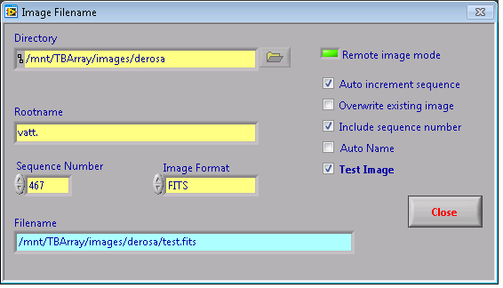

• Click on ʻDetectorʼ in AzCam, from here the binning and the specific region of the detector read out can be changed, and the level of binning in each direction.
The slit length, with row binning equal to 1, corresponds to only 90 rows. To allow for the current small shift in the grating perpendicular to dispersion as elevation changes, 10 rows either side of the image of the slit on the detector should be added to make a total of 110 rows. The actual “First Row” and “Last Row” will depend on the grating used.

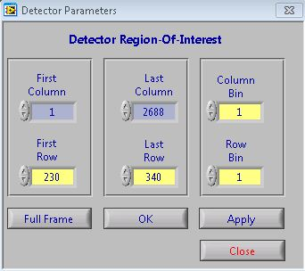

• Click on ‘Preferences’ in AzCam. Uncheck ‘Enable Instrument’ for the present, check “Enable Telescope”, “Clear Array”, “Display image”, and others as desired.

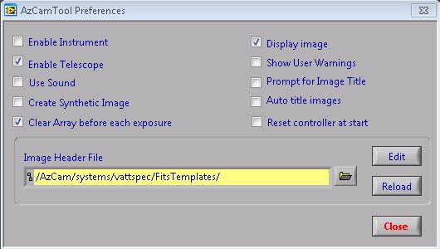

• On the IRAF terminal, within the DS9 window, ensure the X axis is inverted (in top line Zoom menu). This places the blue end of the spectrum on the left.
• On the IRAF terminal, open an xgterm widow. Navigate to the home directory (~), and issue cl to start IRAF. Then cd into the directory which contains your images. Issue imexam to gain access to the various analysis procedures (e.g., j to measure the FWHM of a calibration lamp line, or k to measure the FWHM of the spectrum), or use implot on a particular file (i.e. implot vatt.0001), to plot particular rows/columns etc. Implot command “:x 2680 10” inverts X axis, when plotting line(s).
NB. (1) resizing Implot window is only possible after doing a “q.
(2) reload imexam (after “q”) for each new image.

Initializing Coordinates, and Acquiring an Object

To see an object in the guide camera, remember to open the slit cover! And put in the U-Mirror!
Focusing VATTSpec and the telescope

• Replace the U-mirror with the center mirror on the guider GUI.
• Turn on a selection of Argon, Mercury, and Neon lamps, and allow a minute for them to warm up. NB: Mercury warms up twice as fast as the other two, and you may want to delay its turn-on.

• Take a ~10 second exposure, and measure the FWHM of a particular line.
• Change the spectrograph focus on the VATTSpec GUI in steps of ~100, and take another exposure. Measure the FWHM of the same line as before. Search for the focus value which minimizes the width. For the narrow slit, this value is near 2.0 (pixels).
• Turn off the lamps by clicking on the ʻMeʼ, ʻNeʼ, and ʻArʼ buttons.
• Replace the center mirror with the U-mirror on the guider GUI.
• Place the bright star in the slit using the paddles. The dome floodlights can be turned on, and the guider exposure time increased for the slit to be visible on the guider camera.
• Once the bright star is in the slit, take an exposure with the spectrograph.
• Use implot to measure a particular column of the spectrum, for example column 1300 (command “:c 1300”).The goal of telescope focusing is to make the spectrum as narrow as possible in the direction perpendicular to the dispersion. Adjust the telescope focus at the Guider GUI and take another exposure. Plot the same column again, and adjust the focus until the spectrum is as narrow as possible.

Guiding, and taking science data

• Slew to the first target using the XEPhem GUI.
- Once the target is acquired and it has been maneuvered into the slit using the paddle, the autoguider can be started.
- If this is the first night after an instrument change, then the transformation parameters for the autoguider moves will need calibrating. See the documentation, “VATT Autoguiding Setup”.
• If there is a bright star in the guider field of view, ensure that the aggressiveness has been set at 0.5 in the ʻguider setupʼ box, drag the small white guider box over the bright star, click ʻupdate marksʼ, then ʻNot Guidingʼ, to begin guiding in “off-axis” mode.
• If there is not a bright star in the guider field of view, set the aggressiveness to 0.1 in the ʻguider setupʼ box, drag the small white guider box over the position of the star as obscured by the slit, click ʻupdate marks’, then ʻNot Guidingʼ, to begin guiding in “on-axis” mode. Autoguiding will be better the brighter the guide star can be made by longer integration times, even to seemingly filling in the obscured image on the slit.
Appendix A: Setting Grating Value for a Central Wavelength
Note: the 1354 pixel position is for when the data is not binned; it would be 1354/2 for 2x binned data.
