Kuiper 61” Telescope
UPS Start Up/Shut Down Procedure
John Morris
7/10/24

Start up:

- Plug in the UPS feed cable.
- Turn on the UPS feed breaker.
- Turn on the DC breaker (in the UPS lower panel, use key to open).
- Turn on the UPS key switch and wait for ready light on panel.
- Plug in the UPS output cable.
- Turn on the UPS output breaker.
- It is now safe to plug into clean (orange) power outlets.

Shut down:

- Unplug everything plugged into a clean (orange) power outlet.
- Turn off UPS output breaker.
- Turn UPS key switch off.
- Turn off DC breaker (in the UPS lower panel, use key to open).
- Turn off UPS feed breaker.
- Unplug UPS feed and output cables.

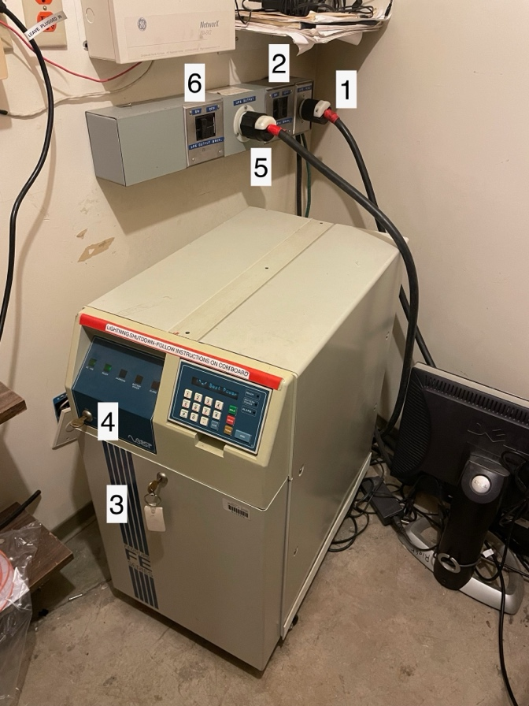
Numbers above reference Start Up steps

