Kuiper 61” Telescope
Lightning Shutdown Procedure (Mont4K Edition)
John Morris
7/12/24

- Complete “End of Normal Night of Observing” shutdown.
- In dome
- Turn off all instrument electronics:
Camera power supply
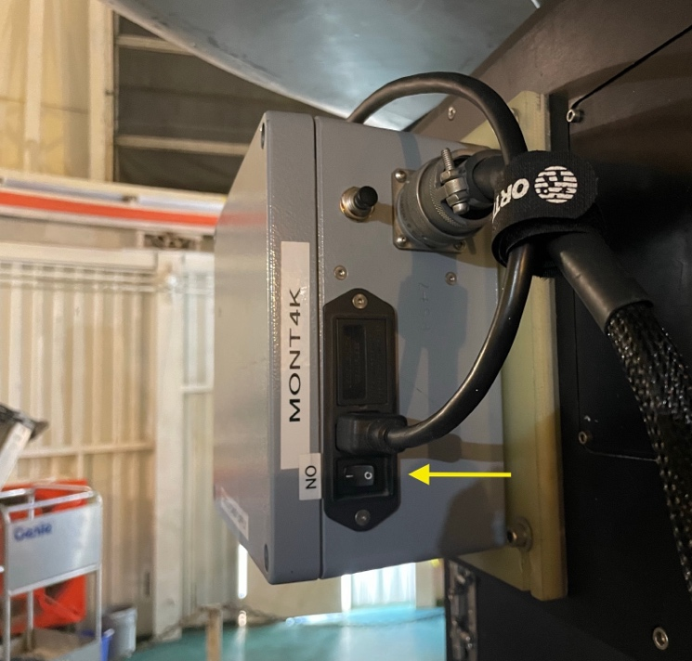

Guider controller
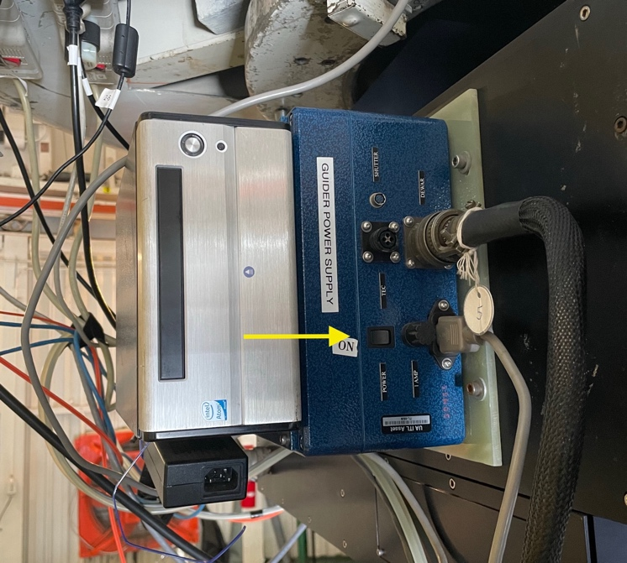

Guider chiller
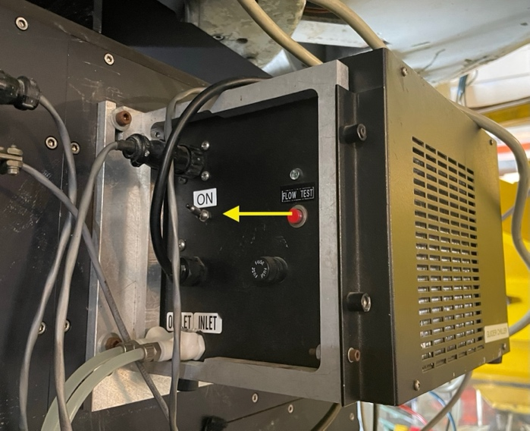

Filter wheel
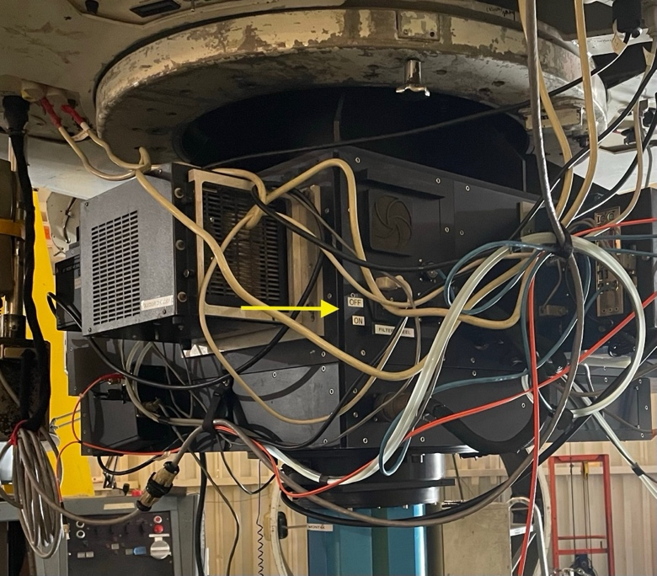

Shutter control box
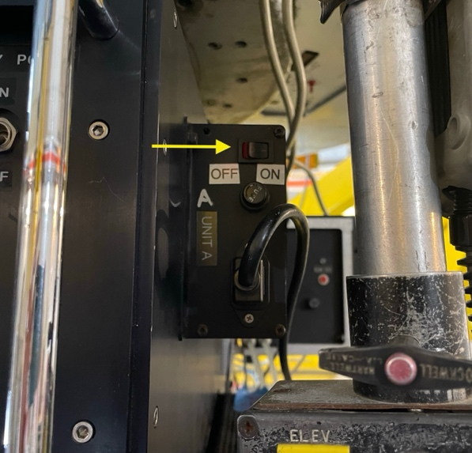
- Unplug the four (4) cords from the “clean” orange outlets on the underside of the telescope:
East outlet (camera power supply and guider controller)
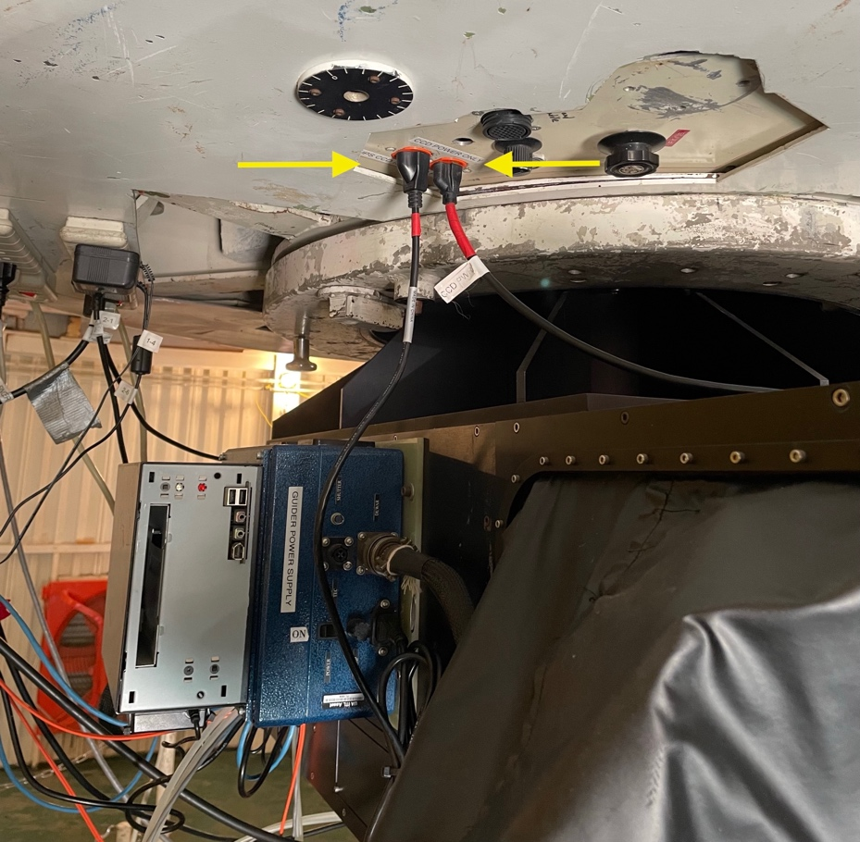

West outlet (two (2) power strips)
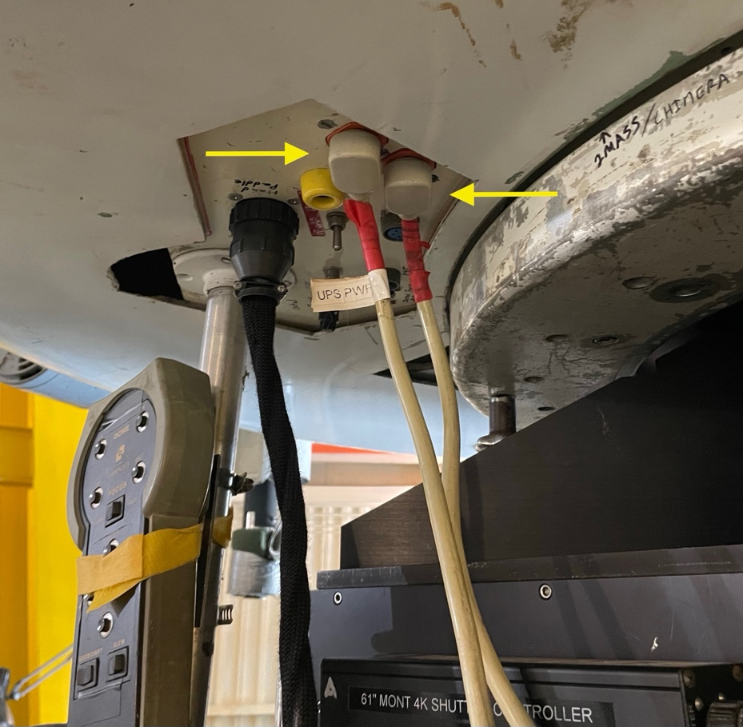
- Shut down laptop computer (if in use) and unplug two (2) cords from the “clean” orange UPS outlets located near the floor on the platform control console.
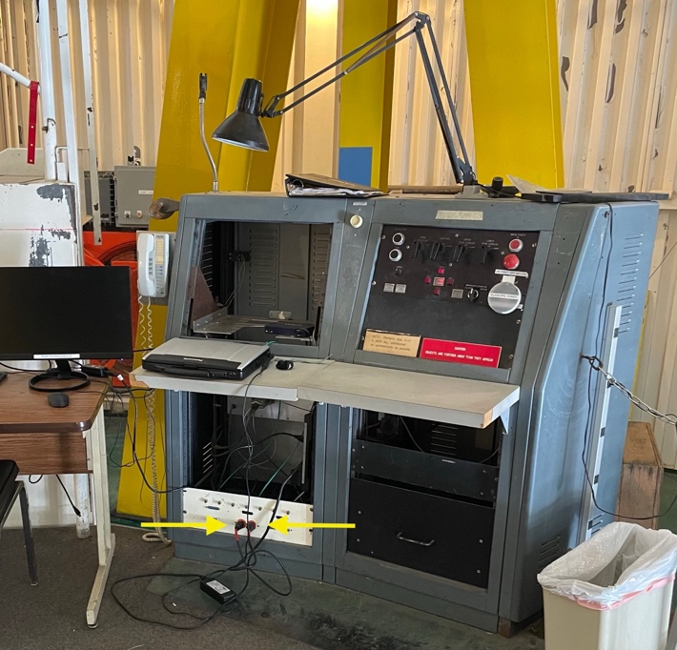

- Turn off TCS by turning the rotary switch on the side of the junction box. NOTE: NEVER TURN OFF TCS UNLESS TELESCOPE IS IN STOW POSITION!
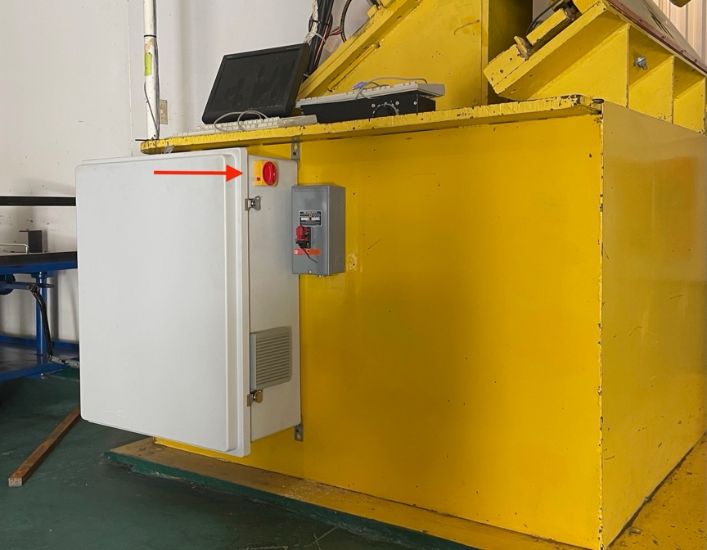

- Lower platform (if not already lowered).

- Turn off telescope power and main power (note instructions on console regarding order of switches).
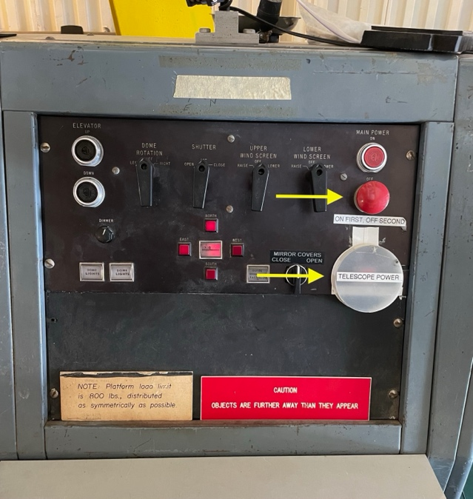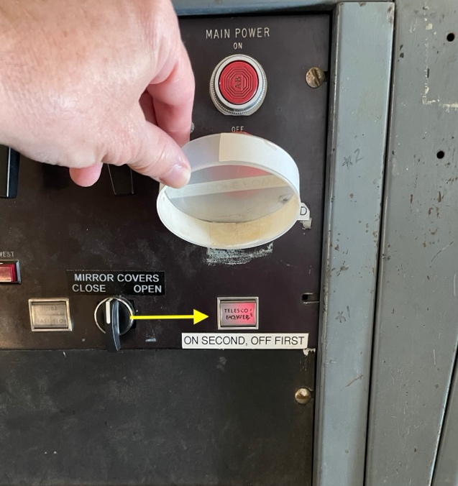

- In control room:
- Shut down computers BigAux, BigCCD, Gerard, and BigGuider via their respective sutdown icons on their monitors.
- Shut down BigPop computer and Telcom Server via button/switch on front of their panels.
- Unplug all power cords marked with red tape from “clean” (orange) outlets on wall behind the computer monitors.
- Unplug printer relay cord (not in orange outlet).

- In UPS room:
- Unplug Brandywine and Kensington power strip cords from “clean” (orange) power outlet (both are marked with red tape).
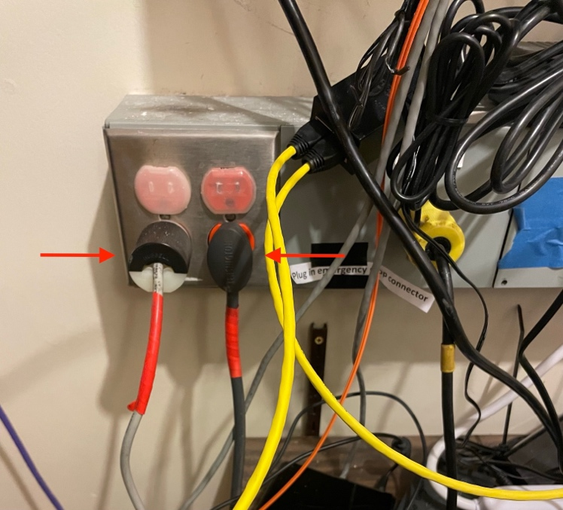
- Unplug Trendnet (small white box w/red tape and grey network cable attached) from “dirty” (regular) power outlet (NOTE: Trendnet MUST be plugged into a “dirty” power outlet when coming out of lightning shutdown).
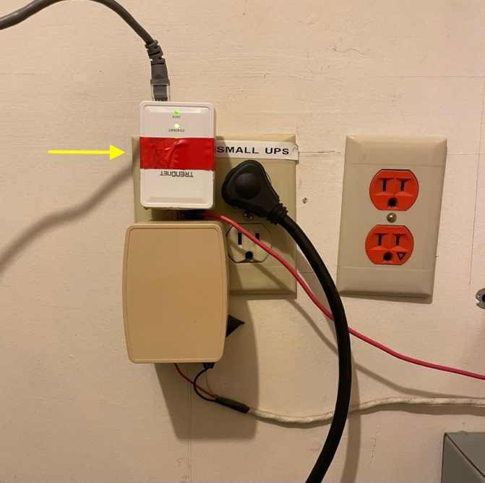
- Follow separate instructions for UPS shutdown posted on UPS room wall.

