Triplet Oil Stress Relief

Last update: June 6, 2013

- The camera-collimator lens can contains a triplet with a large CaFl element in the center. Cargille 1160 oil is used to optically couple the three elements of the triplet. Oil was chosen over an optical glue such as Sylgard in order to allow flexibility later on, should the triplet need to be dismantled for some reason. Cargille 1160 was found to be UV transmissive, and unreactive to Sylgard and the rubber O-ring which seals the oil layers in the lens cells.

- At the top of the cells, a small pliable tube allows overflow relief. The tube comes out of the top of the spectrograph, and is connected to a small plastic bowl. We've stretched a finger cot over the plastic bowl. The finger cot material is very flexible compared to the seals in the lens cell or the other tubing. When the atmospheric pressure changes, or the oil expands or contracts because of changes in temperature, the finger cot gives before the seals do. In general, the oil should not come anywhere near the finger cot or the part of the tubing that sticks out of the spectrograph.

- The finger cot should be checked before each run, and replaced if it has been damaged.

- In addition, there is a spigot in the tube, near the finger cot. At one point, we had to transfer MAESTRO into the telescope chamber from the loading dock area by tipping it 90 degrees and pulling it through the hatch. In order to prevent oil from the triplet spilling into the tube and finger cot area, we put a spigot in the line. The labels on the spectrograph say that the spigot may be open when the spectrograph is pulled through the hatch because the spectrograph was always tipped the same way, with the finger cotalways above the triplet.

- The spigot is accessible when the spectrograph is mounted on the telescope.

- The spigot should be closed when the spectrograph is on the telescope and the telescope is tipped over, e.g. when the operator is opening the mirror cover, or when you are observing. Since the spectrograph rotates, the finger cot may not always be above the triplet.

- The spigot should be open whenever the spectrograph is experiencing a change in atmospheric pressure, or temperature. Specifically, the spigot should be open when the spectrograph is being transported up and down the mountain.

In sum:
Spigot open: During transport, and whenever there is a change in pressure or temperature.
Spigot closed: When observing, or tipping the spectrograph for any reason.

- The spigot is OPEN when its handle is parallel to the tubing. The spigot is CLOSED when its handle is perpendicular to the tubing.

- All the plumbing in this area was purchased at Ace Hardware, in the lawn sprinkler section.

Pictures:

Photograph of the Triplet Oil Stress Relief system, with the spectrograph on the cart.

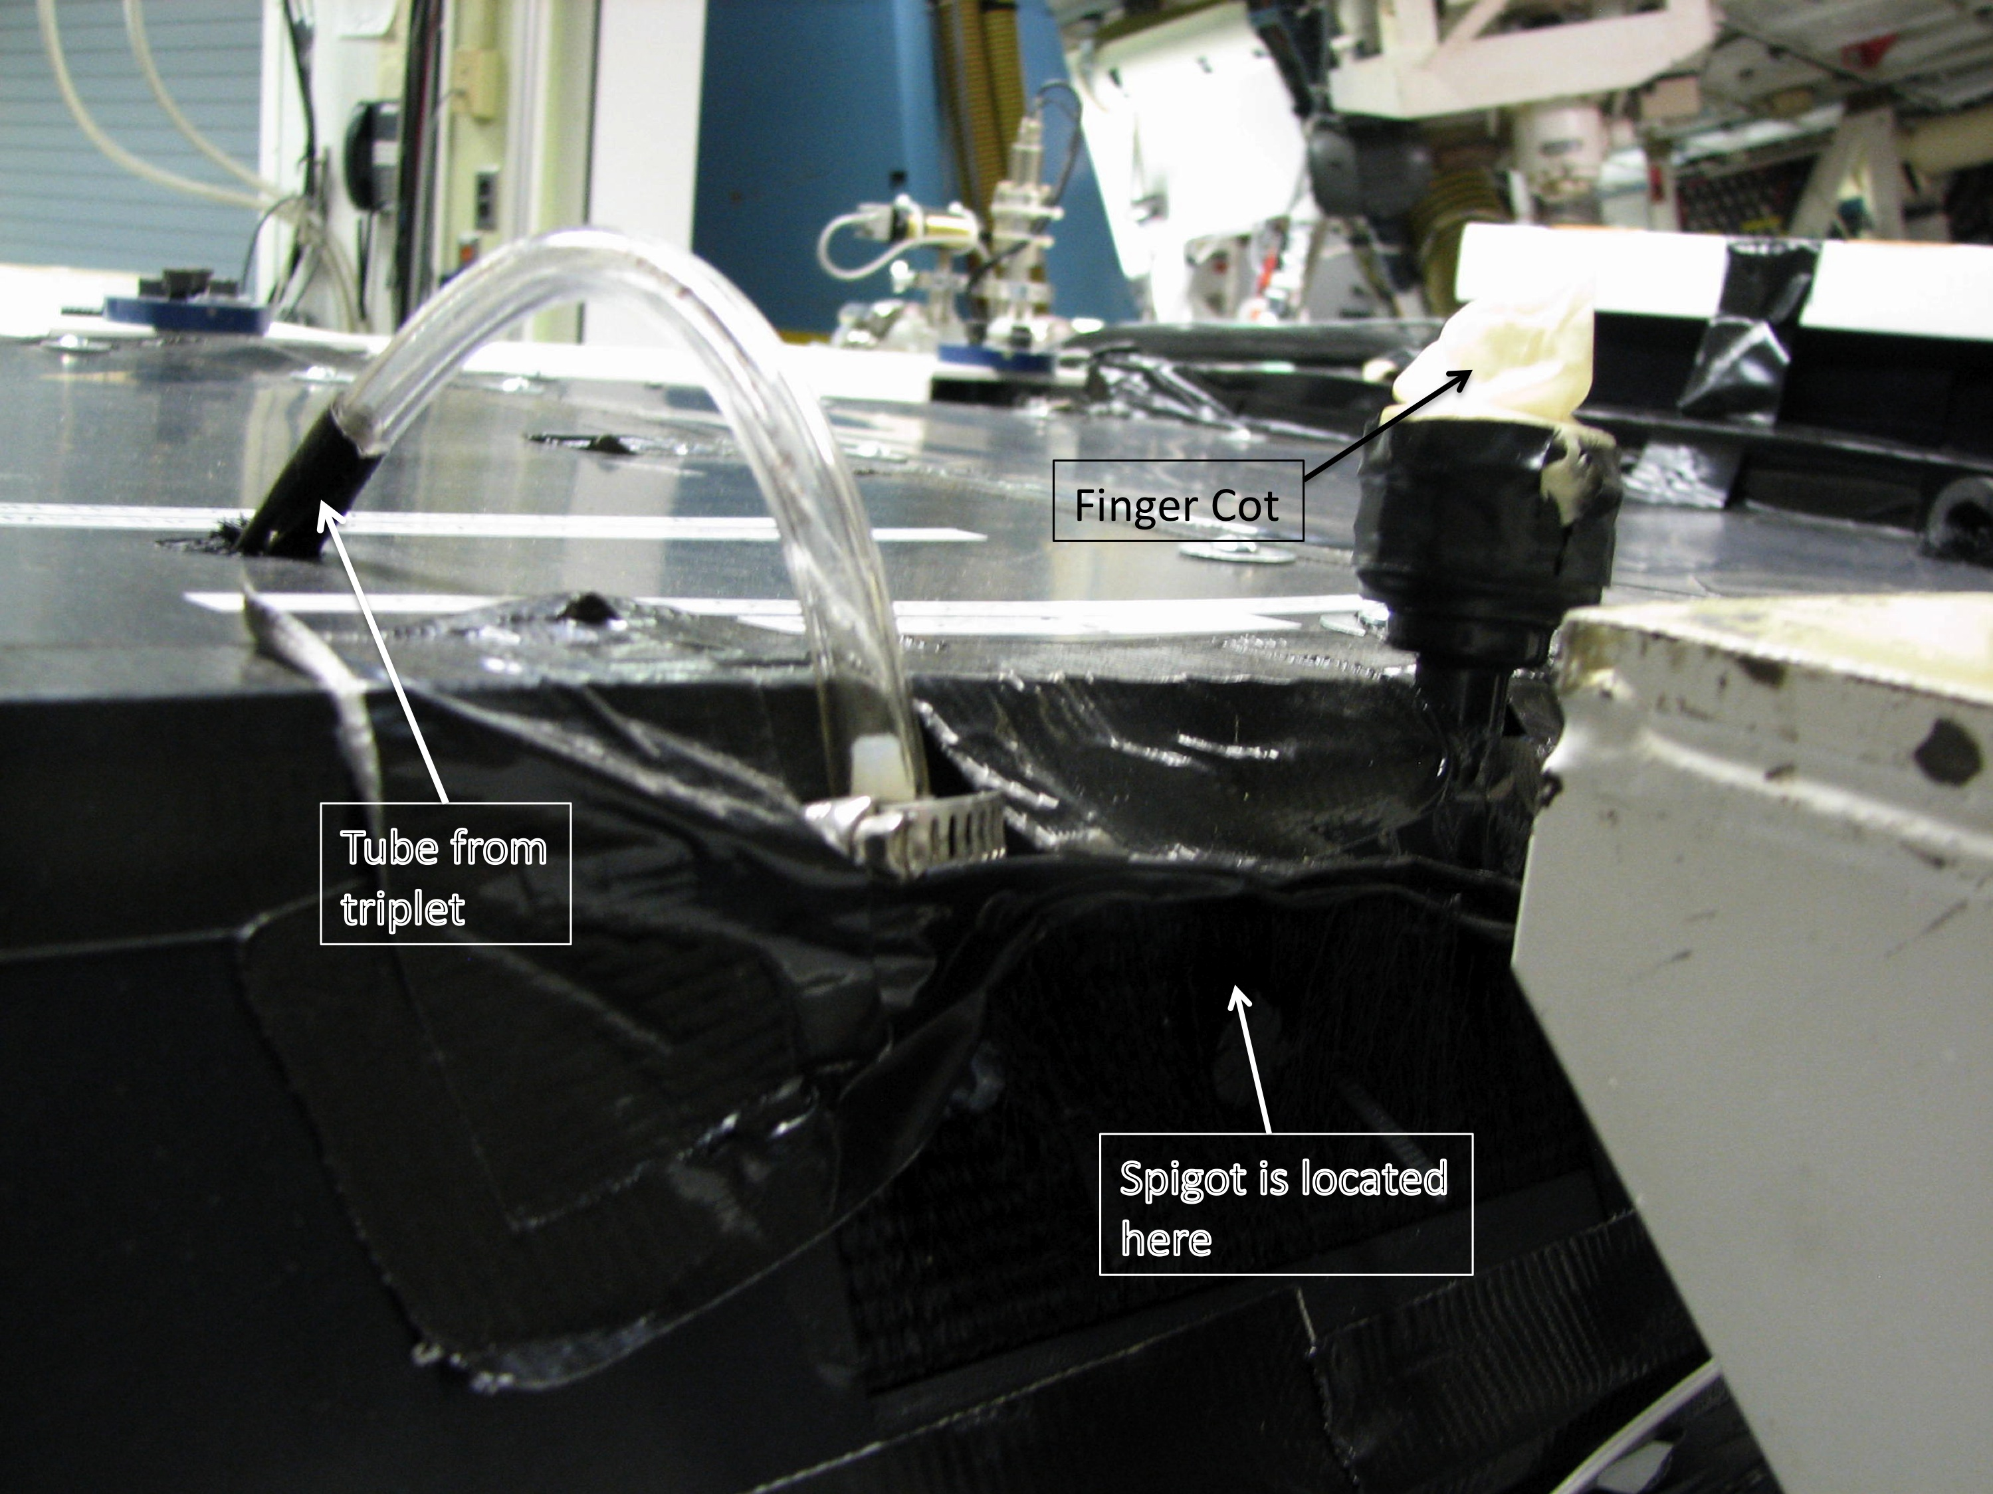

View you see when the spectrograph is mounted on the telescope. Spigot is located above the "OPEN CLOSED" label.

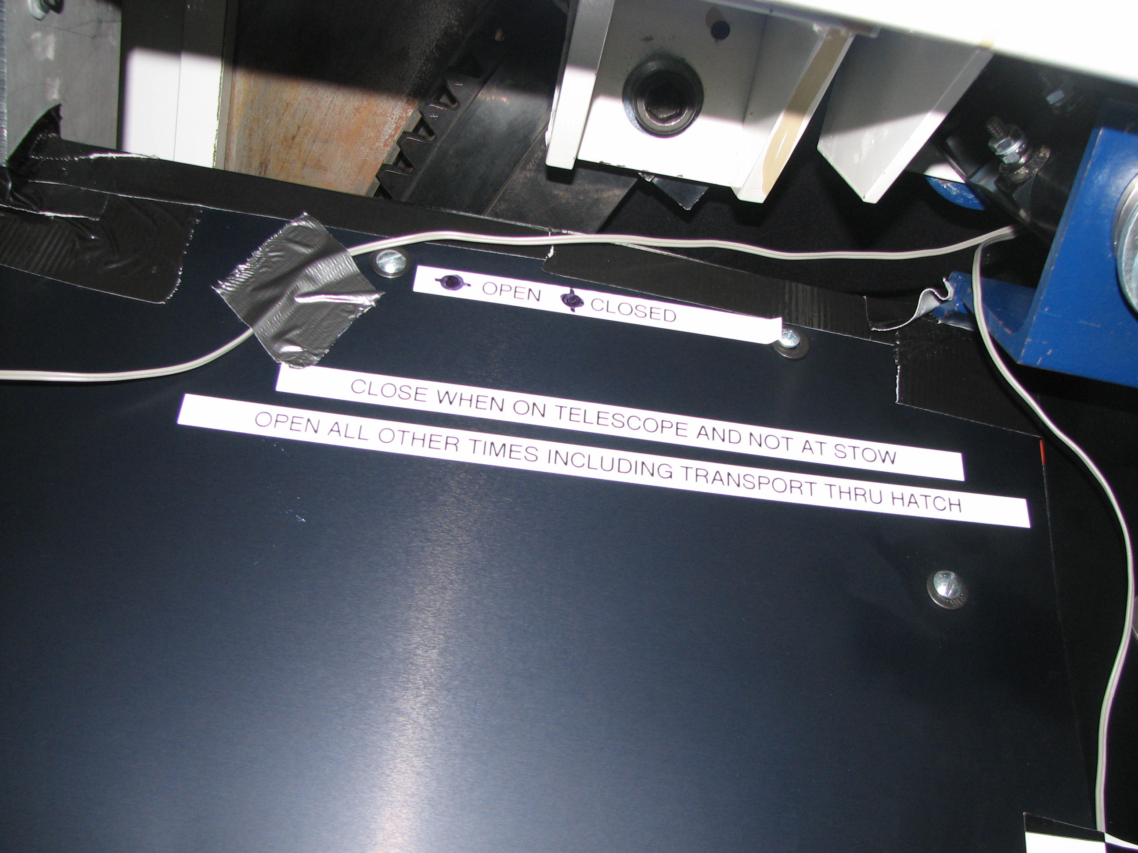

A bag of spare finger cots is kept in the Maestro cabinet in the common building:

