MAESTRO PROCEEDURE
Raising the spectrograph from the alignment frame to the cart
Last Revisions: April 18, 2013, Jill Bechtold; June 14, 2013, Richard Green

Introduction
For working on the spectrograph off the telescope, we constructed a tan, steel “alignment frame” which allows us to take the spectrograph off the cart and hang it as if it were on the telescope. We investigated using the NOAO Flex Rig for this purpose (see photo archive), but decided not to use it for a number of reasons. The MAESTRO alignment frame is modular, and can be disassembled for transport. Detailed photos of the alignment frame to aid assembly and disassembly are in the photo archive, along with notes.

General Notes

1. Read the procedure through before starting, to remind yourself about what needs to be done. Review “Tour of the MAESTRO spectrograph” to remind yourself of terminology.

2. The underlying principle to keep in mind during this procedure is that MAESTRO is quite asymmetric, and will tip easily. The use of nuts and allthread enables the raising and lowering of MAESTRO in a controlled manner, without bending the spectrograph body, or tipping.

3. Make sure cables are safely stowed out of the way so they will not be pinched.

4. Having 4 people makes the tedious part of the procedure go quickly. One person can do it alone if necessary, but at least two people are recommended. Two people can complete this procedure in about 2.5 hours.

Equipment needed

1. Two 3⁄4 inch wrenches for each person. One of these should have a ratchet to make the procedure easier. MAESTRO has purchased several 3⁄4 inch wrenches and ratchets for this procedure.

2. One inch driver.

3. Hardware to attach spectrograph to the cart. These should be left attached to the cart when the spectrograph is on the alignment frame:
3⁄4 inch bolts, each 2 inches+
3⁄4 inch washers
3⁄4 inch nuts

4. Six lengths of 5/8 inch allthread attached with nuts and washers in all but the two inner weldment attachment locations (see photo). These usually are attached to the alignment frame, and travel with it.

5. Level

6. 12-inch ruler, or similar. One for each person is optimal.

Procedure

1. Roll the cart under the alignment frame. Roughly align the cart to match up the eight attachment wings on the spectrograph with the corresponding structures on the alignment frame. There is only one way the spectrograph will fit on the cart: the cart and the alignment frame are both labeled with “Grating side” and “Dewar Side” so you can go in the right way.

BE CAREFUL NOT TO SMASH THE CART INTO THE ALIGNMENT FRAME.

Note that the cart moves easily, and changes direction easily IF it is moving. If it is not moving, the cart is heavy and changing direction of the wheels is very difficult. Those of you who have driven a car without power steering will understand how to move the cart naturally.
The 4 spectrograph weldment attachment wings should be to the grating side of the cart attachment wings.

2. Attach allthread to the spectrograph and alignment frame, in six of the eight spectrograph weldment wings; the two wings on the inner side of the weldment are unreachable. Double nuts and washers should be used at all locations. These usually are attached to the alignment frame, and travel with it.
See attached photos.

3. There are 4 yellow blocks of aluminum on the cart, which push the spectrograph UP. These are used to relieve pressure on the bottom of the spectrograph. Use the 1 inch wrench to loosen/tighten the nuts associated with these.

4. Loosen and remove the 8 bolts that attach the spectrograph to the cart. When the spectrograph is raised, reattach these to the cart for safekeeping.

5. With personnel at each of the 4 corner locations, slowly raise the spectrograph weldment from the alignment frame in 1⁄2-turn increments simultaneously. The current approach is to raise the pushing blocks first with the 1-inch wrenches. It is (obviously) helpful to mark one face of each of the double nuts on the allthread rods to be able to count revolutions. After ~2 revolutions, hand tighten the double nuts on the allthread supporting the spectrograph when hanging from the alignment frame.

6. After each 1 inch of movement, check to see that the spectrograph is staying level, and tension is remaining on the dewar end to keep the weldment level. Measure the distance between the weldment and alignment frame at all points with a ruler. Turn individual allthread nuts as needed to bring all spectrograph attachment points to constant distance from the frame.

7. Continue raising by 1⁄2 turn increments.

8. Wiggle cart and remove when the top of the spectrograph weldment is secure against the alignment frame. (Wrench tighten for final securing of the spectrograph to the frame.)

PHOTOS. See website for full resolution photos

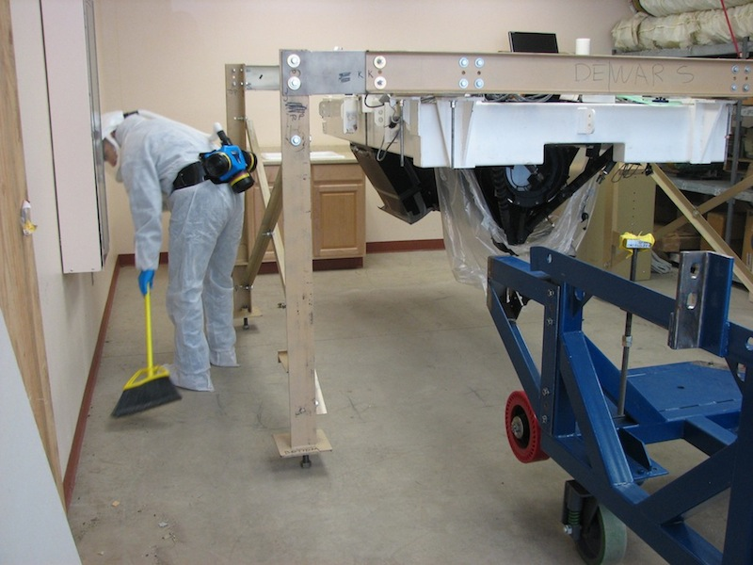

MAESTRO hanging from the tan alignment frame, in the common building lab at the MMT.

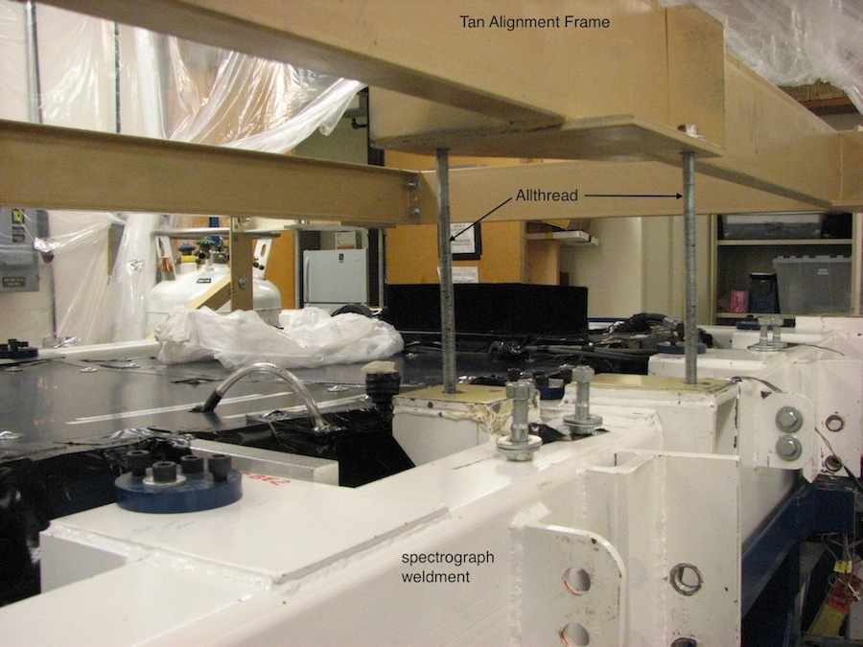

White spectrograph weldment is hanging from the tan alignment frame by allthreads during raising/lowering of spectrograph from the cart. Two of 6 total allthreads are labeled.

