MAESTRO PROCEEDURE
Lowering the spectrograph from the alignment frame to the cart

Last Revision: April 18, 2013, Jill Bechtold

This document:
http://minimaestro.as.arizona.edu/MAESTRO/Engineering/MAESTRO\ Proceedures/dismountfromalignmentframe.htm

Introduction

For working on the spectrograph off the telescope, we constructed a tan, steel “alignment frame” which allows us to take the spectrograph off the cart and hang it as if it were on the telescope. We investigated using the NOAO Flex Rig for this purpose (see photo archive), but decided not to use it for a number of reasons. The MAESTRO alignment frame is modular, and can be disassembled for transport. Detailed photos of the alignment frame to aid assembly and disassembly are in the photo archive, along with notes.

General Notes

1. Read the procedure through before starting, to remind yourself about what needs to be done. Review “Tour of the MAESTRO spectrograph” to remind yourself of terminology.

2. The underlying principle to keep in mind during this procedure is that MAESTRO is quite asymmetric, and will tip easily. The use of nuts and allthread enables the raising and lowering of MAESTRO in a controlled manner, without bending the spectrograph body, or tipping.

3. Make sure cables are safely stowed out of the way so they will not be pinched.

4. Having 4 people makes the tedious part of the procedure go quickly.

One person can do it by themselves if necessary, but at least two people are recommended. Two people can complete this procedure in about 2.5 hours.

Equipment needed

1. Two 3⁄4 inch wrenches for each person. One of these should have a ratchet to make the procedure easier. MAESTRO has purchased several 3⁄4 inch wrenches and ratchets for this procedure.

2. One inch driver.

3. Hardware to attach spectrograph to the cart. These should be left attached to the cart when the spectrograph is on the alignment frame:

3⁄4 inch bolts, each 2 inches+
3⁄4 inch washers
3⁄4 inch nuts

4. Six lengths of 5/8 inch allthread attached with nuts and washers in all but the two inner weldment attachment locations (see photo). These usually are attached to the alignment frame, and travel with it.

5. Level

6. 12-inch ruler, or similar. One for each person is optimal.

Procedure

1. Roll the cart under the spectrograph. Roughly align the cart to match up the eight attachment wings on the spectrograph. There is only one way the spectrograph will fit on the cart: the cart and the alignment frame are both labeled with “Grating side” and “Dewar Side” so you can go in the right way.

BE CAREFUL NOT TO SMASH THE CART INTO THE SPECTROGRAPH.

Note that the cart moves easily, and changes direction easily IF it is moving. If it is not moving, the cart is heavy and changing direction of the wheels is very difficult. Those of you who have driven a car without power steering will understand how to move the cart naturally.

The 4 spectrograph weldment attachment wings should be to the grating side of the cart attachment wings.

2. Allthread is holding the spectrograph to the alignment frame, via six of the eight spectrograph weldment wings; the two wings on the inner side of the weldment are unreachable. There should be double nuts and washers at all locations. See attached photo.

3. On the cart, there are 4 blocks of aluminum with yellow tape, which push the spectrograph UP. These are used to relieve pressure on the bottom of the spectrograph. Use the 1 inch wrench to loosen/tighten the nuts associated with these. See photo.

4. With personnel at each of the 4 corner locations, slowly lower the spectrograph weldment from the alignment frame by loosening the nuts in 1⁄2 turn increments simultaneously.

5. After each 1 inch of movement, check to see that the spectrograph is staying level as lowered, and tension is remaining on the dewar end to keep the weldment level. Measure the distance between the weldment and alignment frame at all points with a ruler.

6. When the spectrograph weldment is approximately 2 inches above the cart top, check the alignment of the cart to the weldment and adjust cart as necessary.

7. Continue lowering by 1⁄2 turn increments checking alignment with holes on the cart, and inserting bolts loosely as holes line up with the cart. See photos.

8. Note that the bottom of the spectrograph will touch the cart when the spectrograph is on the cart. Watch that nothing is crushed.

9. Wiggle cart and wedge as necessary until all 8 bolts are installed.

10. Tighten all 8 bolts to attach the spectrograph to the cart.

11. Remove allthread, reassembling hardware together as removed and attaching it to the alignment frame.

PHOTOS. See website for full resolution photos

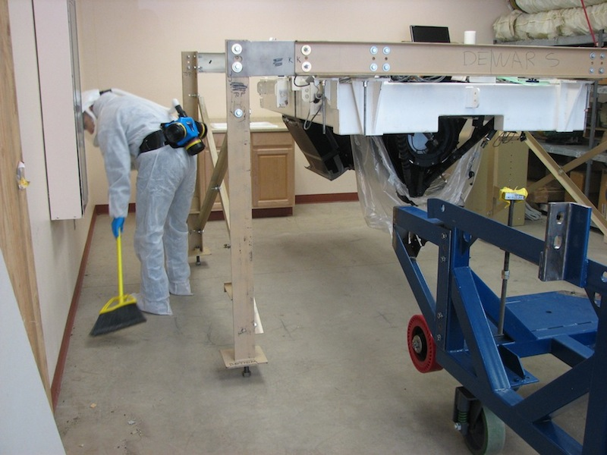

MAESTRO hanging from the tan alignment frame, in the common building lab at the MMT.

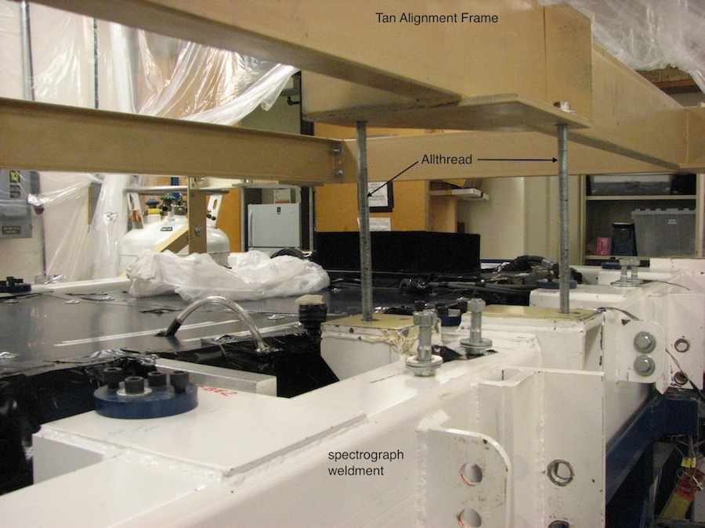

White spectrograph weldment is hanging from the tan alignment frame by allthreads during raising/lowering of spectrograph from the cart. Two of 6 total allthreads are labeled.

