Filling the Science Dewar

last update: June 10, 2013

- The CCD dewar is large, and typically needs filling only once every 24 hours. During the run, we try to fill it every 12 hours.

- The dewar has a brass plug inside the LN2 port, which keeps the LN2 from spilling while observing. However, when this plug is in the dewar, the MMT's LN2 tube, which is used to fill Blue and Red Channel's dewars, does not fit in MAESTRO's hole.

- MAESTRO therefore has its own pipe and tube to attach to the keg of LN2 (pictured below).

- The special tool to remove the brass plug is kept in the MAESTRO cabinet in the common building (see picture below). Insert the tool into the dewar hole, rotating it until its nobs catch the groove in the brass plug. Then turn the tool counterclockwise, and pull the tool and plug out of the dewar.

- To fill the dewar, insert the pipe into the LN2 hole and tighten the pipe fitting onto the threaded opening of the dewar. Open the spigot on the LN2 keg slowly. Wait until the dewar is full; LN2 will spill onto the floor. If you open the spigot too fast, or try to fill the dewar too fast, the whoosh of air can remove LN2 from the dewar, which would be a bad thing. When LN2 is spilling on the floor in a steady stream, the dewar is full, so close the spigot. Wait for the tubing to defrost somewhat before removing the pipe from the dewar, or else the tubing may shatter.

- IMPORTANT SAFETY NOTE: The LN2 hole is located above the vacuum fitting which is used for pumping down the dewar. If LN2 spills onto this fitting, it can be damaged. Then air and dirt can enter the dewar and harm the CCD (this has happened). Do NOT under any circumstance touch the vacuum fitting. A piece of white PVC (see picture), labeled "MAESTRO CCD Fill" is provided and should be hung on the vacuum fitting to protect it, while the dewar is being filled. Keep this item with the keg of LN2 so that it is always handy. If you can't find it, improvise and use some other piece of hard plastic or metal to protect the vacuum fitting.

- Once you have filled the dewar, make a note of the date and time on the white board in the control room.

Photos:

Dewar fill items, stored in the MAESTRO cabinet in the common building.

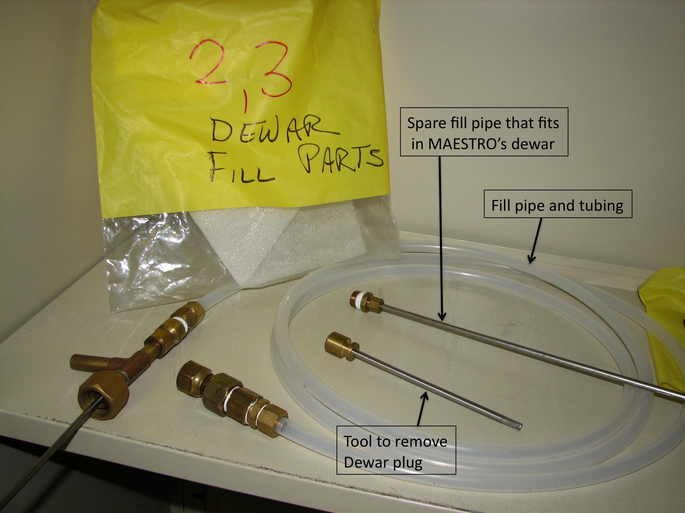

MAESTRO on the telescope. The door swings open to allow access to the dewar for filling with LN2.

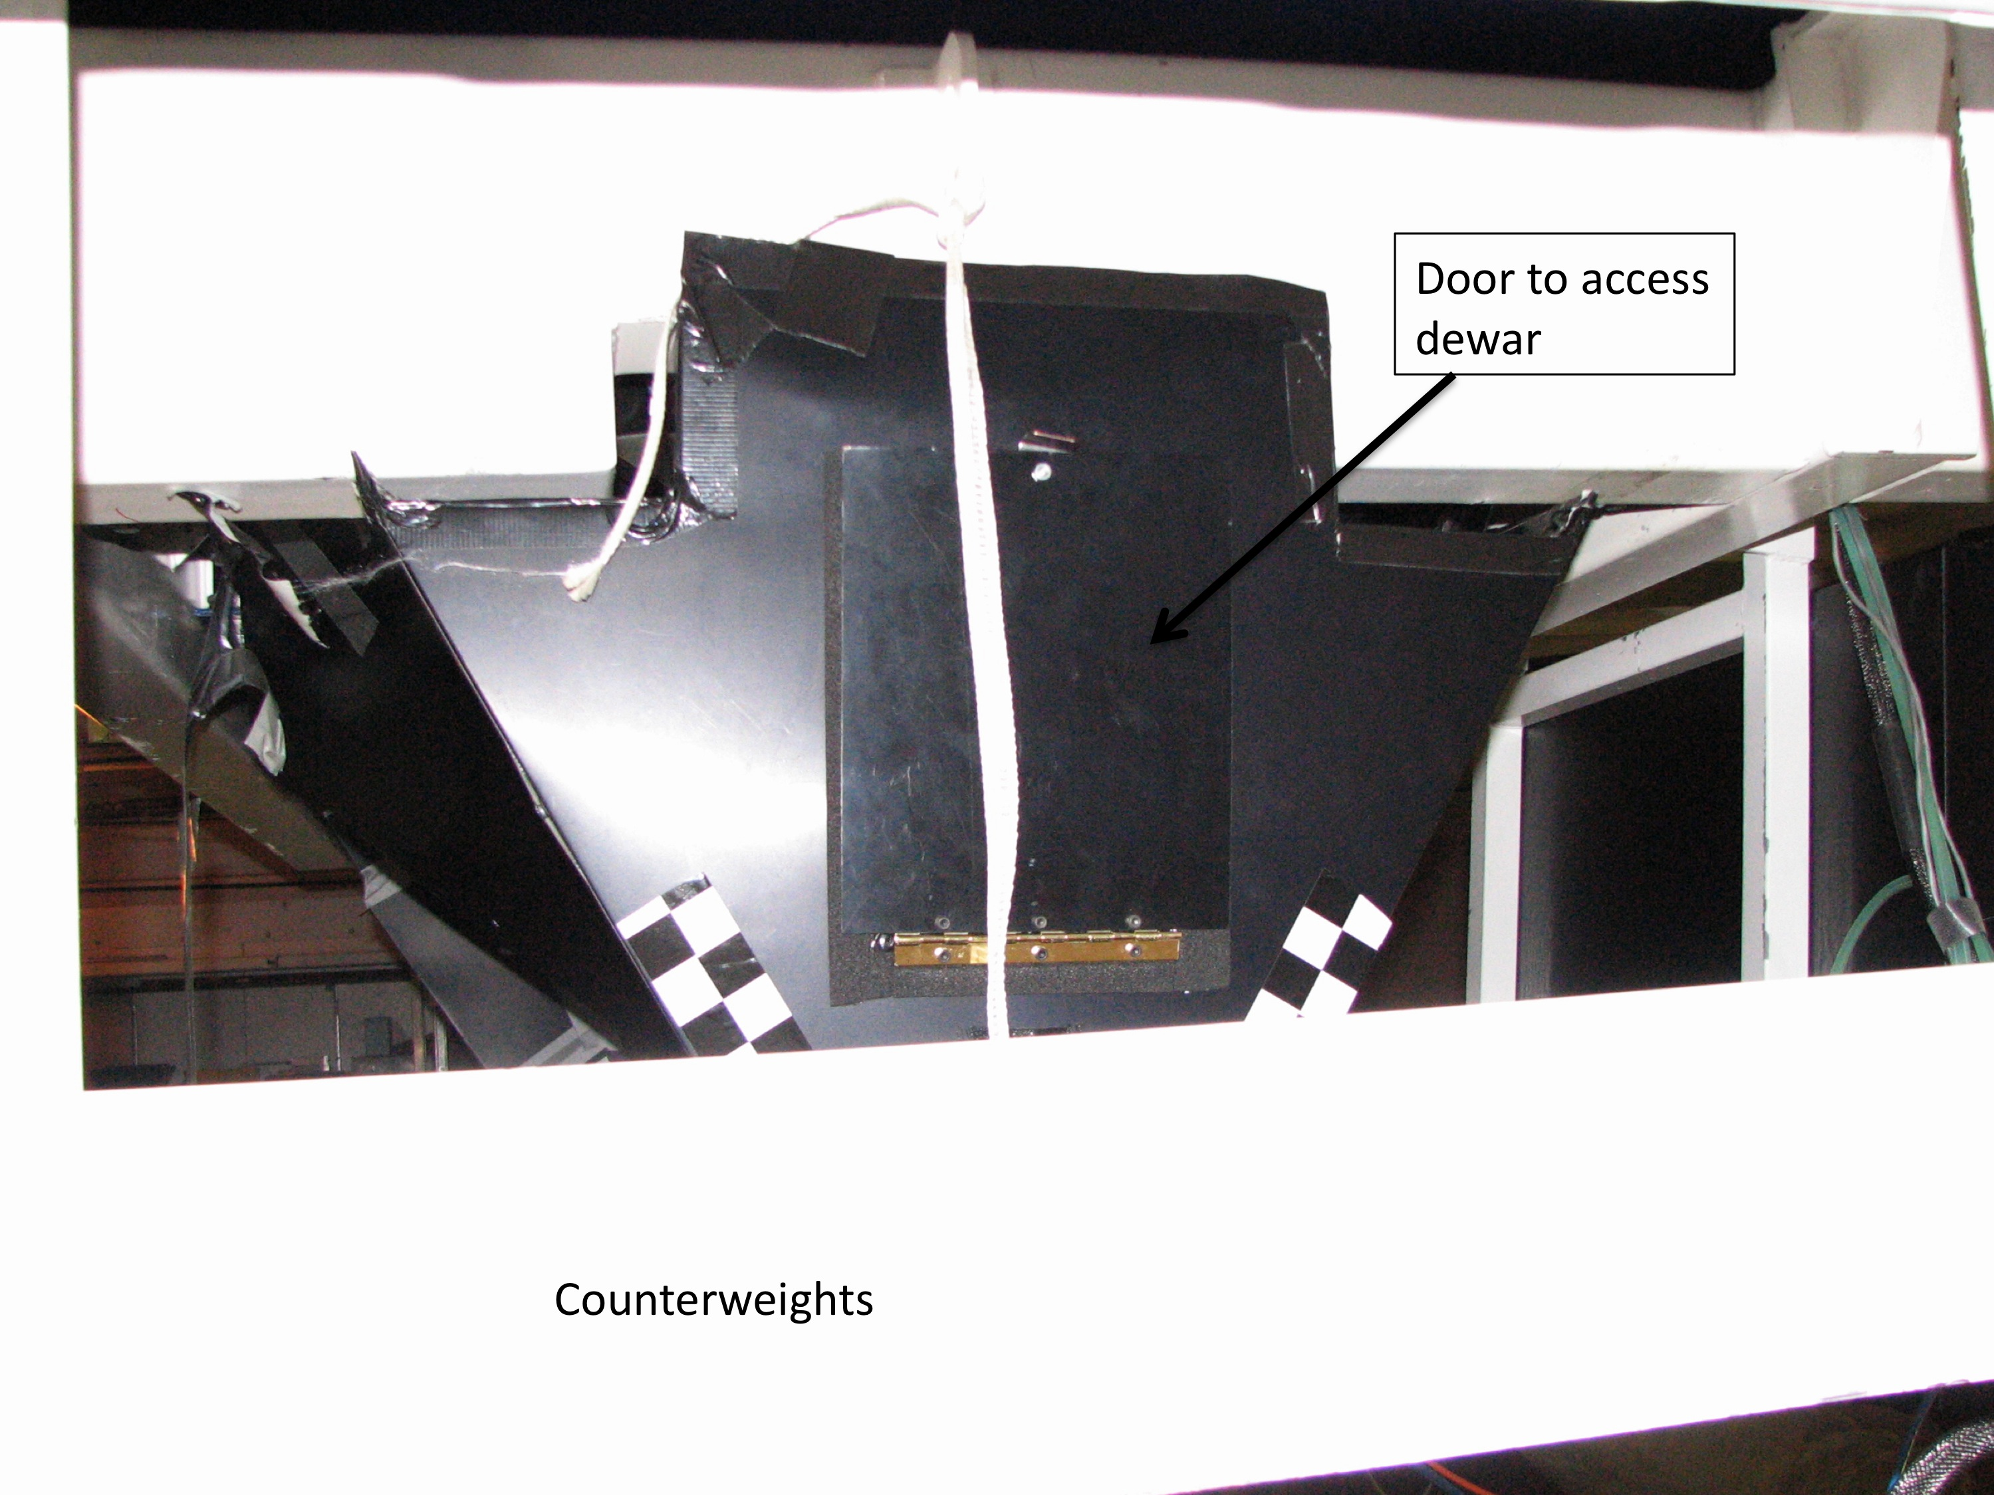

The PVC fixture used to protect the vacuum fitting from damage while filling the dewar:

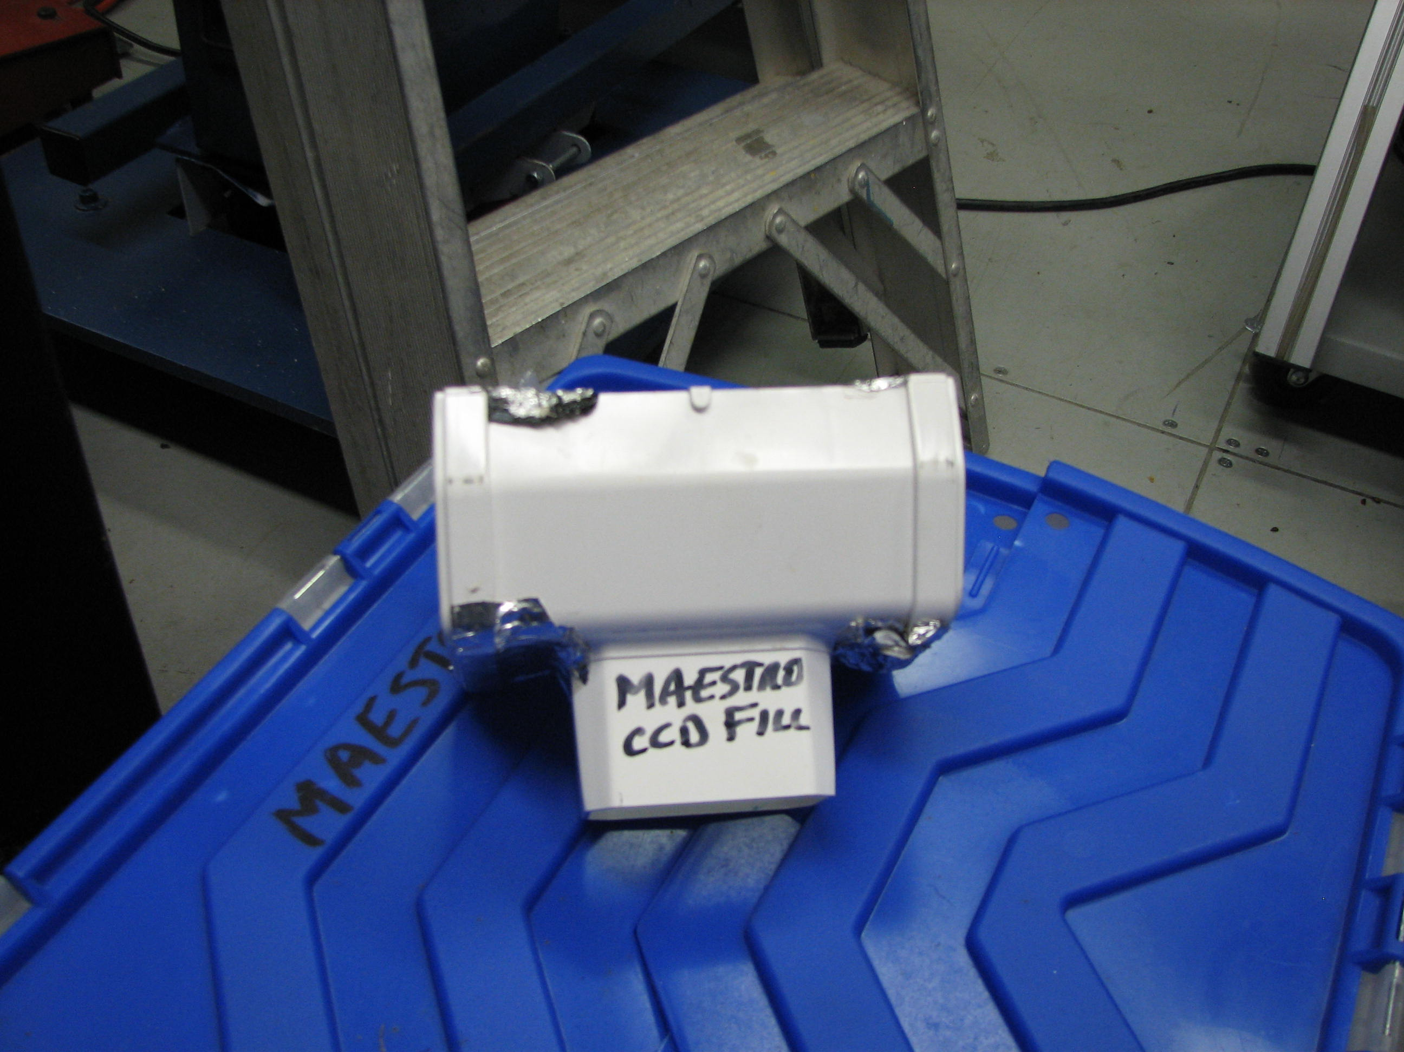

The anatomy of the dewar, showing the hole for LN2, and the vacuum pump fitting. The spectrograph cover has been removed in this picture.

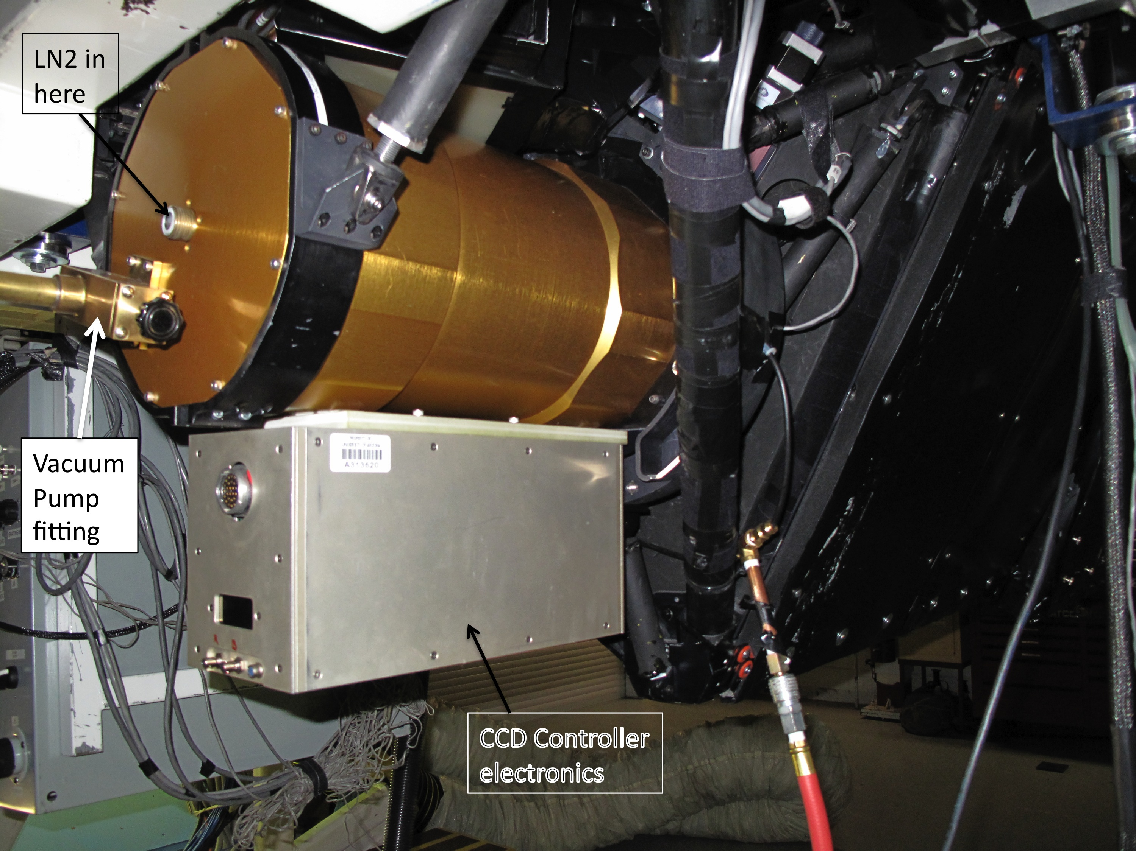

The dewar being filled. MAESTRO is on the cart. A piece of aluminum has been placed on top of the "MAESTRO CCD Fill" PVC to further protect the vacuum fitting.

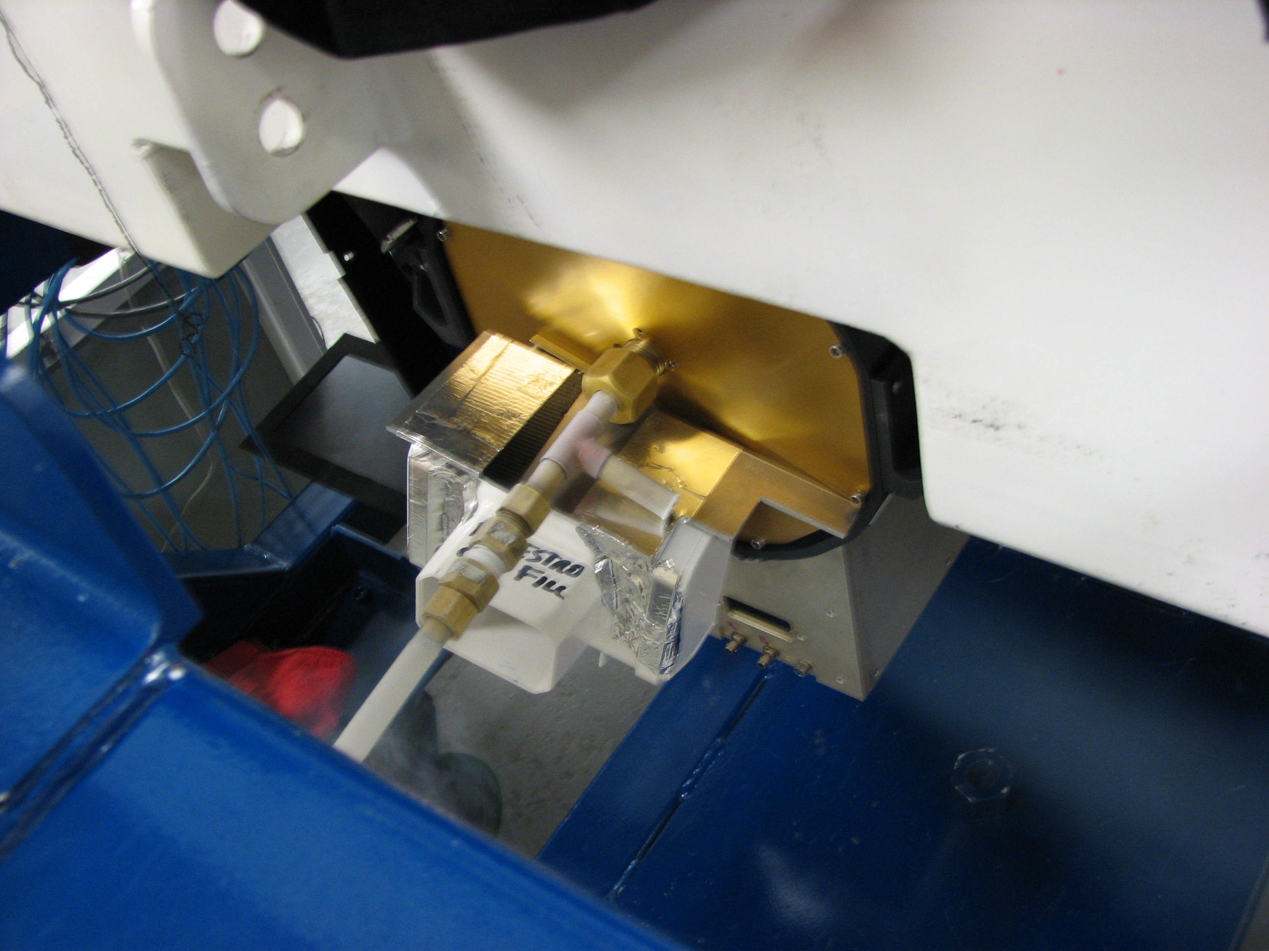

Dewar being filled on the telescope:

