Quartz and Thorium-Argon Lamp Replacement

http://minimaestro.as.arizona.edu/MAESTRO/

last update: June 6, 2013

Notes:

- In order to change the quartz lamp or Th-Ar hollow cathode lamp, the spectrograph must be off the telescope.

- If lamps should fail during a run, the f/5 Th-Ar and Quartz lamps, located in the hub of the f/5 secondary, may be used. Note that MAESTRO's slit acts like a pinhole, so your spectra will have images of the f/5 lamp hub superimposed on the spectrum. The f/5 Th-Ar lamps are dim, so exposure times will be long.

- Quartz lamps burn out quickly and are inexpensive. New quartz lamps should be inserted before the start of every run. Spare lamps are stored in a plastic box in the MAESTRO cabinet in the common building of the MMT. At least once, the two quartz bulbs burnt out simultaneously.

- The Th-Ar hollow cathode is a custom made item, with the thorium lines enhanced, and costs $500. There is a fairly long lead time to purchase one. We have one spare, which is kept in the MAESTRO cabinet in the common building of the MMT.

- We also have several other hollow cathodes containing elements besides thorium, but none have as rich a spectrum as the thorium-argon hollow cathode tube.

To Change Lamps:

1. Remove the cover of the spectrograph which is on top of the slit/shutter area. A slightly out-of-date photo is shown below.

2. The cover of the comparison box is in two pieces which are attached to the comparison box by small screws. Remove the screws and remove the cover. Note that the cover on the left side is easier to access. The lamps in their sockets are now easily accessible.

3. Wear rubber gloves when handling any lamp; oil from your fingers can have an adverse efffect on the lamps!

4. There are two quartz lamps, each with a different color-balancing filter. To remove the bulbs, gently pull the bulbs up.

5. There is one hollow cathode lamp socket containing the Th-Ar lamp. A red-blocking filter is in place to make the argon lines dimmer. To remove the lamp, unscrew the nut to loosen the ring which supports the lamp halfway up the tube.

6. There is also a socket for UV LEDs which we intended to use for flat-fielding. These are not functional at this time.

7. The reflective walls of the comparison box and the various relay mirrors act as a poor person's integrating sphere. The lamp light produced a spot on the diffuser, which is UV transmitting. This spot is then relayed onto the focal plane, illuminating the slit plate.

8. After you replace the two halves of the comparison box cover, put a piece of black tape over the crack to keep it light tight.

PICTURES

The top cover of the spectrograph has been removed, showing the comparison (flip) mirror, and the calibration lamp box.

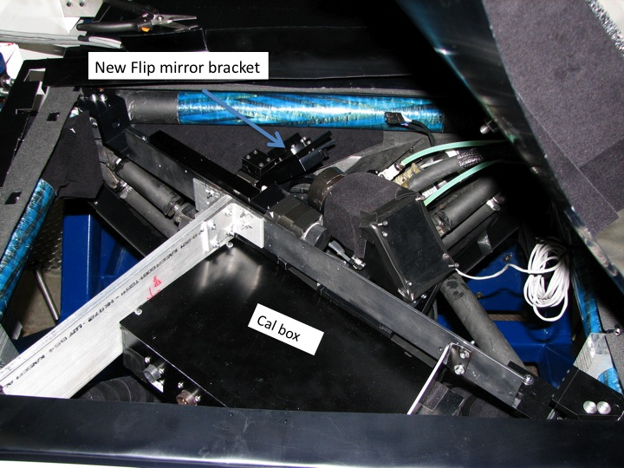

The comparison box area. The top cover of the spectrograph has been rotated up, and can be seen in the upper right hand part of the photograph.

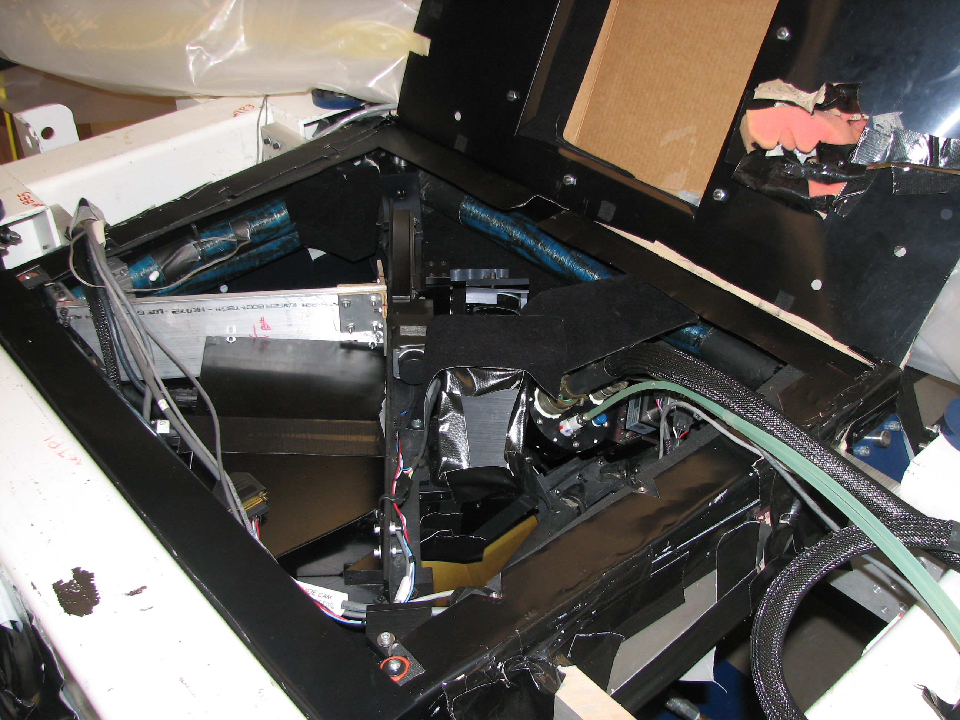

The comparison box, showing the two halves of its cover:

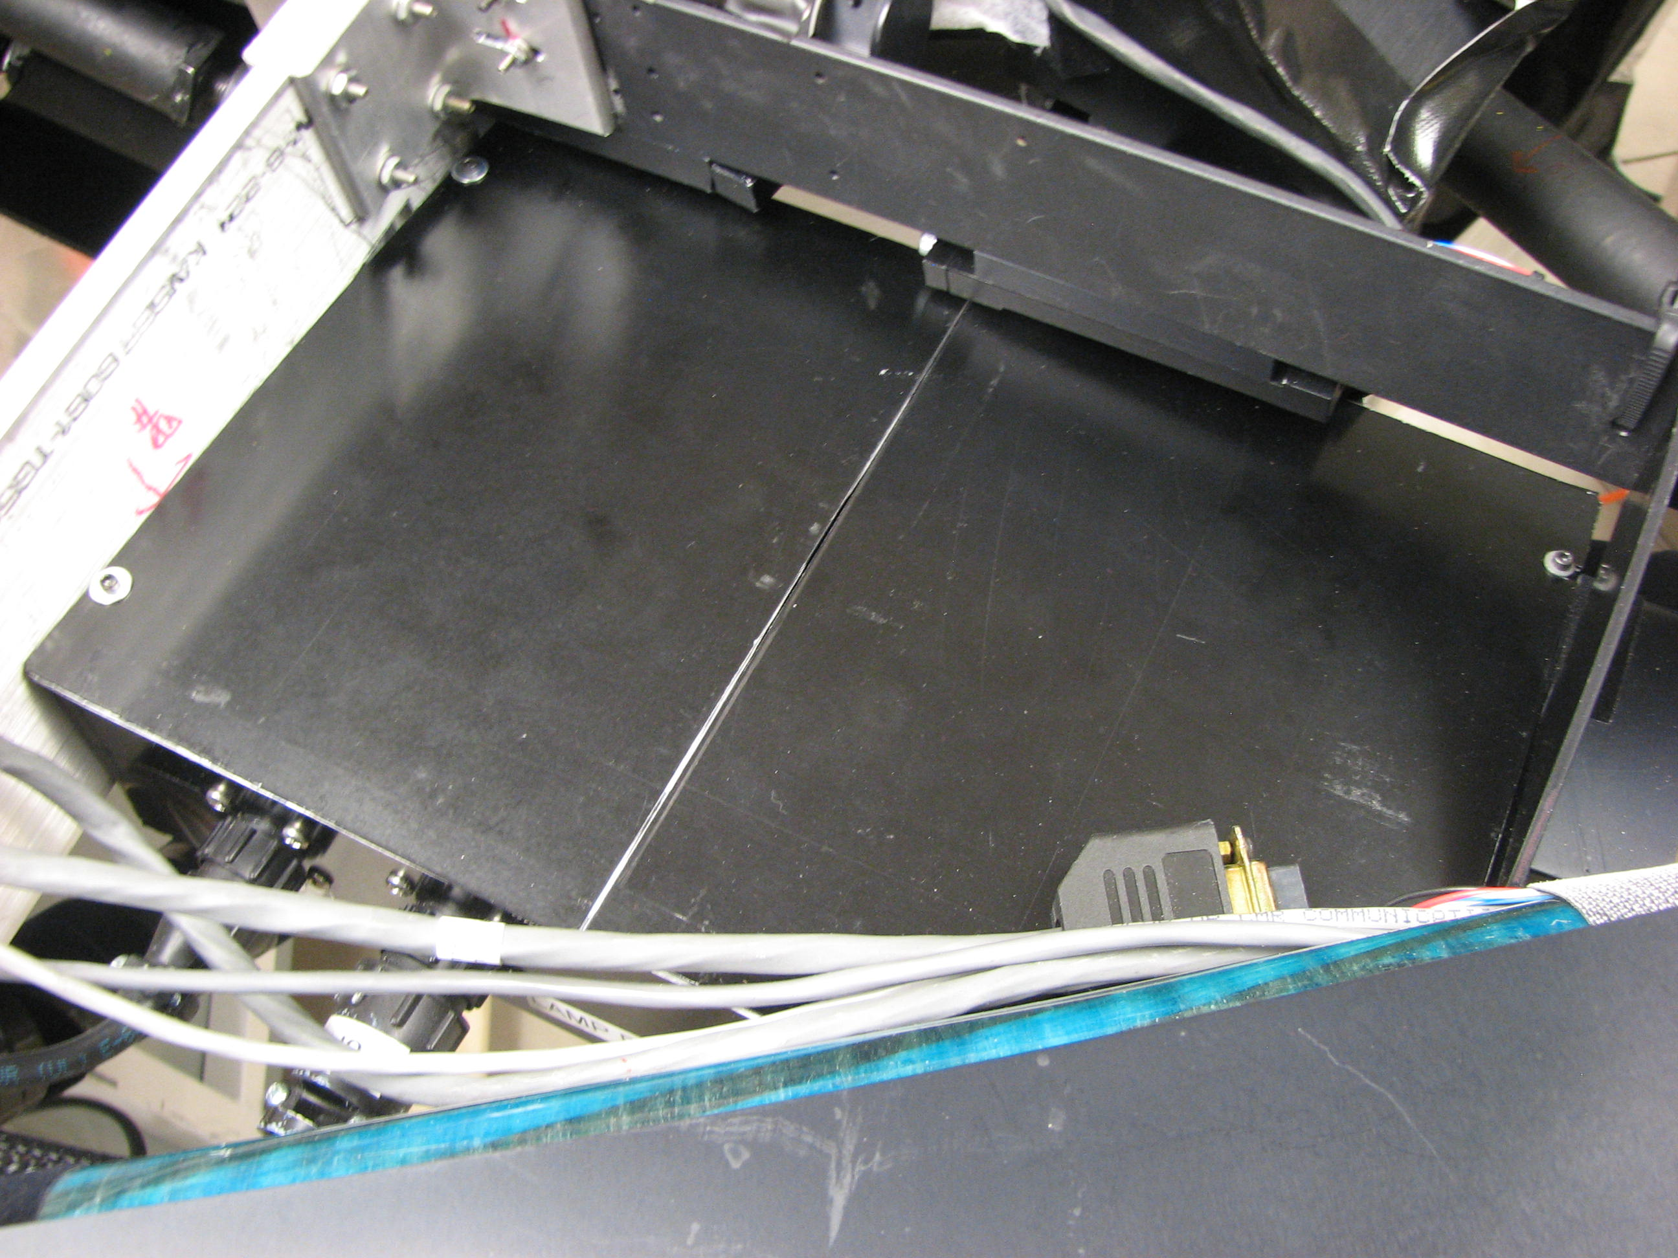

The comparison box cover has been removed showing the inside of the box. This is an old picture, taken during construction, and the filters have not yet been mounted. The picture was taken from the grating side of the spectrograph, so the box appears upside down compared to the pictures above.

