Shutter mounting/unmounting procedure

NOTE: The shutter cable MUST be disconnected before the instrument is mounted in the cart. The shutter can only be connected once the instrument is mounted on the telescope.

1. Feed the cable under the weldment to the top of the Black electronics box.

2. Carefully pull apart the clip at the end of the cable just enough to clip it onto the hole on the shutter mechanism swing arm.

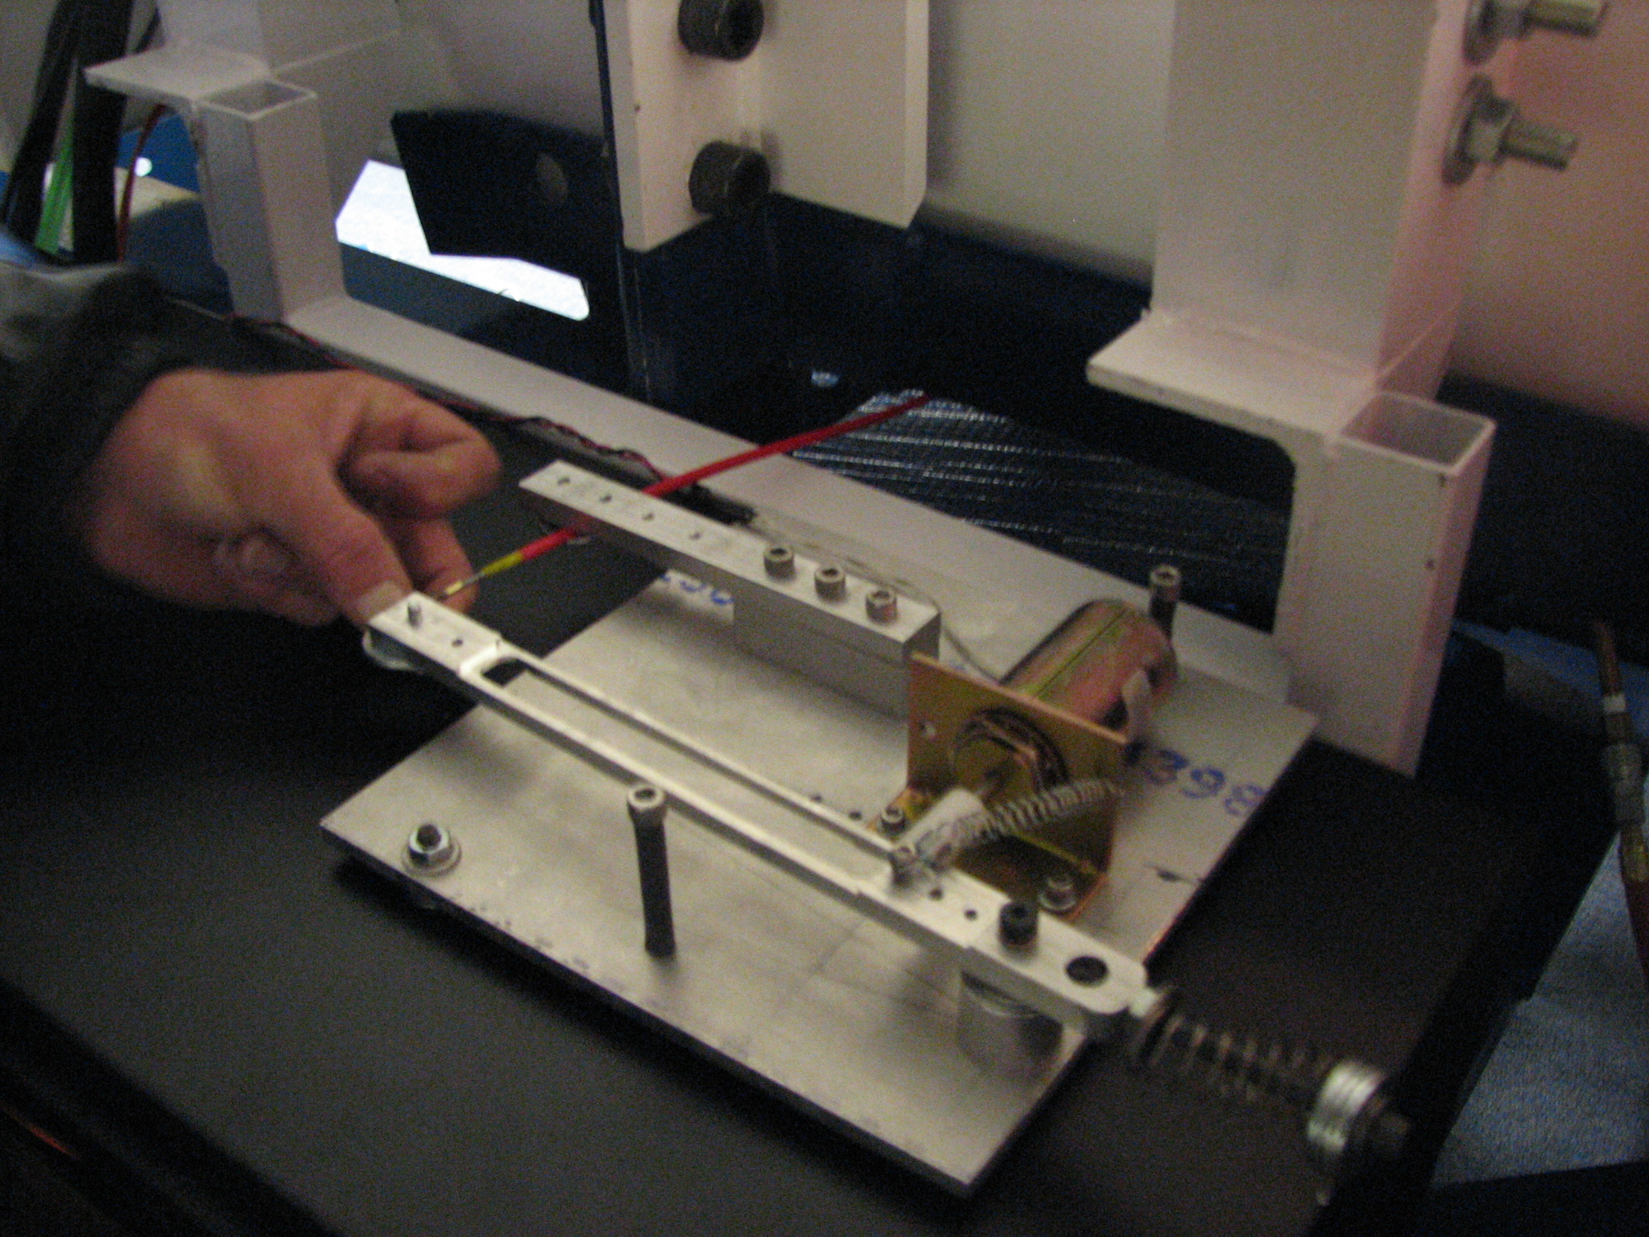

3. Feed the cable under the washer on the fixed bar of the shutter mechanism.

4. Tighten the screw finger tight only to clamp the red cable to the bar between the washer and the bar. Do not crimp the red cable, or the shutter will not move freely.

5. Test the shutter mechanism by hand to ensure smooth operation over the length of the pull.

6. Open the black electronics box, and flip the switch on the red/black twisted wire, to activiate the shutter power.

7. Push the button on top of the shutter electronics box. (Figure needed) to manually test the solenoid operation.

8. Close up the electronics box.

