MAESTRO Engineering Run
July 24-31, 2007
To: Faith Vilas
cc: Russ Warner, Michelle Reed, Morag Hastie
From: Jill Bechtold, on behalf of the MAESTRO team
Date: Aug. 21, 2007

Note: A version of this report, with more details about confidential Steward personnel issues, was submitted to Peter Strittmatter and Jeff Kingsley.

CONTENTS
Page
1. Executive Summary 2
2. In the Lab, before the run 4
3. Personnel 7
4. Transport to the mountain 8
5. Mounting of spectrograph and counterweights 12
6. Balancing the rotator and telescope 15
7. Initial Optical Focus and Flexure Tests 15
8. CCD Read Noise 18
9. Condensation on the Dewar Window 18
10. UV LEDs 19
11. Slit Viewer CCD camera 19
12. First Observations on the Sky 20
13. Optical Performance 21
14. Transport back to Steward 24
15. Prioritized list of things to fix 25
16. November Engineering Time 28
17. Conclusion 29

1. Executive Summary

We had an extremely successful run. Highlights include:

1. Safe transport from Steward Observatory to the MMT loading dock and back again, with no thermal stress to the CaFl lens.
2. Safe transfer of the instrument from the MMT loading dock to the telescope chamber, through the hatch.
3. Mounting of the instrument and counterweights on the telescope. The instrument weighs about 600 pounds less than we had estimated theoretically.
4. Balance testing and adjustment, so that we can rotate the spectrograph and tip the telescope.
5. Cabling of spectrograph electronics, Th-Ar power supply, CCD electronics and dry nitrogen purge.
6. Successful installation on alewife computer of
(1) Ruby code to run spectrograph stepper motors and lamps, and
(2) IRAF/ICE to control the CCD.
7. Focus of Th-Ar spectrum on CCD, with FWHM = 2.0 pixels in both spectral and spatial directions with a 0.4 arcsec slit. Astigmatism is not measurable. We
therefore will be able to realize the full R=90000 spectral resolution.

8. Focus of guide camera on slit plate, and control of the guide camera on the “hoseclamp” computer with Lesser/Schmidt data acquisition gui.

9. Extensive flexure tests using the Th-Ar lamp in the f/5 topbox. Mechanical flexure is within specs.
10. Generation of documentation of procedures, and beginnings of a reduction pipeline.
11. Brief observation on sky was made of Vega, through clouds, despite telescope problems.
12. Verification that the slit position is within an arcsec of the central axis of the telescope.

We have been awarded 4 nights in November to bring MAESTRO back to the MMT, and have a number of things we need to do before then. The highest priorities are to

1. Rework the grating mount so that the spectrum is centered on the CCD.

2. Realign the slit viewing guide camera so we can acquire objects and guide.

3. Replace the shutter with an electronic one.

4. Manufacture the spectrograph cover, and baffles.

The last night of the November run is fairly dark grey time, and we intend to take observations in “science demonstration” mode.

2. In the Lab (up to July 24)
Here is a brief description of the work we did in the 2 months before the July engineering run.
1. Fifth Floor Lab. We set up the spectrograph in the 5th floor lab in Steward, with the spectrograph hung from an "alignment frame" which simulates the back of the telescope. The alignment frame sags much more than the rotator, and is not tippable, so we could not measure flexure until we got to the MMT. We built a “clean room” out of wood and plastic sheeting for approximately $200. Temperature control was maintained by a portable air-conditioning unit. A Linux computer (optics2.as.arizona.edu) was set up in the lab to allow us to run the spectrograph control software and CCD control. Linux was chosen over Windows because of the preference for linux at the MMT. High speed internet was installed in the lab; building rewiring was necessary to provide a reliable Ethernet connection.
2. Lens Can. We installed the main camera/collimator lens can (L1-L6) and aligned it with the direction of the space frame. For initial alignment, we used an optical quality laser mounted on an x,y,z stage and a return flat mirror at the position of the grating, with no prism. Light went through a dichroic so we could compare the outgoing and return beams, using a small, adjustable microscope. Some of the large test optics were lent to us by Gary Schmidt, or scrounged from his lab. Jigging was manufactured by the SO shop.
3. Injection optics and fold mirror. We then transferred the laser to a movable stage above the spectrograph, to simulate the telescope beam. We installed the spectrograph's injection optics and fold mirror, again aligning with the laser and return mirror. Several mechanical conflicts were dealt with.
4. Spectrograph control software. The spectrograph control electronics box was tested along with the Ruby gui software that runs the Galil control of the stepper motors and Pullizi switches for the lamps. The code worked well but crashed often, until Jeff Rill re-worked the architecture to allow simultaneous opening of multiple sockets in a more graceful way. Other modifications were made as experience was gained with the hardware.

5. Spectrograph control electronics. The electronics box had been wired without drilling mounting holes for the bracket which mounts the box on the spectrograph. The electronics were all removed, the holes drilled, and the electronics were replaced. A few problems were encountered, and solved, involving loose connections.
6. Calibration lamps, control and optics. The calibration sources were mounted in a box and then installed in the spectrograph. The cal sources include a Thorium-Argon hollow cathode lamp, two quartz lamps with color balancing filters, and a novel UV LED cluster to produce UV flatfield light. The cal sources are aligned to illuminate a UV transmissive diffuser. The light from the diffuser is then bent via relay mirrors and then passes through transmissive optics to simulate an f/5 beam focused on the slit. The cal box and mounting hardware had to be substantially modified to resolve mechanical conflicts. The entire cal box/flip mirror assembly had to be shimmed upwards about ½ an inch to allow the dewar to be mounted. There are also severe light leaks from cal box, especially through ventilation fans. Baffles were constructed but are not entirely satisfactory.
7. Calibration Flip Mirror. The flip mirror that moves in and out of the beam to direct the calibration light to the spectrograph was tested both manually and under computer control. The flip mirror is moved by a stepper motor and involves a precision stage. The mechanical design of the moving parts proved to be problematic: after a few flips the joints became loose and the mirror would stall. In the process of testing, the motor was damaged slightly. Warren Davidson worked on it, and some parts were re-machined, so that it would work for the run. It flipped back and forth without jamming during the run, but did not always end up in a position which centered the cal beam on the slit (we could see this using the slit viewing camera).
During the run, we saw that we were not illuminating the slit uniformly, even after moving the flip mirror slightly using the stepper motor. For tests of optical quality and
flexure we therefore used the thorium argon sources in the f/5 topbox.
8. The prism, in its cell, was installed in the spectrograph. Baffles were constructed out of paper and black flocked material, because the aluminum baffles which we made did not fit.
9. Grating. The grating in its cell was mounted on the grating platform. We then spent several days trying to mount the grating platform in the spaceframe. We had previously fit check the grating platform with a dummy grating in the cell, and baffles to simulate the position of the prism. The fit check had been difficult, but successful, and we had written a detailed document describing the procedure. However, with the real grating and prism, it proved impossible to mount the grating in the proper position. We also had inadvertently installed the grating cell on the platform at one end of the cell's tilt travel, not in the center of its travel. In the end, we secured the grating platform to the spectrograph with kludged brackets to allow us to get close to the correct position. However, the center of the echelle format is way off to one side of the CCD because we could not mechanically tilt the grating to the correct angle (we need another degree or two), and the correct position with respect to the beam (we're losing 30-40% of the light off one end of the grating) with the ad-hoc brackets we were able to make before the run.
We installed the stepper motor which tilts the grating slightly, but computer control of it had problems. Since we only had a few days left before the run, we replaced the motor with a piece of all-thread and some bolts, which allowed us to tilt the grating by hand.
10. Shutter. The shutter mechanism proved to be another problem, and we spent several days working on it. The design consisted of a small iris shutter, connected to a bicycle brake cable, to be activated by a solenoid. The bicycle brake cable proved too difficult to activate with the solenoid we had. We replaced the bicycle brake cable with a plastic cable/sheath manufactured for model airplanes, which was lighter and had much less friction. We also replaced the solenoid, and installed counterweights on it. Tinkering with the solenoid mechanically allowed us to operate with a shutter triggered by the CCD software. The shutter worked very well during the run until the last day, when we rotated to 90 degrees and tried doing a flexure test, and it failed at elevation=60 degrees. One of the mechanical tricks was to mount the solenoid to minimize curvature in the cable. However, the easiest place to mount it then was external to the spectrograph, which exposed it to damage, and caused a light leak.

We have since found a commercially available electronic shutter, from Uniblitz, for about $300. It went on the market for the first time in January 2007, so we couldn’t have used it initially. We will replace the iris/cable/solenoid shutter before the next run.
11. Guide camera. We fit check the slit-vieing guide camera and tested the stepper motor which moved the precision stage upon which the camera and focusing optics are mounted. Mechanical conflicts were dealt with on an interim basis, but more work is needed. Unfortunately we did not have time to turn on the slit viewer and focus it before the spectrograph was mounted on the telescope. Once mounted on the telescope, further adjustment was not possible because we couldn't access the slit viewer mount.
12. CCD dewar and software. We ran the CCD in the lab and were able to use it to complete the optical alignment of the spectrograph before going to the telescope.
The CCD is read out with AZCAM running on a Windows computer (“maestroccd”) mounted in the CCD electronics box on the spectrograph . The user interface is IRAF/ICE. The AZCAM software was modified to write a single extension FITS file instead of a MEF format file, despite the fact that we read the CCD with two amplifiers. Several bugs in the software were found and fixed in the lab. Mike Lesser and Skip Schaller were able to debug problems remotely, both on optics2 and maestroccd, after installation of VNC. A liquid nitrogen tank was procured, and a transfer line made to allow the dewar to be kept cold. Dewar hold time is 24 hours or more.
13. Covers and baffles. The spectrograph covers were never fully designed and detailed by David Dean, so the MMTO (Shawn Callahan and Morag Hastie) volunteered to supervise a mechanical engineering student hired over the summer by MMTO, to take over production of the covers. However, the permanent covers were not complete before the run, so we fabricated covers and baffles using mylar covered plastic bubble wrap (from Home Depot), covered with black flocking material which was kindly donated to us by the MMTO. These were attached to the spectrograph primarily with velcro, to allow subsequent access. They have the advantage of insulating the Calcium Fluoride element from thermal shock. The blue boat oars which are in the optical path were covered with black flocking material as well. The black flocking material does not stick well to the boat oars so we will need to replace it.

For transport, the entire spectrograph was covered with corrugated cardboard. On the day of transport, it was raining, and we put a tarp over the spectrograph and cart.
14. Dry nitrogen purge. The initial concept and manufactured hardware for purging the dewar window with dry nitrogen proved to be unworkable mechanically. We rigged a black piece of drip irrigation hose with holes punched in it, and inexpensive fittings from ACE hardware, to provide a dry nitrogen purge.
15. Triplet oil reservoir. The camera/collimator lens can contains a triplet which is optically joined by oil. We installed a pressure relief system so that the seals wouldn't
leak. The system involves a flexible membrane at the end of a pipe, and a spigot to close the system when the spectrograph is tipped 90 degrees to go through the MMT hatch.
This system changed in concept and execution in the days before the run.
There is still a very, very slow leak in the triplet cell. We installed plastic and felt to keep the oil from contaminating other parts.
16. Overall alignment and focus. After initial alignment with the optical grade laser, we adjusted the alignment by eye, using the quartz lamps in the cal box, and observing the spectrum visually before mounting the dewar. Just before the run, we were able to obtain a spectrum of the thorium-argon lamp through the entire system, and test focus. The best focus appeared to be beyond the adjustment of the L1 element. We readjusted the L1 stepper motor and stage in order to allow L1 to be able to go through focus. However, we did not have time in the lab to actually focus the spectrograph.
3. Personnel

It is worth mentioning a personnel issue we dealt with during this period. Due to events outside our control, an important member of the MAESTRO team was suddenly unable to work. The practical result was that we faced getting most of the moving parts working, as well as most of the mechanical conflicts resolved, without his help. A lot of the details about handling the spectrograph were not documented, and drawings are missing.

Fortunately, Dave Baxter, of Mike Lesser's lab, was able to spend about 2 weeks working in our lab, which was an enormous help. He worked on the numerous small problems which needed to be solved to make the spectrograph work. Morag Hastie, the Firestone fellow at the MMT, worked in the lab, as did Ed Olszewski of Steward. J.T. Williams, Warren Davidson, Mario Rascon, Tom Stalcup, Tim Pickering, Skip Schaller, Shawn Callahan, Grant Williams and Gary Schmidt shared their extertise when we needed it. Several undergraduates working for MMTO spent time in the lab and provided muscle when necessary. Finally, our teenage children who were on summer vacation (C.J. Olszewski, Megan Reed and Duncan Reed) were pressed into service to help.

4. Transport to the Mountain
Two issues concerned us regarding transport to the mountain:

1. We obviously wanted to maintain the optical alignment and not damage fragile optics and mechanisms.

2. The large CaFl element, although encased in an oiled triplet in the lens can, could potentially shatter if exposed to thermal shock. The only quote I had been able to get for the blank for this element was $500K; ultimately our optician pulled in favors with CaFl manufacturers to procure it for considerably less. The “lore” is that thermal changes should be controlled to be less than one degree C per hour. Since we were transporting the spectrograph during height of the Tucson summer heat, we were concerned about thermal shock.

After lengthy discussions with the MMTO staff, we settled on using the MMTO’s air ride truck. Responsibility for organizing the transport was undertaken by Morag Hastie, J.T. Williams and Russ Warner. The air ride truck had the advantage that it is owned by the MMTO, and so is familiar to the staff, and available for test runs. The disadvantages include that it has a translucent roof, so gets very hot on sunny days. Also, the gate lift is not rated to support the weight of the spectrograph. The truck bed is not level with the Steward loading dock, and so we were worried that we would not be able to push the spectrograph uphill over the ramp onto the truck.

A dry run of the loading procedure was made on Thursday, July 19, when the MMT staff was in town for a meeting. Modifications were subsequently made to the cart, including removal of two of 6 casters.

Transport to the mountain was originally scheduled for Sunday evening, July 22. On Thursday, July 19, we asked the MMTO to postpone the transport until Monday evening, and since we needed the extra time in the lab. They wisely suggested that we transport on Tuesday evening, and graciously rearranged their schedules to accommodate our slip. This effectively meant that we gave up the chance of being on the telescope for our first night, Wednesday, July 25, since the same crew who transported the spectrograph to the mountain would be the ones to mount the spectrograph on the telescope. We therefore turned over Wednesday night to MMTO for f/5 WFS engineering. The aim of the f/5 engineering was to test off-axis WFS operation, which would enable MAESTRO to be operated with constant updates to focus and alignment while observing. As it turned out, thunderstorms and a cap cloud precluded any observations on sky that night.

On Tuesday, July 24, the spectrograph was lowered from the alignment structure in the lab, and attached to the blue spectrograph cart. The cart was taken down to the loading dock area in the Steward freight elevator.

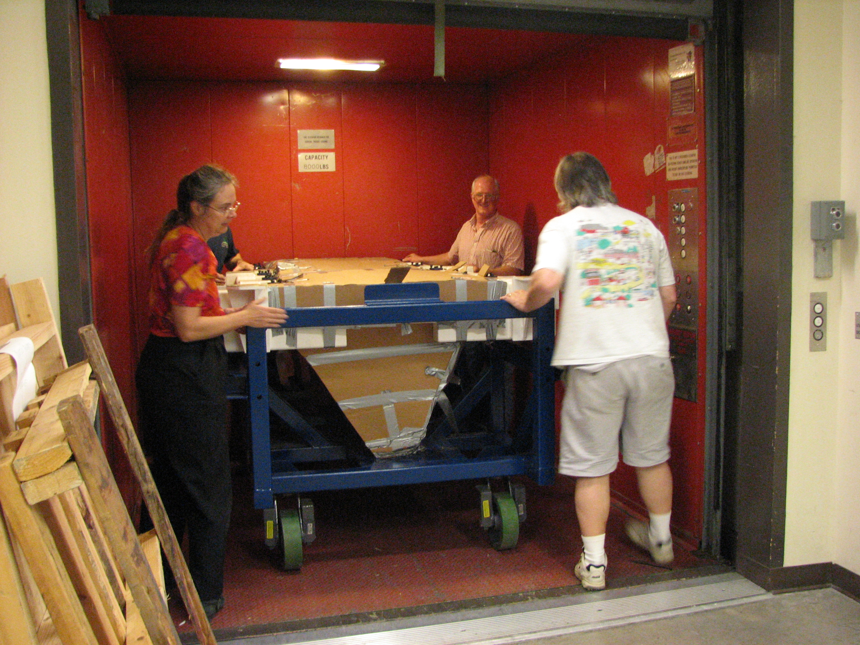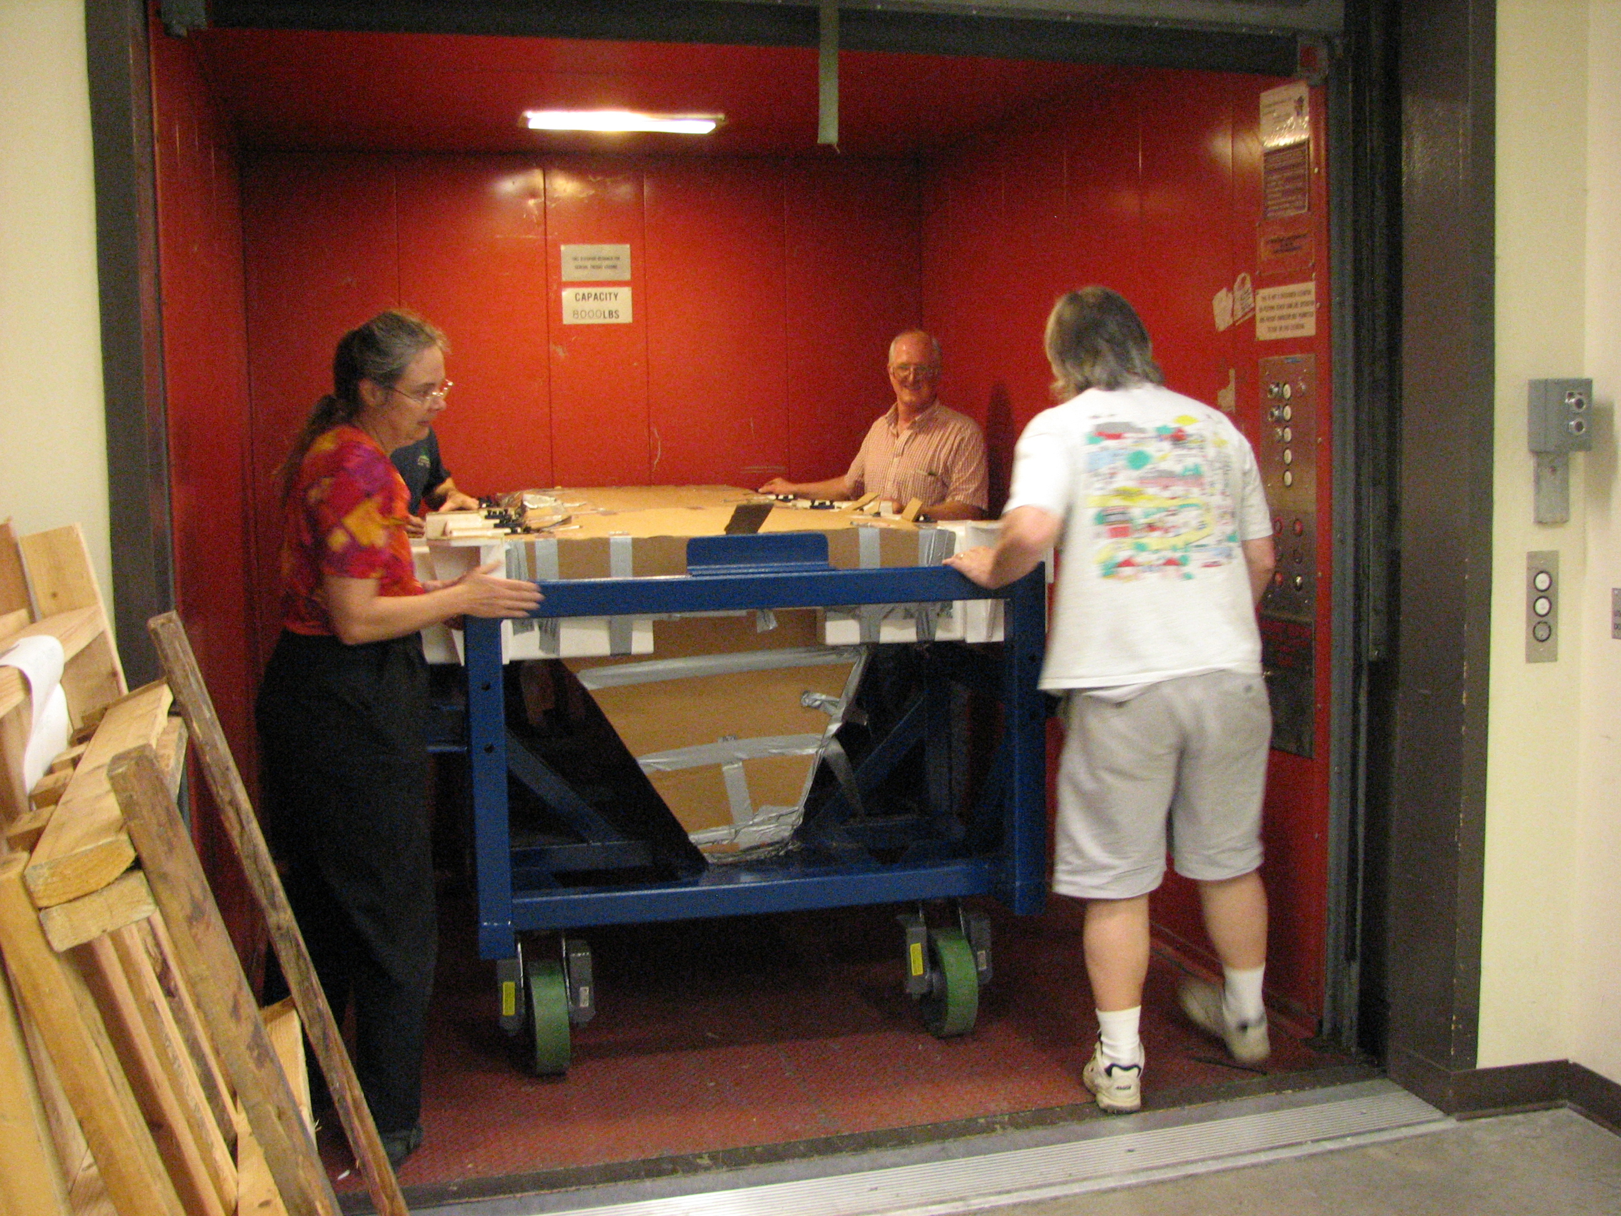

Michelle Reed, David Baxter and Ed Olszewski push MAESTRO into the Steward freight elevator. An MMTO student is behind Michelle.

At midnight on Tuesday, July 24, Russ Warner, Morag Hastie, JT Williams, Dennis Smith, Ricardo Ortiz and Bill Stangret loaded MAESTRO into the air ride truck without problem. A Steward machinist was on hand at the request of the MMTO, but was not needed. The spectrograph was easily wheeled into the truck and secured in its center with cross-wise straps. The counterweight structure and its cart were also loaded into the truck.

Bill Stangret drove the air ride truck up the mountain, and the spectrograph was unloaded. The crew immediately transferred the spectrograph through the hatch to the chamber, using the crane. The spectrograph was tipped 90 degrees, lifted over the hatch doors, the doors are closed, and then the spectrograph is set down in the chamber. We had earlier executed a dry run of this procedure without the optics mounted, and it went smoothly this time. A few potential modifications to the cart to make the procedure easier were noted. The counterweights, still mounted on their cart, were lifted through the hatch to the chamber also.
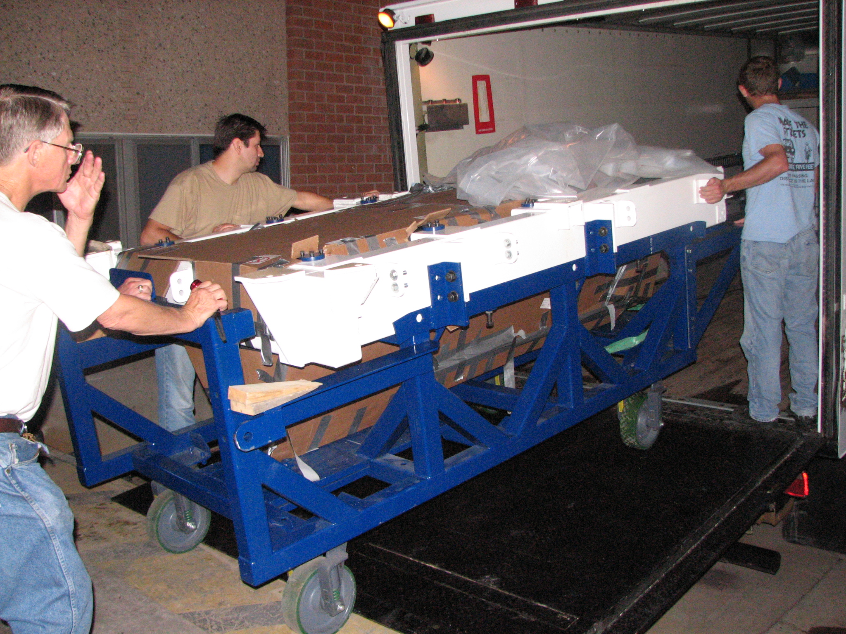

MAESTRO being loaded onto the air ride truck at midnight, July 24, 2007.

Before leaving the lab, we had mounted a temperature sensor on the lens can near the CaFl element, which was remotely readable using a wireless receiver. We monitored the ambient temperature and lens can temperature throughout the transport. The rate of temperature change was kept well within limits. We also mounted four 5g magnetic shock accelerometers to the grating platform and lens cell support structure. None of these tripped.

While on the crane, we weighed the spectrograph and cart. They weigh 2800 pounds, about 600 pounds lighter than what we had predicted from theory, no doubt because we always rounded up on estimates, to be conservative. The cart by itself weighs 1440 pounds, close to the 1500 pounds we predicted. Thus the spectrograph weighs 1360 pounds, without the dewar (50 pounds), counterweights (600 pounds) or electronics boxes (two at about 50 pounds each). The total, about 2100 pounds, is well below the limit of 3000 pounds for instruments hanging from the rotator.

Michelle Reed, Dave Baxter, Mike Lesser and I arrived on the mountain on Wednesday, July 25. Mike and Dave brought the CCD dewar and electronics. They spent most of the day getting the “maestroccd” computer and “alewife” talking to each other correctly. They also mounted the guide camera. Michelle Reed and I transported a lot of miscellaneous parts and hardware which were unloaded and taken up to the chamber.

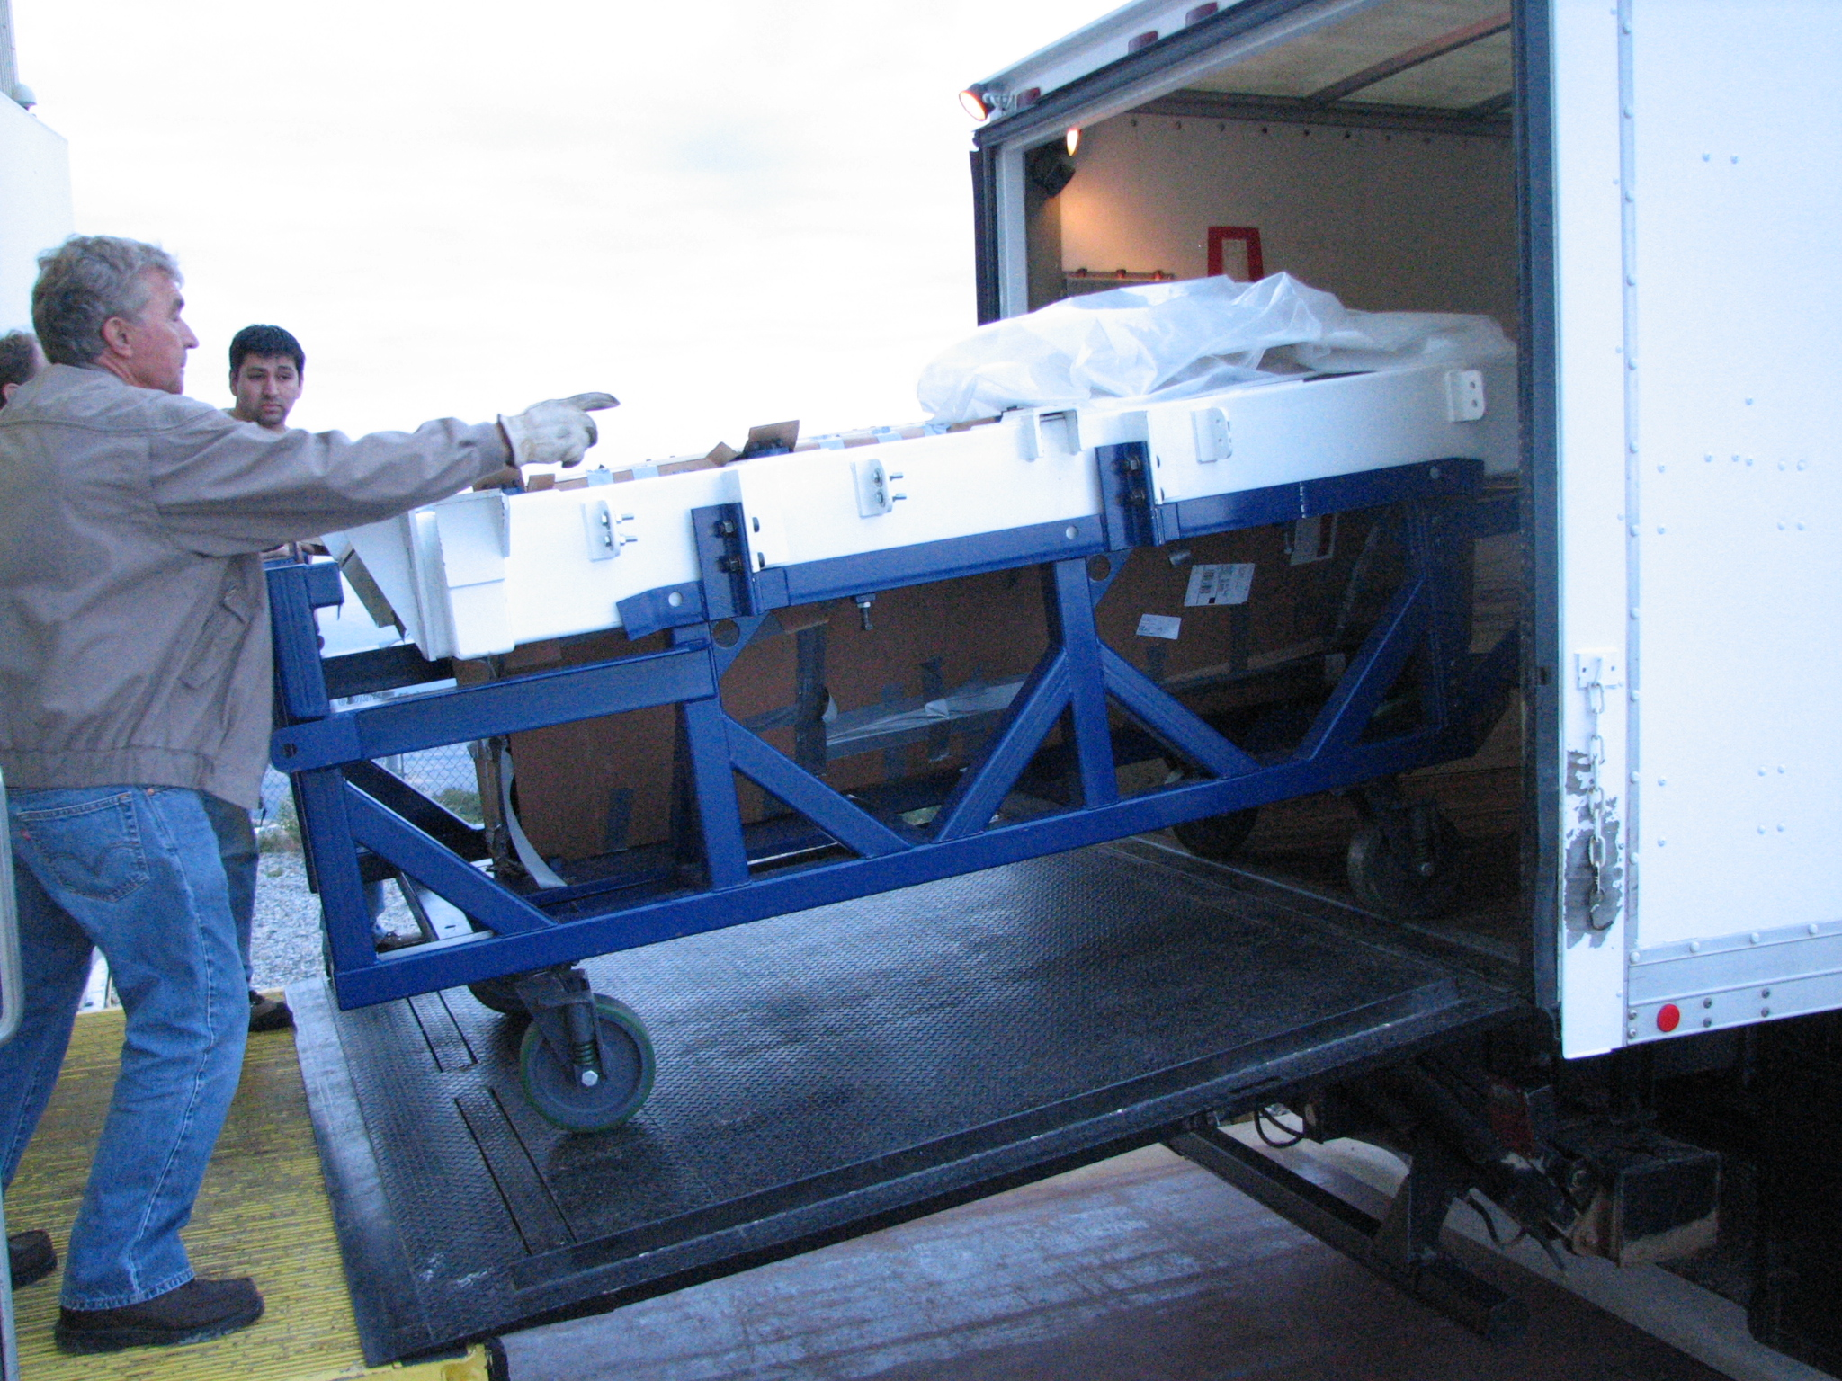

MAESTRO arriving at the MMT.

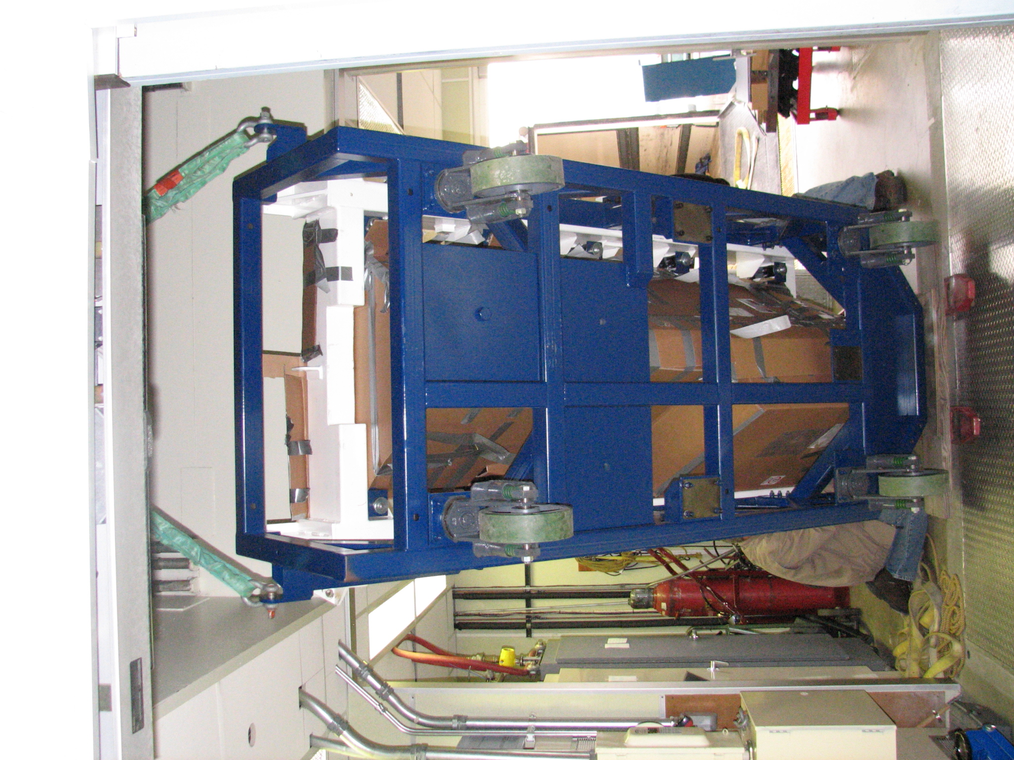

MAESTRO being lifted up through the hatch to the chamber.

5. Mounting the Spectrograph and Counterweights

The spectrograph was mounted on the telescope on Thursday, July 26. Although we had gone through a dry run of mounting the spectrograph without optics, there were unexpected problems which had to be dealt with. Since our dry run, the instrument lift had been replaced, we had made some modifications to the cart, and we had redesigned some of the hardware that attaches to the telescope. The problems were dealt with by modifying the details of the mount procedure.

The spectrograph on the cart was lifted with the MMT instrument lift until the top of it was about 3 inches away from the rotator. A very small stop bar was attached to the instrument lift on the grating end of the spectrograph, to prevent the casters from rolling off the lift. However, when the spectrograph is aligned with the rotator, the casters are only a few mm from the edge of the lift, and the stop bar would have not offered much resistance, should the spectrograph start to roll off the lift. This situation caused great trepidation to the MAESTRO team, but was calmly dealt with by the MMTO staff.

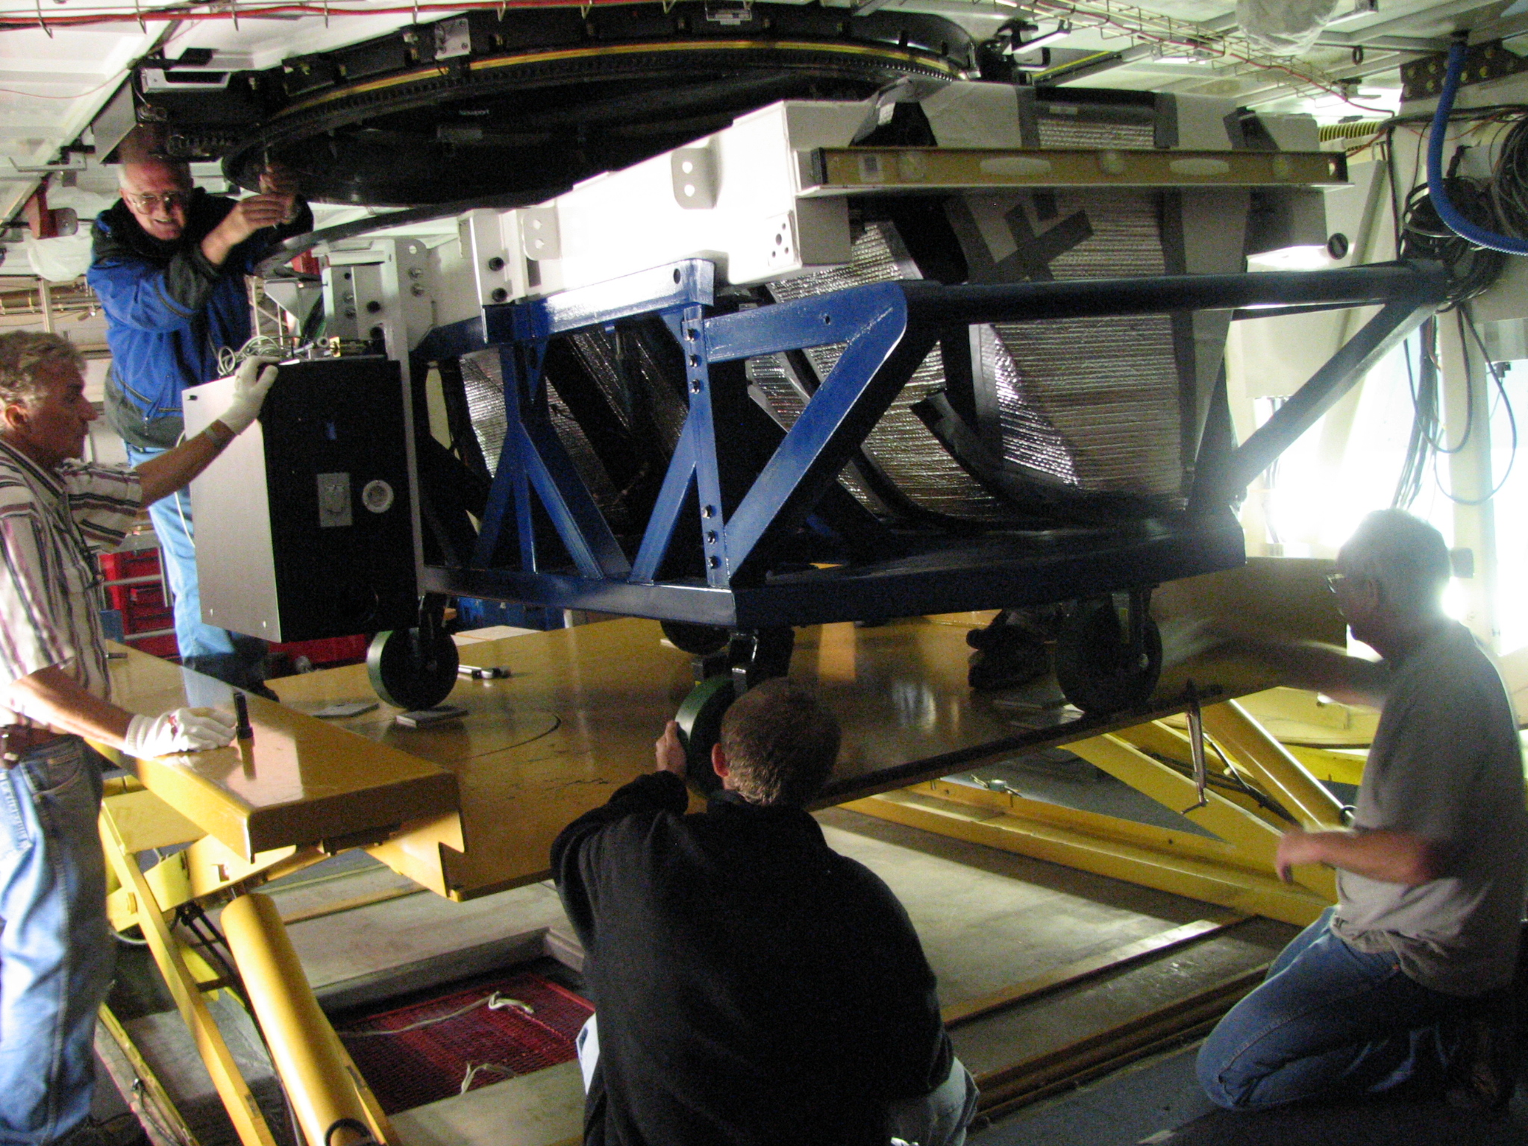
MAESTRO on the instrument lift. The stop bar, in the foreground, is attached to the lift with a c-clamp.

The spectrograph is lifted the final few inches by 3 manual jacks placed under the cart. Eventually, the spectrograph was bolted to the rotator.

The counterweights were then attached to the rotator. During our earlier dry run, this process had been problematic, and since then we had purchased a scissor lift to lift the counterweights to the rotator, without using the instrument lift. (We couldn’t use an existing lift because none owned by the MMT could lift the heavy counterweights high enough). The counterweights cannot be lifted with the instrument lift because their CG is outside the footprint of the lift when the counterweights are attached to the rotator. The MMTO staff modified the cart and counterweights to provide stability during this process.

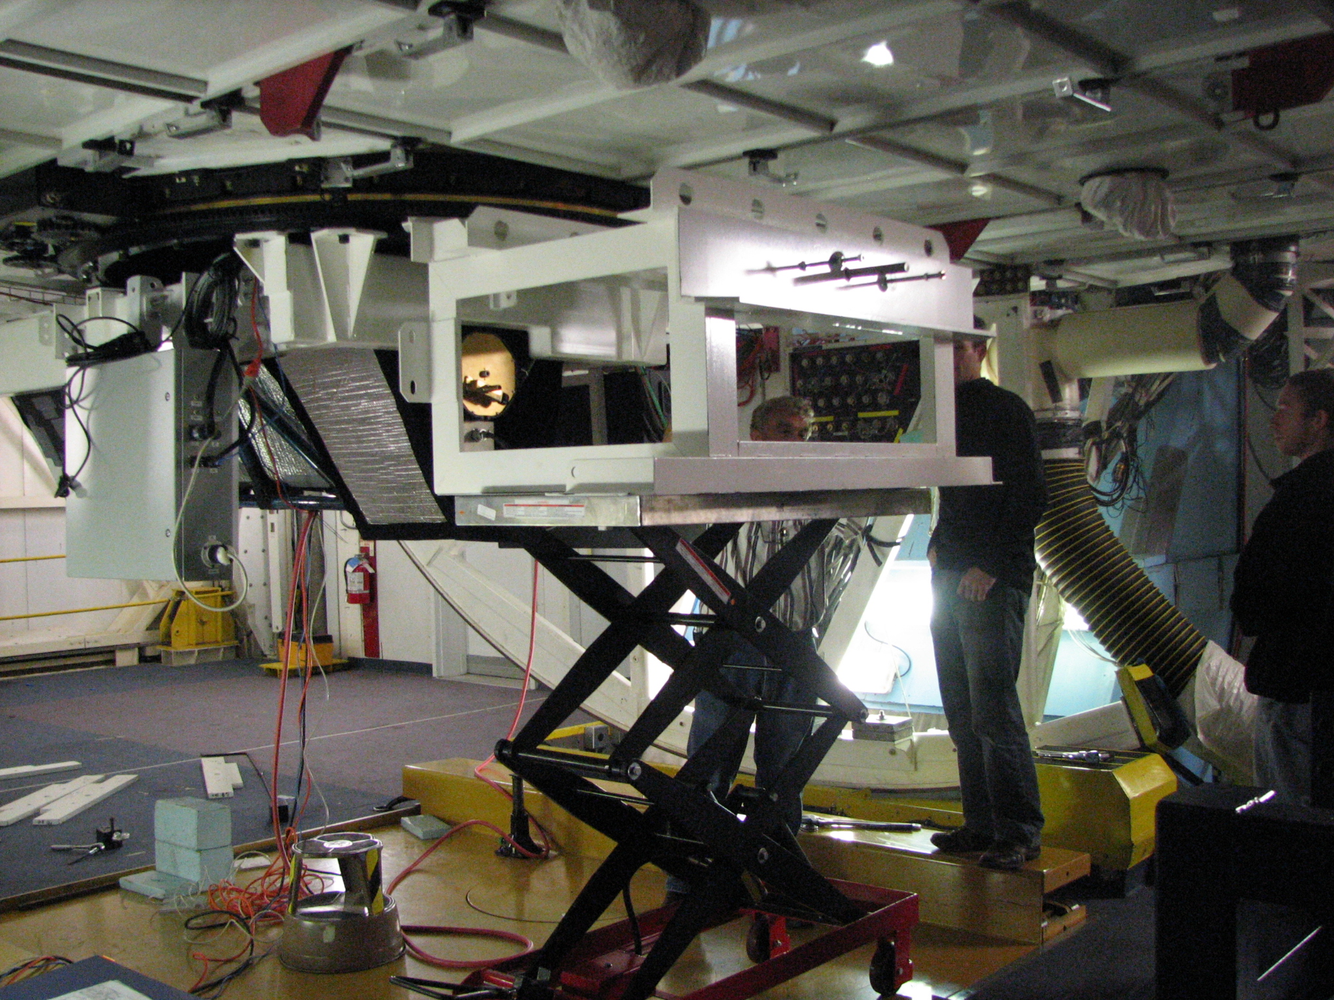
Counterweights (white box-like structure) on scissor lift.

We brought two pairs of turnbuckles to install on the spectrograph.

One set attaches the counterweight to the rest of the spectrograph. It is crucial that these be installed before the counterweight is removed from the cart, so as not to torque the rotator. It turned out that JT Williams had discussed with David Dean that compression mounts should be used instead of turnbuckles, but turnbuckles had been purchased. Also, the hardware to mount the turnbuckles had been designed but not fabricated.

A second set of turnbuckles connects the grating end of the spectrograph to the central part of the weldment. Upon reflection, it does not seem like these two turnbuckles provide any meaningful support: their angle with respect to the axis of the spectrograph is quite small, so they are pulling almost parallel to the long axis of the spectrograph. We plan to measure the flexure with these turnbuckles attached, and then with them removed, to see if we can dispense with them altogether.

We mounted the counterweight turnbuckles using some of the hardware for the grating turnbuckles, and Dave Baxter left the mountain to go to the machine shop in town to fabricate additional hardware for mounting the grating turnbuckles.

We hooked up the spectrograph control electronics, and CCD electronics. We made hardware to allow the dewar to be filled. The dry nitrogen purge was hooked up. We worked on cabling to the PI panel on the telescope. Baffles were made and installed.

The weather deteriorated. Because of thunderstorms, we had to unplug electronics a lot of the time. Since the roof leaks, the primary cover cannot be opened when it is raining, and so measurements with the f/5 top box were not possible for much of the run. Heavy rain persisted most of Thursday, Friday and Saturday.

6. Balancing the rotator and telescope

On Friday, July 27, Dennis Smith, Creighton Chute and Bill Stangret came in on their day off and balanced the rotator and telescope. Balancing of the rotator was achieved by attaching weights at either of two positions on the counterweight structure. The spectrograph was rotated at increasing elevation angles and the current of the motors watched. We began with most of the weights attached, but turned out to need less weight for the best balance. The telescope was easily balanced as well.

We are able to rotate the spectrograph only 120 degrees out of the possible 180 degrees, since there is interference with the red turnbuckle attachment hardware for the Hecto fiber positioner. Since these supports are positioned to very tight tolerances they cannot be removed. Most observers would want to park with the slit aligned with the parallactic angle and have the derotator off. However, for high Galactic latitude fields, we may need to rotate in order to have a bright enough star for the WFS for continuous wave front sensing. The allowed rotation range should be sufficient.

Creighton instructed us on how to mount the f/5 calibration lamp box in the f/5 secondary structure, since it is not routinely mounted. The telescope elevation brakes were leaking, so the MMTO staff spent the rest of the Friday workday fixing them.

7. Initial Optical Focus and Flexure Tests

We put in a slit plate with a single small hole, and attempted to focus the spectrograph. The images were alarming, as the orders were overlapping in a funny way, and the best focus FWHM was 40 pixels. It turned out that small holes in the slit plates which were used for alignment were allowing light to come through far off-axis, in addition to the slit, and these spectra were overwhelming the spectrum of the light coming through the slit.

After plugging these holes, we focused with a 50 micron (0.4 arcsec) hole, and were very pleased that excellent focus was achieved, with 2 pixels FWHM in both spatial and spectral directions.

Our focus measurements were cut short, since we had to shut down for several hours because of thunderstorms. Morag Hastie and Tom Stalcup were able to open late in the evening, and ran flexure tests. The results were very good.

One of the big challenges for MAESTRO was controlling flexure, to assure that any motion of the spectrum on the detector as an object is tracked across the sky could be calibrated out with lamps, given with the long exposures typical of high resolution spectroscopic observations. All other echelle spectrographs at large telescopes (> 4m) are located at Nasmyth or are bench mounted and fed by a fiber. In fact, review committees for NOAO/Gemini concluded that it is impossible for an echelle spectrograph like MAESTRO to be mounted at Cassegrain, because flexure would be intolerable.
As the flexure tests for MAESTRO show, there is some hysteresis, but first order corrections may be possible with a look-up table. Even without a flexure map, long exposures will be possible at all elevation angles. The spectrograph focus is unchanged through all elevation angles. The tests shown below were carried out with the rotator set at the nominal 0 degrees, so that the slit is aligned with the parallactic angle. We started tests at other rotator angles on Sunday, July 29, but the shutter stopped working for elevation < 60 degrees, and the rotator set at 90 degrees.

In summary, the structural performance of MAESTRO is excellent. Aside from the shutter, everything works well at all elevation angles and we can rotate without problems.

MAESTRO flexure, measured with Th-Ar line centroid, in x-axis as a function of elevation, for two consecutive runs in elevation. 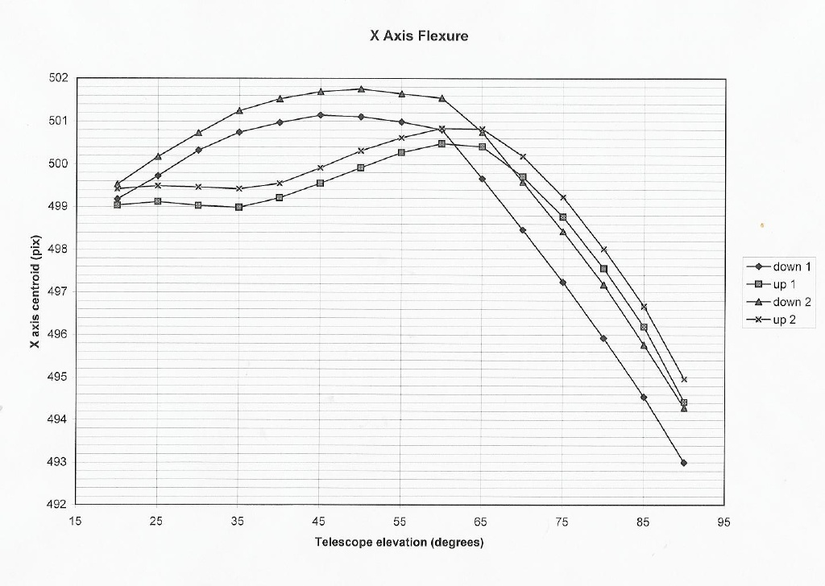
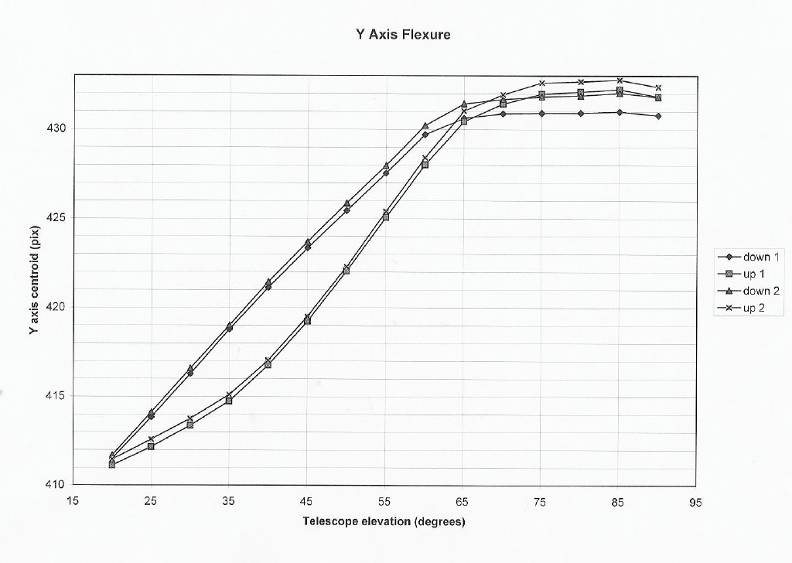
.

Same as previous plot, but in y direction.

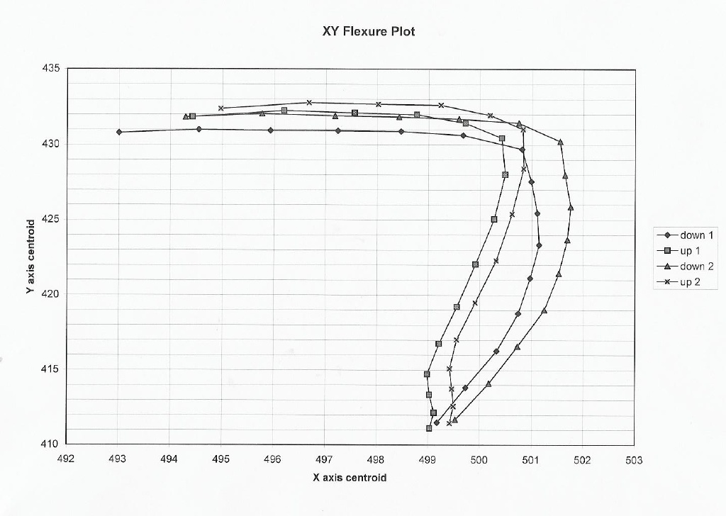

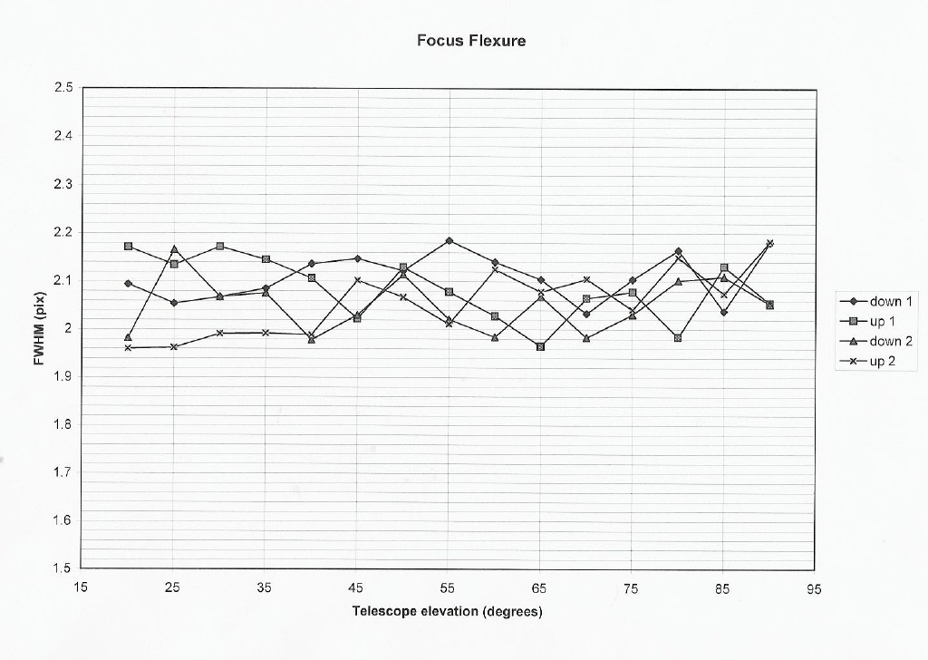
No appreciable change in focus with elevation.

8. CCD Read Noise

On Saturday, July 28, it rained all day, and the mountain was engulfed in heavy fog. Thus, we were not able to do any tests with the f/5 top box, and since the internal cal flip mirror did not always go in at the position to fully illuminate the slit, we could not do any more flexure or focus tests.

We were able to measure the CCD read noise, which is an important limit on sensitivity, since most of the spectrum is in the read-noise limited regime. It decreases like “root N” but varies with time (2 electrons RMS to 11 electrons RMS), since there is substantial RF noise. With an ohmmeter we determined that the dewar is not isolated from the spectrograph and telescope. The only point of connection which doesn't already have a G10 layer for isolation is a ring which mounts on the rear of the dewar and is supported by struts attached to the space frame. We tried removing these to see if the RF noise improved, but it did not. It will be important for ultimate performance to track down and solve this problem.

9. Condensation on the Dewar Window

When we started taking images on Saturday morning, we found alarming caustic-like structures in the Thorium-Argon spectra, which initially we thought might be due to problems with the oil. However, it turned out that the dry nitrogen compressor had turned off during a power outage, and did not turn on again, so there was heavy condensation on the dewar window. Although we were familiar with the appearance of condensation during the winter (ice) we were thrown a bit by the effect of liquid water on the window. We were instructed on how to re-start the condenser. The window was blown off, and the dry nitrogen purge cleared it quickly. However, we will need to clean the window when the dewar is back in town.

10. UV LEDs

Flatfielding in the UV is a problem with every spectrograph that covers the wavelength range shortward of 400 nm, since quartz lamps are essentially black bodies which peak in the red. Recently, inexpensive LEDs in the UV have come on the market, primarily for the semiconductor industry. We installed a set in the cal box to cover the spectral range from 320nm to 390nm. Since the human eye is not sensitive to these wavelengths, we installed a switch in the cal box cover so that the lamp cannot be on when the cover is open.

We found that the UV LEDs provide a very nice flat field at blue wavelengths. The only problem is that they are faint, but we will probably be able to adjust the current to make them brighter. We took several long exposures, and plan to write a short technical paper to describe this new cal source.

Thunderstorms on the mountain forced us to turn off everything for the rest of Saturday evening.

11. Slit Viewer CCD camera

To acquire objects, a Lesser/Schmidt CCD camera is pointed at the slit plate. Guiding should be possible with spilled light. The camera and focusing optics are mounted on a stage to allow the camera to be focused. Cooling is achieved by a closed liquid refrigerator.

We were able to run the camera with slightly modified SO guider software on the “hoseclamp” computer. The CCD itself is read out on “maestroccd” using AZCAM. We focused the camera, but it is not pointing at the center of the slit plate. The FOV provided by the optics is what we anticipated, but we will need to realign it. It is impossible to access the camera when the spectrograph is mounted on the telescope. There is essentially no provision mechanically to point the camera, but we should be able to achieve this easily.

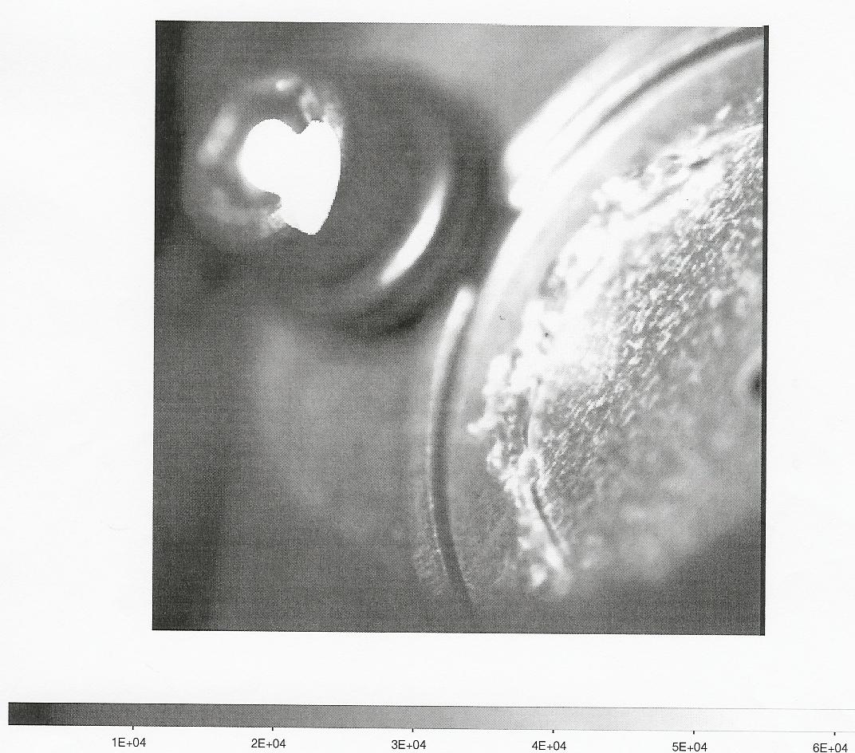
Mounting screw
Slit

Image from slit viewer CCD. Here we have mounted a very large hole, for initial focusing and alignment. Although we are in focus, the slit should be in the middle of the CCD FOV.

12. First Observations on Sky

On Sunday, July 29, at about 9pm, we were finally able to open and attempt observations on the sky. We used a large (100 micron) slit, because we couldn't see the smaller slit with the slit viewer, and because we thought that the seeing would be poor.

We had problems with the secondary mirror servos. Mike Alegeria, the TO, tried every trick he could think of, but it took about 90 minutes between the time we opened to the time we could point at the first object. Although the seeing was amazingly good – 0.9 arcsec – the focus and collimation of the telescope was poor, since the servos made the star images at the focal plane jerk around with amplitudes of about 10 arcsec.

We finally were able to get Vega located on the slit and took an exposure (see below).
We then went to a fainter (V=8) star which has very narrow ISM lines, to test the spectral resolution. However, we were unable to keep the star in the slit. We returned to Vega, and obtained a few exposures. Thick clouds rolled in and out, and we sometimes could not see Vega in the guide camera. After about an hour, we gave up trying to observe, closed the dome, and did focus and flexure tests. However, the on-sky measurements showed that our slit is located within an arcsec of the telescope axis, better than we had hoped for.

Part of the spectrum of Vega, 5 minute exposure. Red orders are on the bottom. Telluric absorption bands are visible in the red.

13. Optical Performance

FOCUS. Focus tests on the telescope confirmed that the optical performance of MAESTRO is excellent. A series of Th-Ar spectra were taken, varying the position of L1, using the f/5 Th-Ar lamps and a 50 micron circle. The FWHM in the spatial and spectral directions is about 2.2 pixels, as predicted. There is no measurable astigmatism.
The following plot uses a single thorium line, near the edge of the format, 80% of the total radius out from the optical axis. The excellent focus results are due to the work of Michelle Reed, who mounted and aligned the camera/collimator optics.
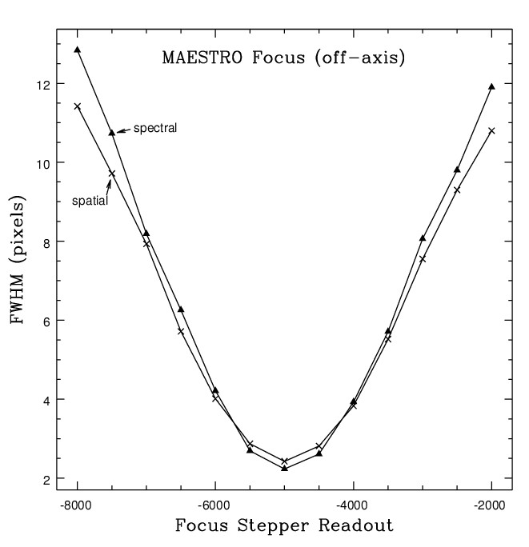

SPECTRAL LINE FUNCTION. The spectral line function is very nearly Gaussian – see plot below, which shows data (plus signs) and gaussian fit.

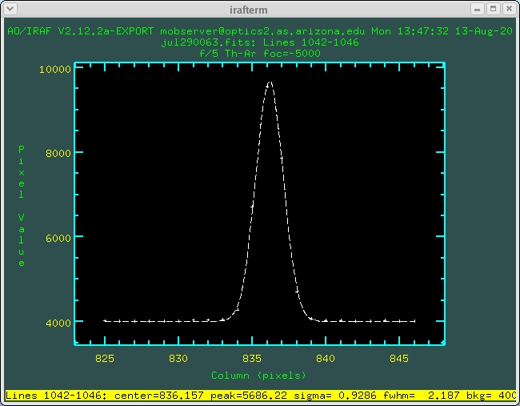

Alignment with the telescope. As mentioned above, the slit is centered within an arcsec of the telescope axis as measured by the hecto instruments. We could not do any better at aligning the optical axis of the spectrograph to the optical axis of the telescope.

Wavelength Coverage. Due to the problems mounting the grating platform described above, we lose about half the spectrum off the detector. This is schematically shown in the figure, where I’ve plotted the free spectral range of the echelle format and a square to indicate the footprint of the detector.

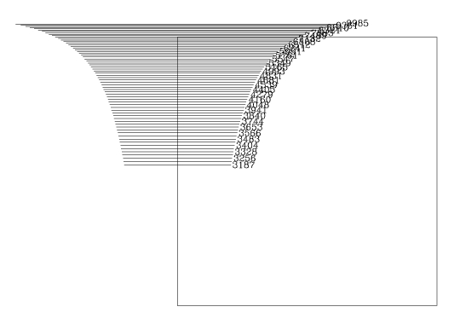

Scattered Light. Despite some effort to make temporary baffles during the run, we suffer severe scattered light. About 30% of the area at the level of the rotator is open, and must be closed. It was hard to access this area once the spectrograph was mounted. During our observations of Vega, we had to close the rear shutters of the telescope to shade the spectrograph from moonlight so that we could detect Vega (m=0). Baffling should be easily accomplished when the permanent covers are fabricated.

In addition, light from the calibration box scatters into the dewar directly. We will need to baffle the area around the calibration box, dewar entrance, and shutter permanently. Little baffling had been included in the mechanical design.

Once these obvious sources of scattered light are eliminated, it remains to be seen what level of scattered light will be present from the grating, lens can and prism. All surfaces were blackened as best as we could, but undoubtedly there will be some scattered light present when we're done.
14. Transport Back to Steward

Our original intent was to store MAESTRO at the MMT, once the run was over. However, since we need to remove the grating platform, and have a lot of modifications to make, we decided to transport MAESTRO back to the 5th floor lab. The MMTO staff kindly did this for us.

The plan for storage is to lower MAESTRO to the MMT pit, and build a protective cover for it. We had studied the “lab” that the AO laser guide star team had set up in the pit, and bought enough of the fire resistant rip stop that they used to create a protective cover for MAESTRO in the pit. However, I was hoping that if we needed to work on MAESTRO we would be able to work on it somewhere on the mountain besides the Pit, and had planned an enclosure which was not much larger than the footprint of the spectrograph.

In fact, there really is no place on the mountain to set up MAESTRO to work on it except in the Pit. The pit is really not a nice place to work: it floods when it rains (see below), there is oil in the air so the enclosure must be filtered, and one needs to lower personnel and equipment down a ladder. Moreover, the MMTO staff were replacing the floor in the chamber, a very messy job, and they were glad to take MAESTRO downtown, since they needed to move as many instruments as possible to the pit during construction.

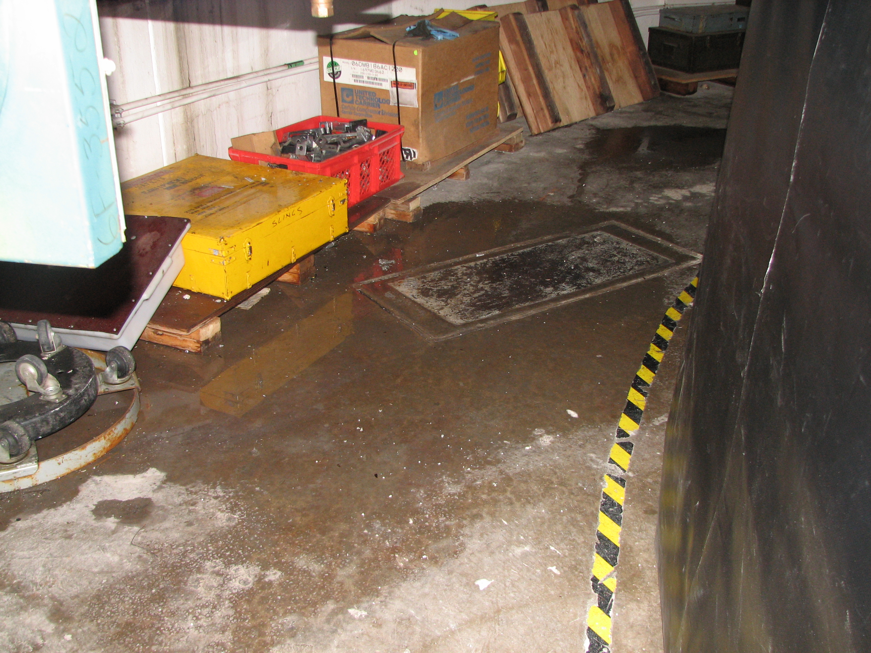

A puddle on the floor of the pit, where MAESTRO is to be stored.

Finally, we ran out of time and energy before we figured out the details for exactly how we were to construct the enclosure for MAESTRO in the pit. David Dean was supposed to work on this during the run, but was no longer available. A student working for MMTO was supposed to come up to the summit to help, but the road was too hazardous because of flooding, and he didn't come. After looking at the Pit, we decided that design of the MAESTRO enclosure will take a fair amount of thought and planning.

So for all these reasons, we transported MAESTRO back to the 5th floor lab at Steward.
When we go back in the end of November it will be cool enough to transport MAESTRO during regular working hours, and we plan to have solved our storage problems by then.

15. Prioritized List of things to fix before the next run

After the run, Michelle Reed, Morag Hastie, Russ Warner, Jeff Rill and I met to discuss a list of things to fix before the next run, which included input from Dave Baxter. We had another meeting with Morag and Shawn Callahan to talk about the MMT contribution to MAESTRO in the next few months.

The highest priority tasks involve problems that must be solved before MAESTRO is ready to take useful science data. They are:

1. Grating Platform. Rework the grating mount so we can center the spectrum on the CCD. Currently over 50% of the spectrum is not on the CCD. We will need to remove the grating platform from the spectrograph, remove the grating cell from the platform, and modify the grating platform.

2. Guide Camera. We need to modify the mount of the slit viewer guide camera so the field-of-view is centered on the slit.

3. Shutter. Replace the solenoid/cable system with an electronic shutter. This will require removal of the slit plate/turn mirror assembly and the cal box, so will require realignment when done.

4. Covers and Baffles. We need to make the permanent covers for the spectrograph. Morag has suggested that the baffles internal to the spectrograph be made by the MAESTRO team, and that the MMTO take on the external baffles as part of the cover manufacture effort. External baffles need to be mounted at the rotator ring level, with a cone at the spectrograph entrance.

Next we describe tasks which are also high priority:

1. Comparison Swing Mirror. Make the “in” position repeatable, with a hard limit and switch so we always illuminate the slit the same way. This will take some mechanical design time and fabrication.

2. Slit Plates. Plug the alignment holes. Rework the slit insertion scheme. Currently, it is very difficult to change slits, but small modifications to the slit plate platform will make changing slits much safer.

3. Test off-axis WFS using the f/5 Shack-Hartmann sensor.

4. Build the enclosure for MAESTRO in the pit.

5. Expand the alignment frame so that it’s easier to work on the spectrograph. Parts have already been made.

6. Anodize the front ring of the dewar, and clean the dewar window.

7. Re-do the Th-Ar power connector with 600 watt approved connectors.

8. Cal box mount. Make permanent shims, and put attach an electronic buffer plate permanently on the bottom of the box for isolation with the dewar. Fine-tune the cal box focus.

9. Reduce and analyze data obtained in July.

10. Finish the procedure documents and this report.

11. Replace the water in the guide camera cooling system with a water/alcohol mixture.

12. Work on electronic isolation of the CCD dewar.

Medium Priority tasks are listed below.

1. Ruby Gui/Spectrograph control electronics. Make the software come up reliably reading steps and limits. Include a “home” button to send stages to limit position.

2. Counterweights.
- Rework the design, per JT’s suggestions
- Replace the turnbuckles for the counterweights, or eliminate them.
- Allow the dewar to be removed when the counterweights are mounted.
- Streamline the counterweight mounting proceedure.

3. Spectrograph cart. Move the two casters at the end inwards so we are not close to the edge of the instrument lift. We need to figure out how far the casters can be moved and still allow easy tipping of the spectrograph 90 degrees. Possibly add a rubber wheel to act as a tipping point.

4. L1 focus. Put in hard limits with switches so that “home” can be reliably found.

5. Install grating tilt motor and get it to work.

6. Oil system in triplet. Check for drips. Top off the oil and rework the spigot system with something more robust. Figure out how to drain the oil if necessary (drain holes are currently blocked by mechanical supports). Figure out a place for the spigot that is accessible yet protected from damage.

7. Work on User’s manual, technical manual and other documentation.

8. Work on data reduction pipeline. Ed Olszewski began a pipeline based on IRAF, which subtracts the overscan region appropriate to each half of the detector, and trims the image, creating one 4096x4096 image. Bechtold is making the script more general, and extending it. Betty Stobie of the MMT and Rodger Thompson are interested in helping develop a reduction pipeline. However, the main task, identifying Th-Ar lines, will have to be redone when the spectral format is better centered on the CCD, and it is not clear how far we should try to go at this point.

9. Modify the grating cover so it is easier to install and remove. Currently the cover is heavy and awkward. Installing it or removing it is dangerous for the grating and the prism. We want to remake it out of a lighter material (it’s currently steel) and have it attached with captive thumb screws, instead of the badly mounted inserts currently in use.

Low priority tasks follow.

1. PZTs. Three PZTs are attached to the back of the grating to allow very small tilts to dither the spectrum on the detector. We did not have time to test the hardware or software for the PZTs. We also need to remake the bracket that holds the PZT electronics box on the spectrograph so we can lower the spectrograph on the cart with the PZTs attached.

2. Compile a master copy of the drawings. For some reason, about 10% of the drawings that were archived in sitescape are now missing. Roughly another 10% of all the drawings were never archived, but probably exist on Richard Nagy’s or David Dean’s computer. We need to update the electronics drawings on sitescape, and update the spare parts list. We need to get a master hardcopy of all drawings printed out (the one we made earlier has migrated to various labs), a master copy on sitescape, and a copy on the MAESTRO web site.

3. Hook up the temptrax sensors and get the tracking software going.

4. Write the user interface for spectrograph control. The current Ruby gui is fine for engineering, but crashes frequently, and maybe 3 times out of 5 comes up without reading steps or limits. Skip Schaller is interested in writing the user interface, having written one for Blue and Red channel. Now that we have some experience with observing we have a better idea of what we want to do – for example, we would like to put rarely used functions on a window that can be minimized. A major improvement would be to change the architecture of the software so that ICE can query the status of the spectrograph and put things like the focus value and spectrograph temperature in the CCD image headers.

5. Work on the cable drape (part of the cover effort).

6. Get a dry air hose of the right length.

7. Put an on/off switch on the outside of the spectrograph electronics box.

8. Put switches on the CCD electronics box to reset the guider and science CCD electronics separately.

16. November Engineering Time

We have been awarded 4 nights of engineering time next semester, Nov. 26-29, 2007. The last night is grey time and we plan to carry out “science demonstration” observations of faint objects for three projects that were proposed by Steward postdocs and staff.
Our goal is to get MAESTRO to the point where it can be left at the MMT after the November run, and offered for general observing beginning in January 2008.

17. Conclusions

MAESTRO performed well.

The camera-collimator lenses give images which are 2 pixels FWHM in both spatial and spectral directions. The full spectral resolution of R=90,000 will be realized. The CCD will not have to be adjusted in the dewar.

The basic mechanical structure is excellent. We have workable procedures to transport the spectrograph and mount it on the telescope. Flexure is within tolerances, making MAESTRO the first echelle spectrograph on a large telescope to be successfully mounted at Cass.

The only performance metric we were not able to measure is overall throughput. Our inablility to focus the telescope because of servo problems, the lack of guiding, and cloudy conditions made it impossible to make any estimate of throughput. However, as MIKE at Magellan has shown, the quasi-Littrow, fully transmissive design has very high throughput, compared to classical echelles with reflective collimators and grating cross-dispersers. The increased observing efficiency achieved by the ability to WFS simultaneously during exposures will also help MAESTRO be competitive with similar instruments on larger telescopes.

While this report has outlined the many things that need to be fixed, there are no “show-stoppers” in the sense that we have clear paths to fix all the technical problems encountered. The resources needed to fix the technical problems are modest.

We are extremely grateful to the entire staff at the MMTO. Everybody was incredibly helpful in all phases, leading up to the run, during the run, and after the run. They not only contributed hardware, expertise and labor, but also enthusiasm and good humor, which we sorely needed at times. It was very clear to me early on that Faith Vilas let it be known to her staff that MAESTRO was to be supported fully, and we are very grateful to her for her support. The resources provided by the MMTO provide important leverage in our effort to get departmental funds to fund the remaining work that needs to be done. We’re optimistic that in November we will provide the MMT with a powerful instrument to complement the existing f/5 instrumentation.

