SUMMARY OF FINDINGS
WELDMENT TRIP 7-25-05

Equipment needed:

Piano mover
Pallet jack
Adjustable wrenches.
Socket driver for ¾ bolts
2 5 foot metal ended straps
1 8 foot strap
2 10 foot straps
2ft x 2 foot ½ inch thick steel plate
6” x 6” x 1 foot wood blocks
6”x 6” x 2 ft wood blocks

- Transportation of the instrument will be in two pieces. The weldment and Cart will be transported attached. The counterweight assembly will be transported separately.
- Load the counterweight into the hatch area. The counterweight will need to be solid plate down, resting on a piano mover.
- Load the instrument/cart assembly into the hatch area. Use a fork lift to lift the instrument as shown in Figure 1.

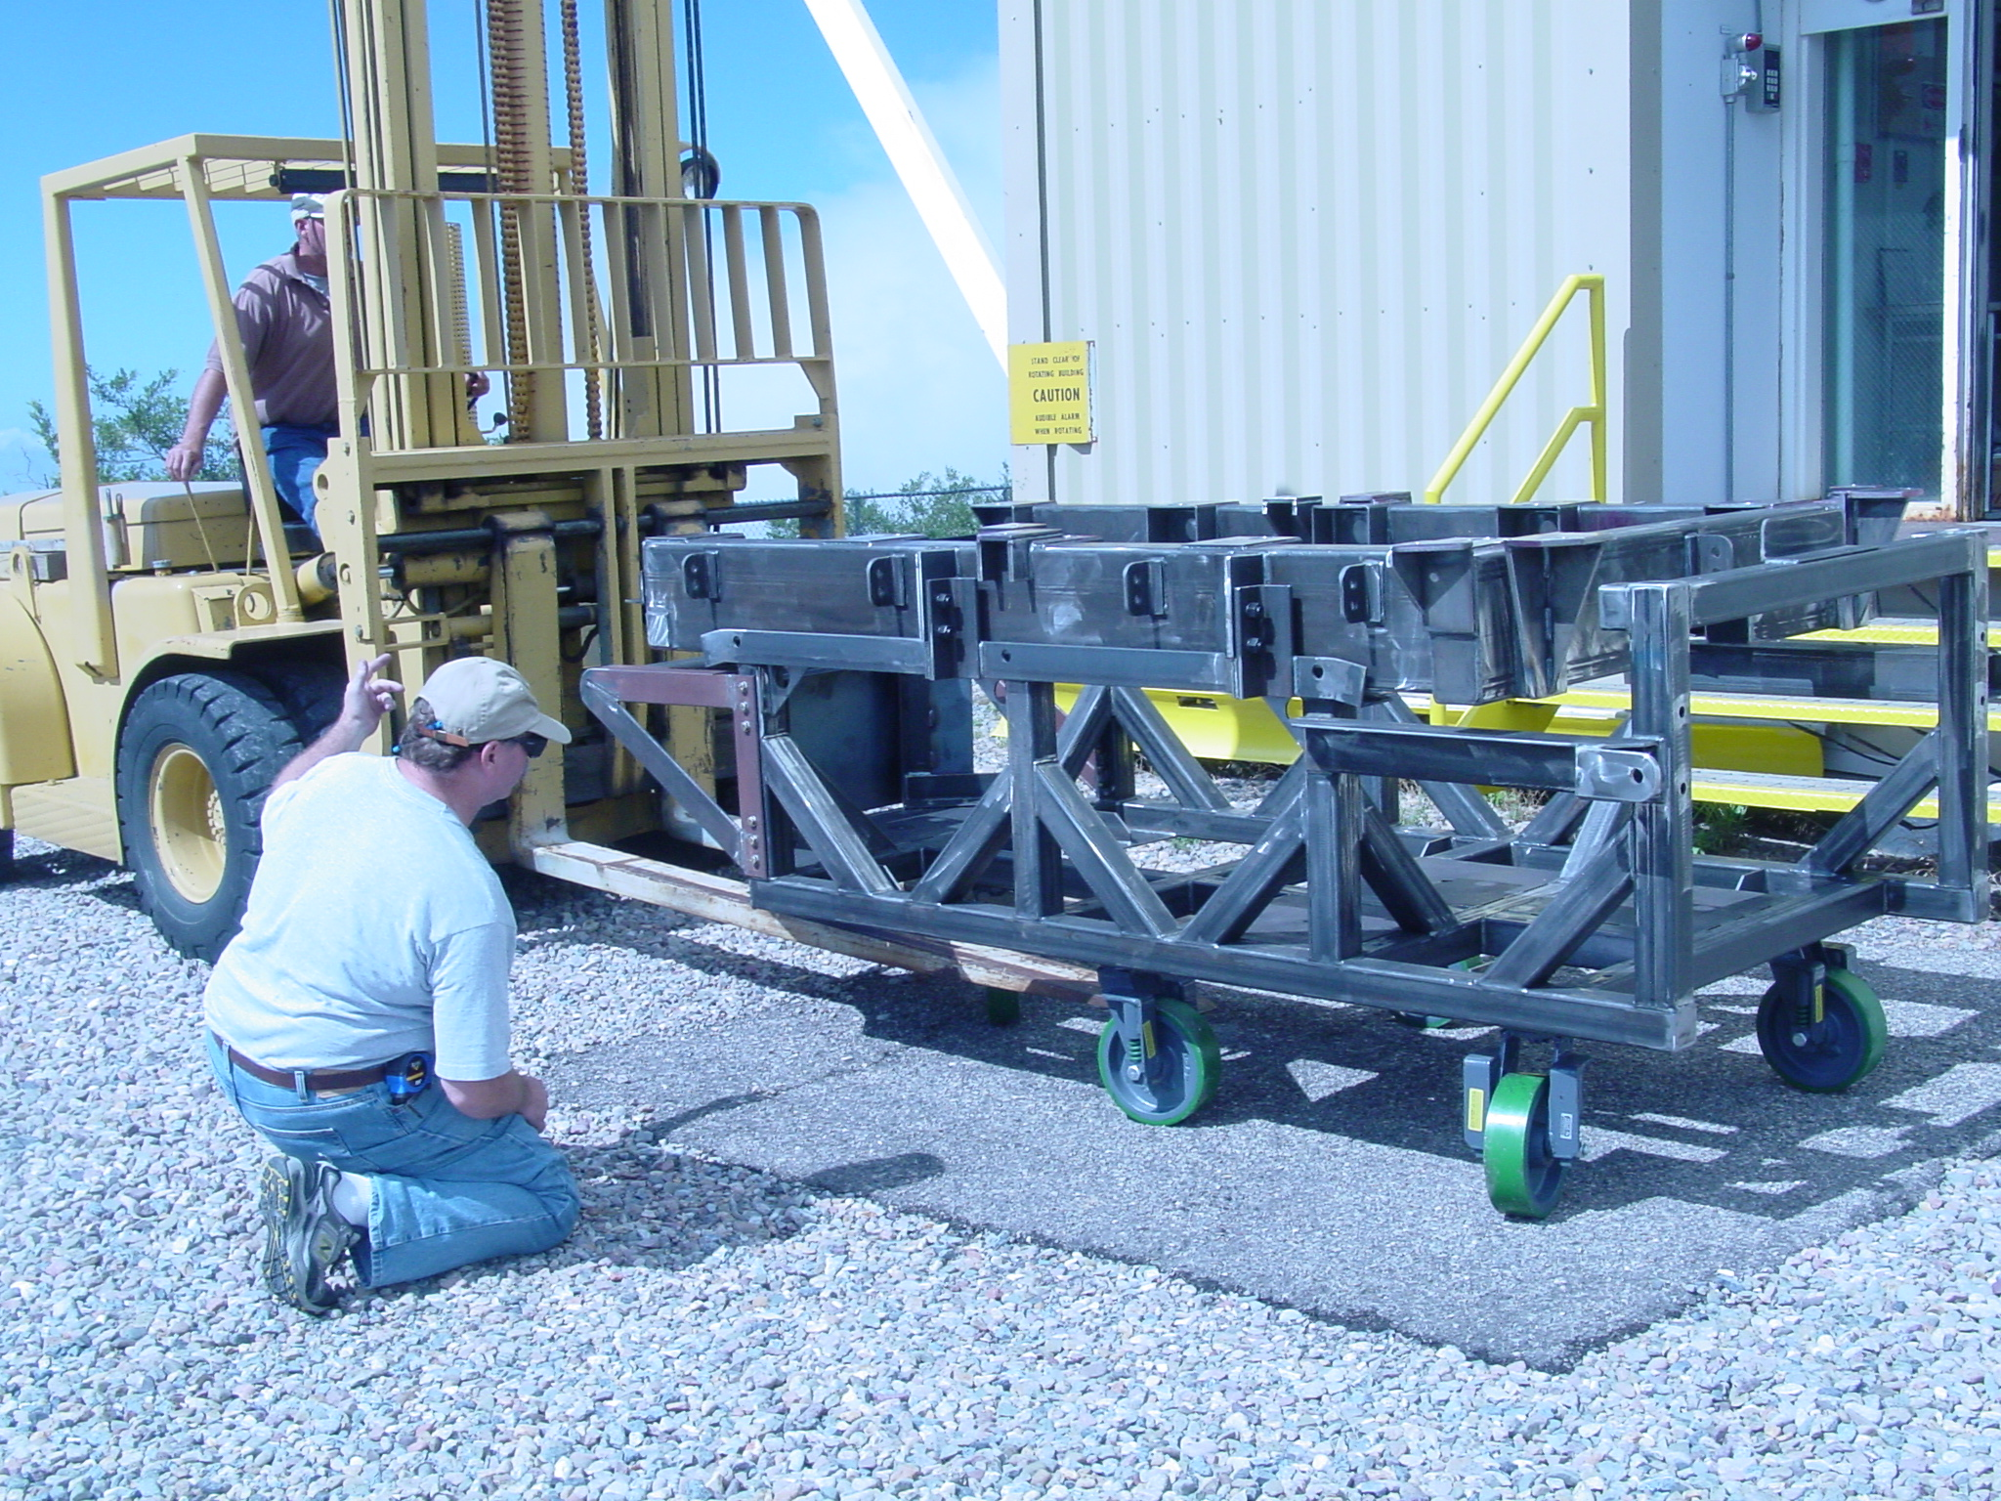

Figure 1

- Once the instrument is approximately positioned to start the lifting, lock the pivot wheel into position.
- ***** The telescope should be pointing to zenith*******. Recommend that the telescope be pointing about 5-10 degrees off of zenith so that interference does not occur with the mirror cover frame or the secondary structure.
- Using the crane and the two 10 foot straps, lift the counterweight assembly to the telescope floor. The lifting point is as noted in Figure 2.

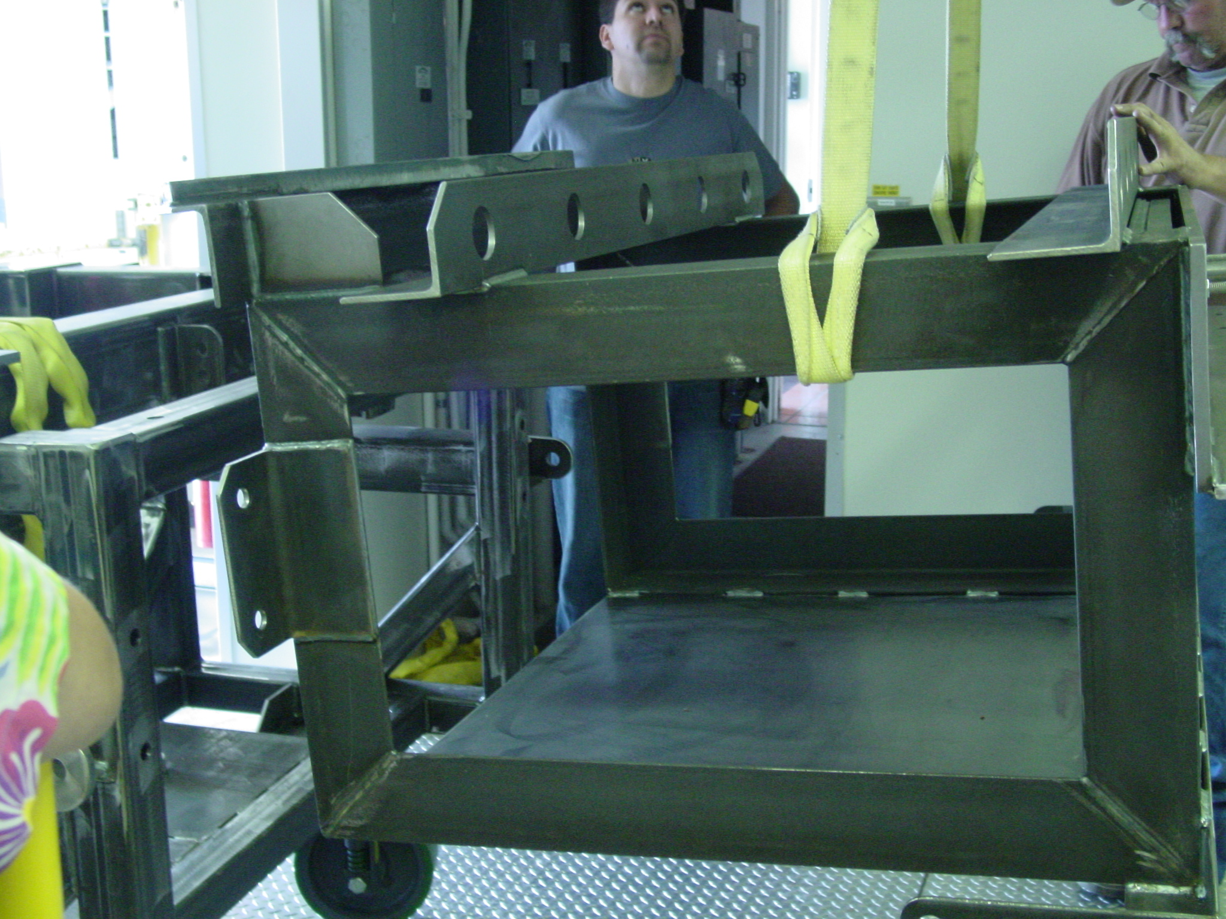
Figure 2

- Lift the instrument to the telescope floor by the lifting lugs using the 2 five foot straps attached to the lifting lugs, and those attached to an 8 foot strap to the crane. See Figure 3.

(I need to do a drawing to insert here)
Figure 3

- Slowly lift the instrument while rolling it to remain centered under the hatch.
- As you approach the pivot wheel point, place a plate under the pivot wheel to spread the load. See Figure 4

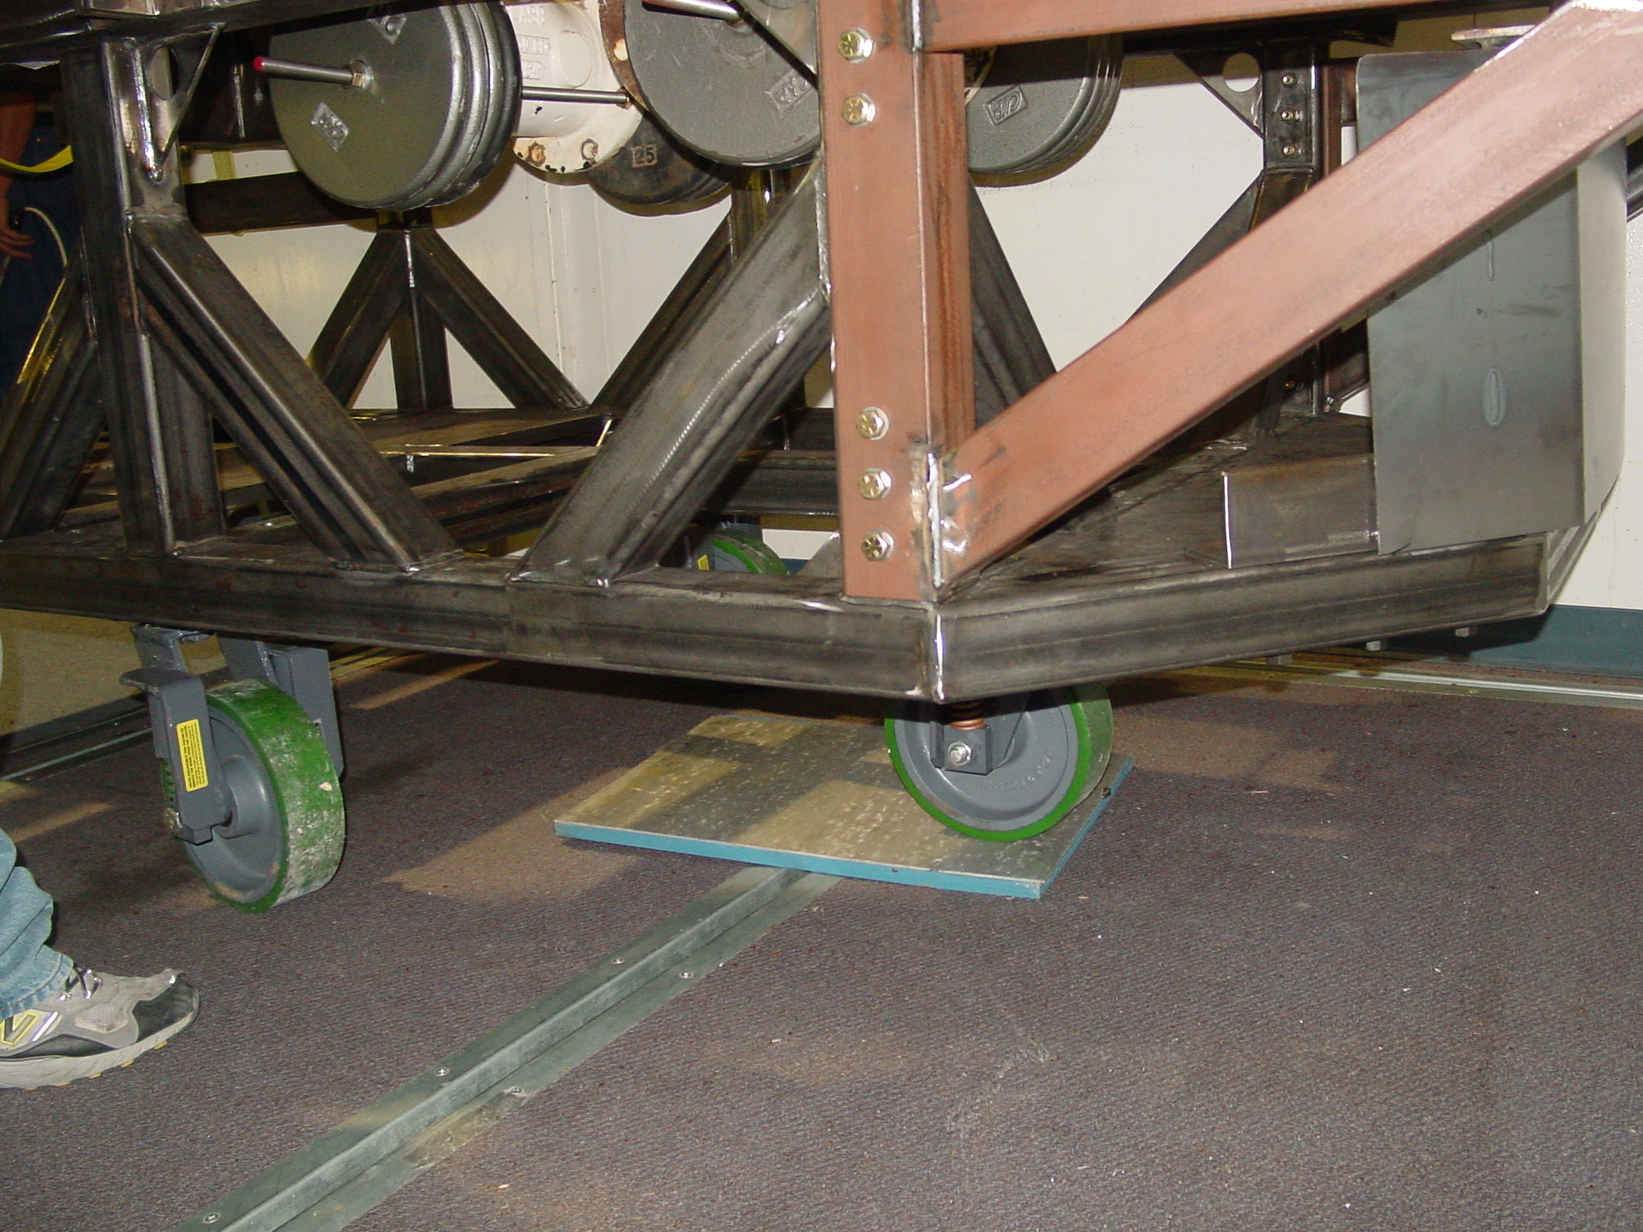
Figure 4

- Once onto the wheel, roll the pallet jack barely under the end so that it will support the pivot point after the wheel is no longer on the ground. See Figure 5.

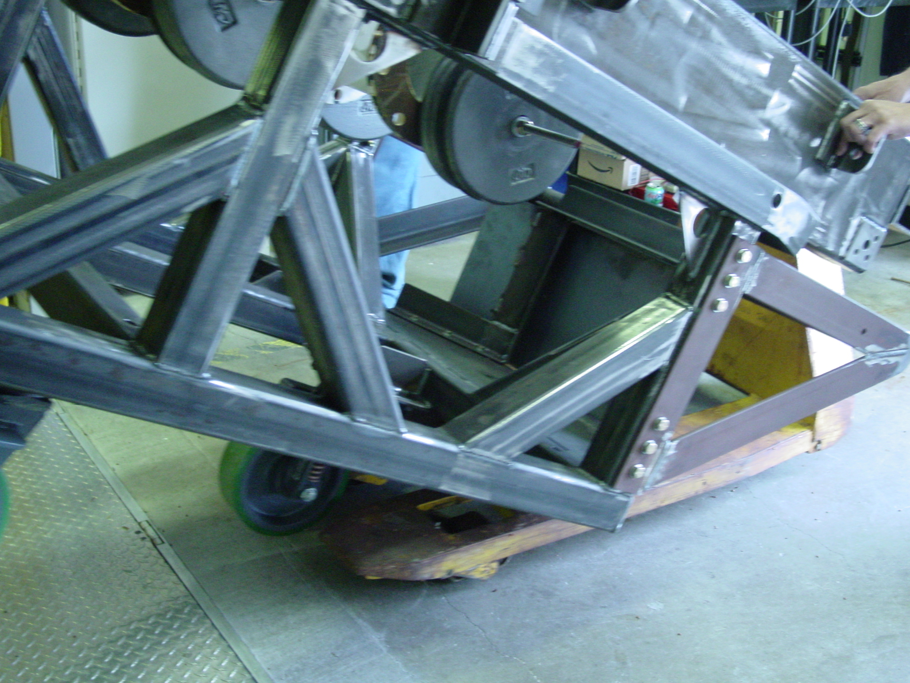
Figure 5

- Continue to roll the pallet jack forward as the instrument continues to rise to maintain crane centration through the hatch.
- With the instrument suspended from the crane, close the hatch doors
- Place a 6 x 6 x 2 board centered 36 inches from the wall, with one 2ft. x 2ft x ½ inch steel plate next to it. Place two 3 x 3 x 2 boards at 90 degrees from the 6 x 6 board and between the board and the wall. This will act to help the turning points for the instrument. See Figure 6.

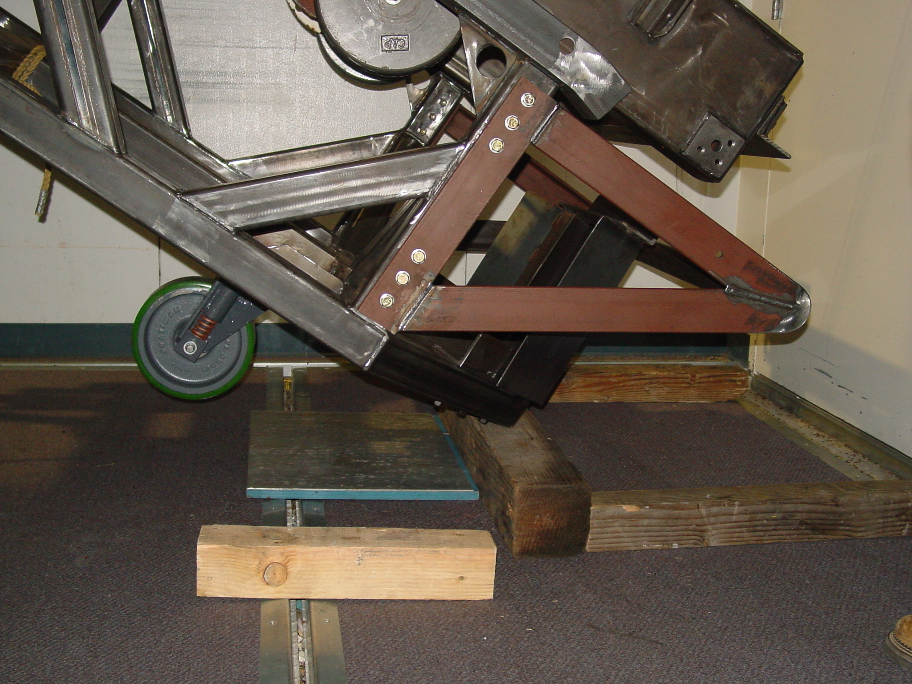

Figure 6

- Rest the instrument on the 3 x 3 boards and slowly lower the crane to pivot the instrument first onto the 6 x 6 block and then onto the single wheel. Make sure the ½ inch steel plate is under the wheel when it comes down to help spread the load.
- continue lowering and rotating the instrument until it is fully lowered onto the floor. NOTE: The instrument will tend to drag the crane along the trolley, so take this very slow and easy.
- If the telescope is kept at vertical you will have to be carefull that the trolley does not get dragged hard into the telescope structure.
- Once the instrument is lowered onto the floor, lift the counterweight with the crane and attach it to the cart assembly. See Figure 7.

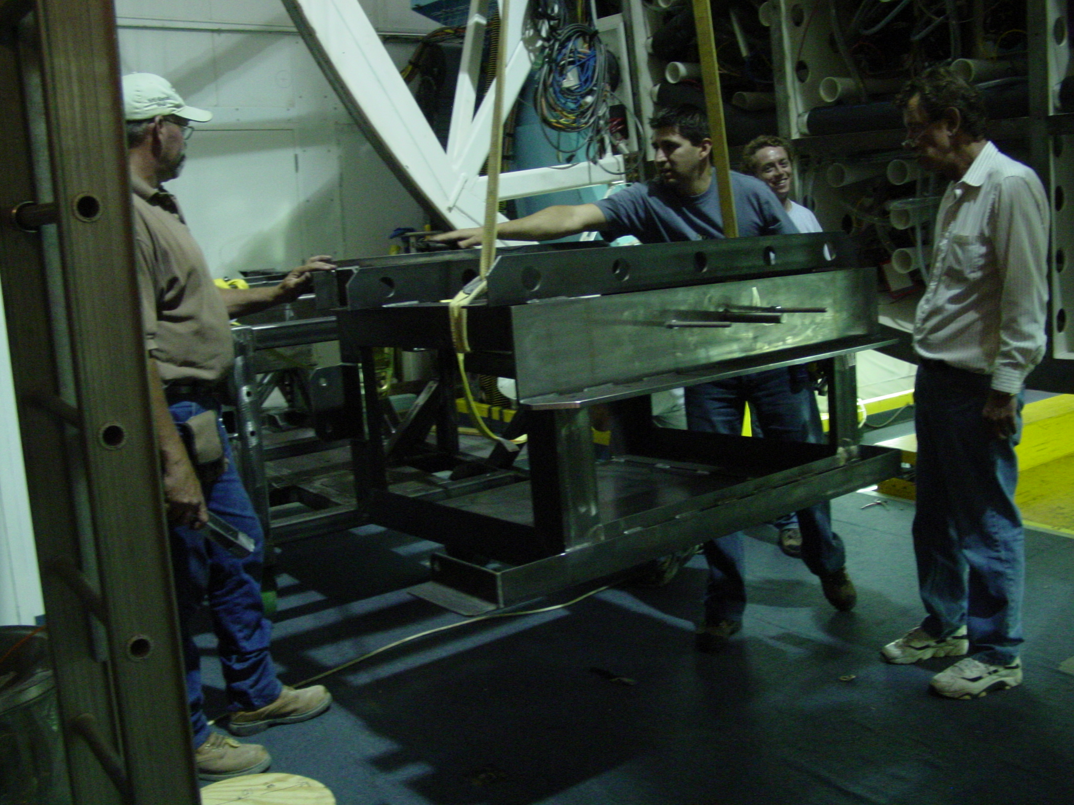
Figure 7

- Wheel the assembly under the telescope counterweight end first. See Figure 8.

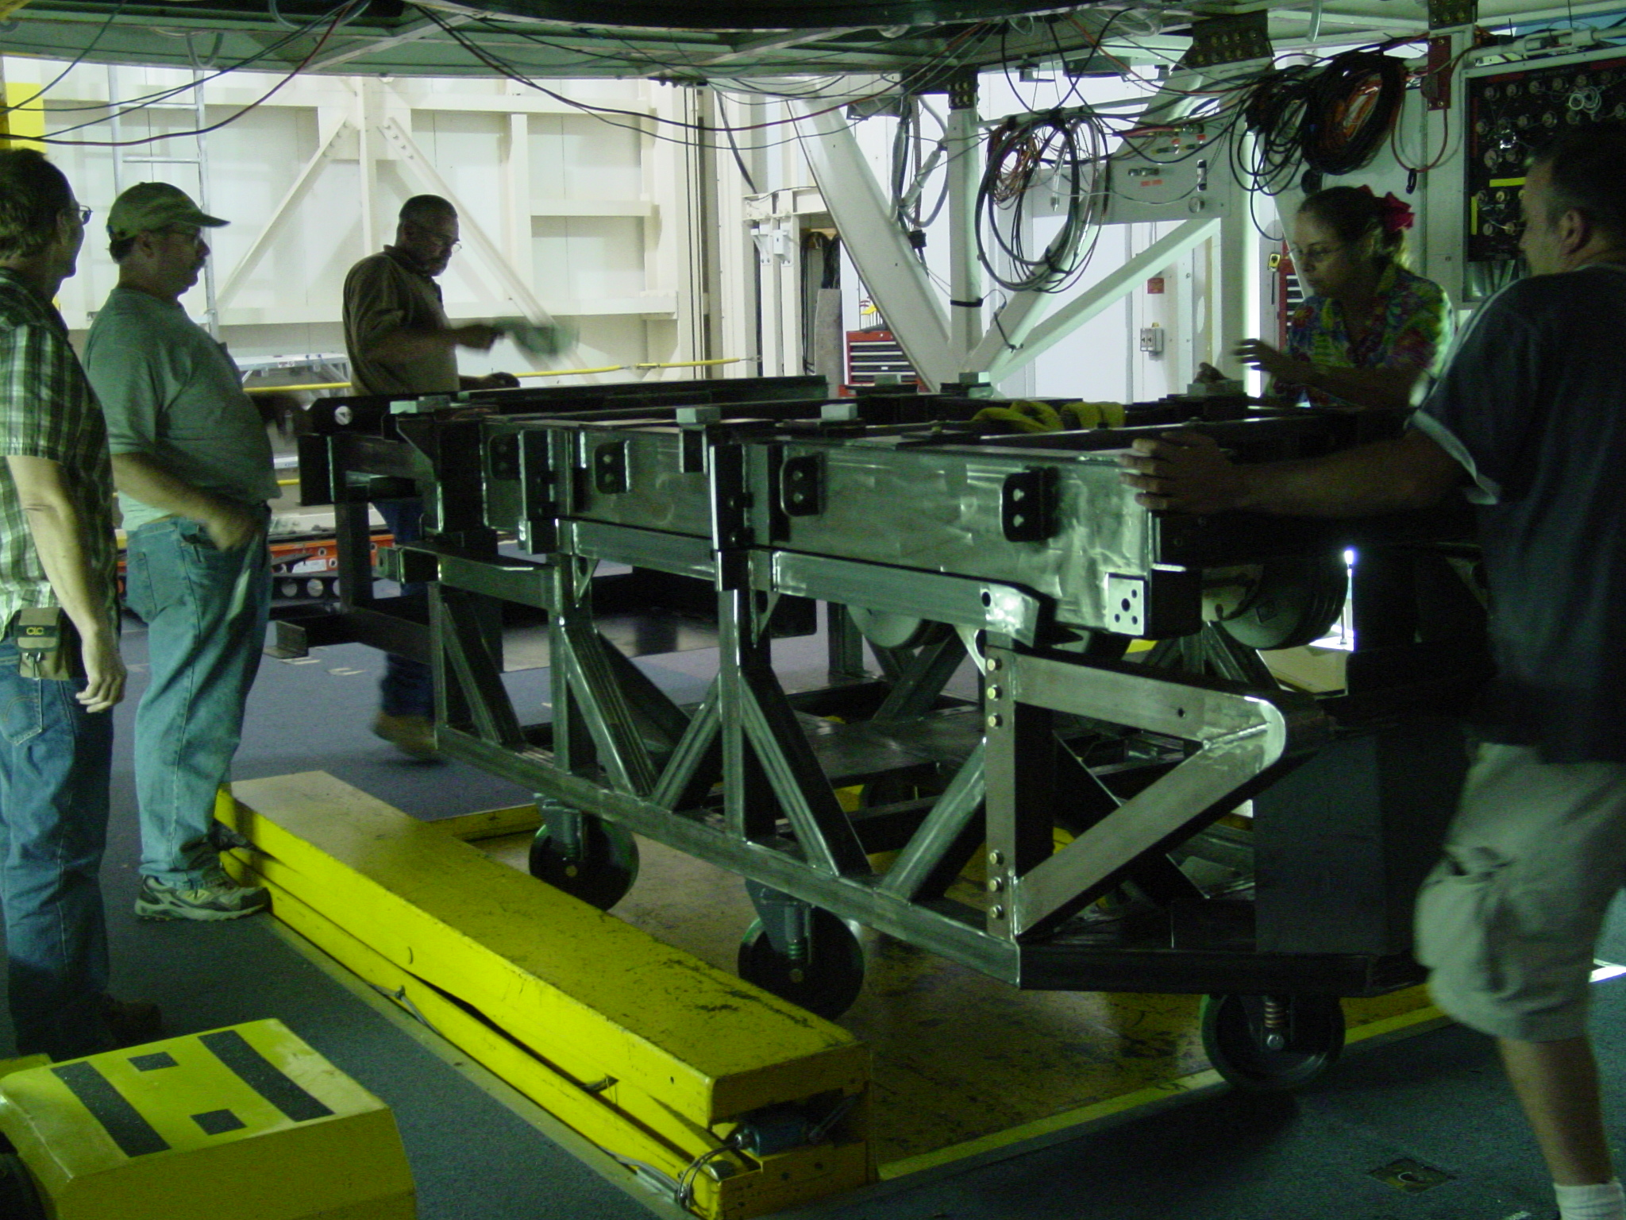
Figure 8

- Attach guide pins to the appropriate hole locations in the derotator flange. Lift the full cart assembly on the hoist, using guide pins to align the instrument to the derotator ring.
- Attach the counterweight, with associated turnbuckles, to the telescope first. See Figure 9.

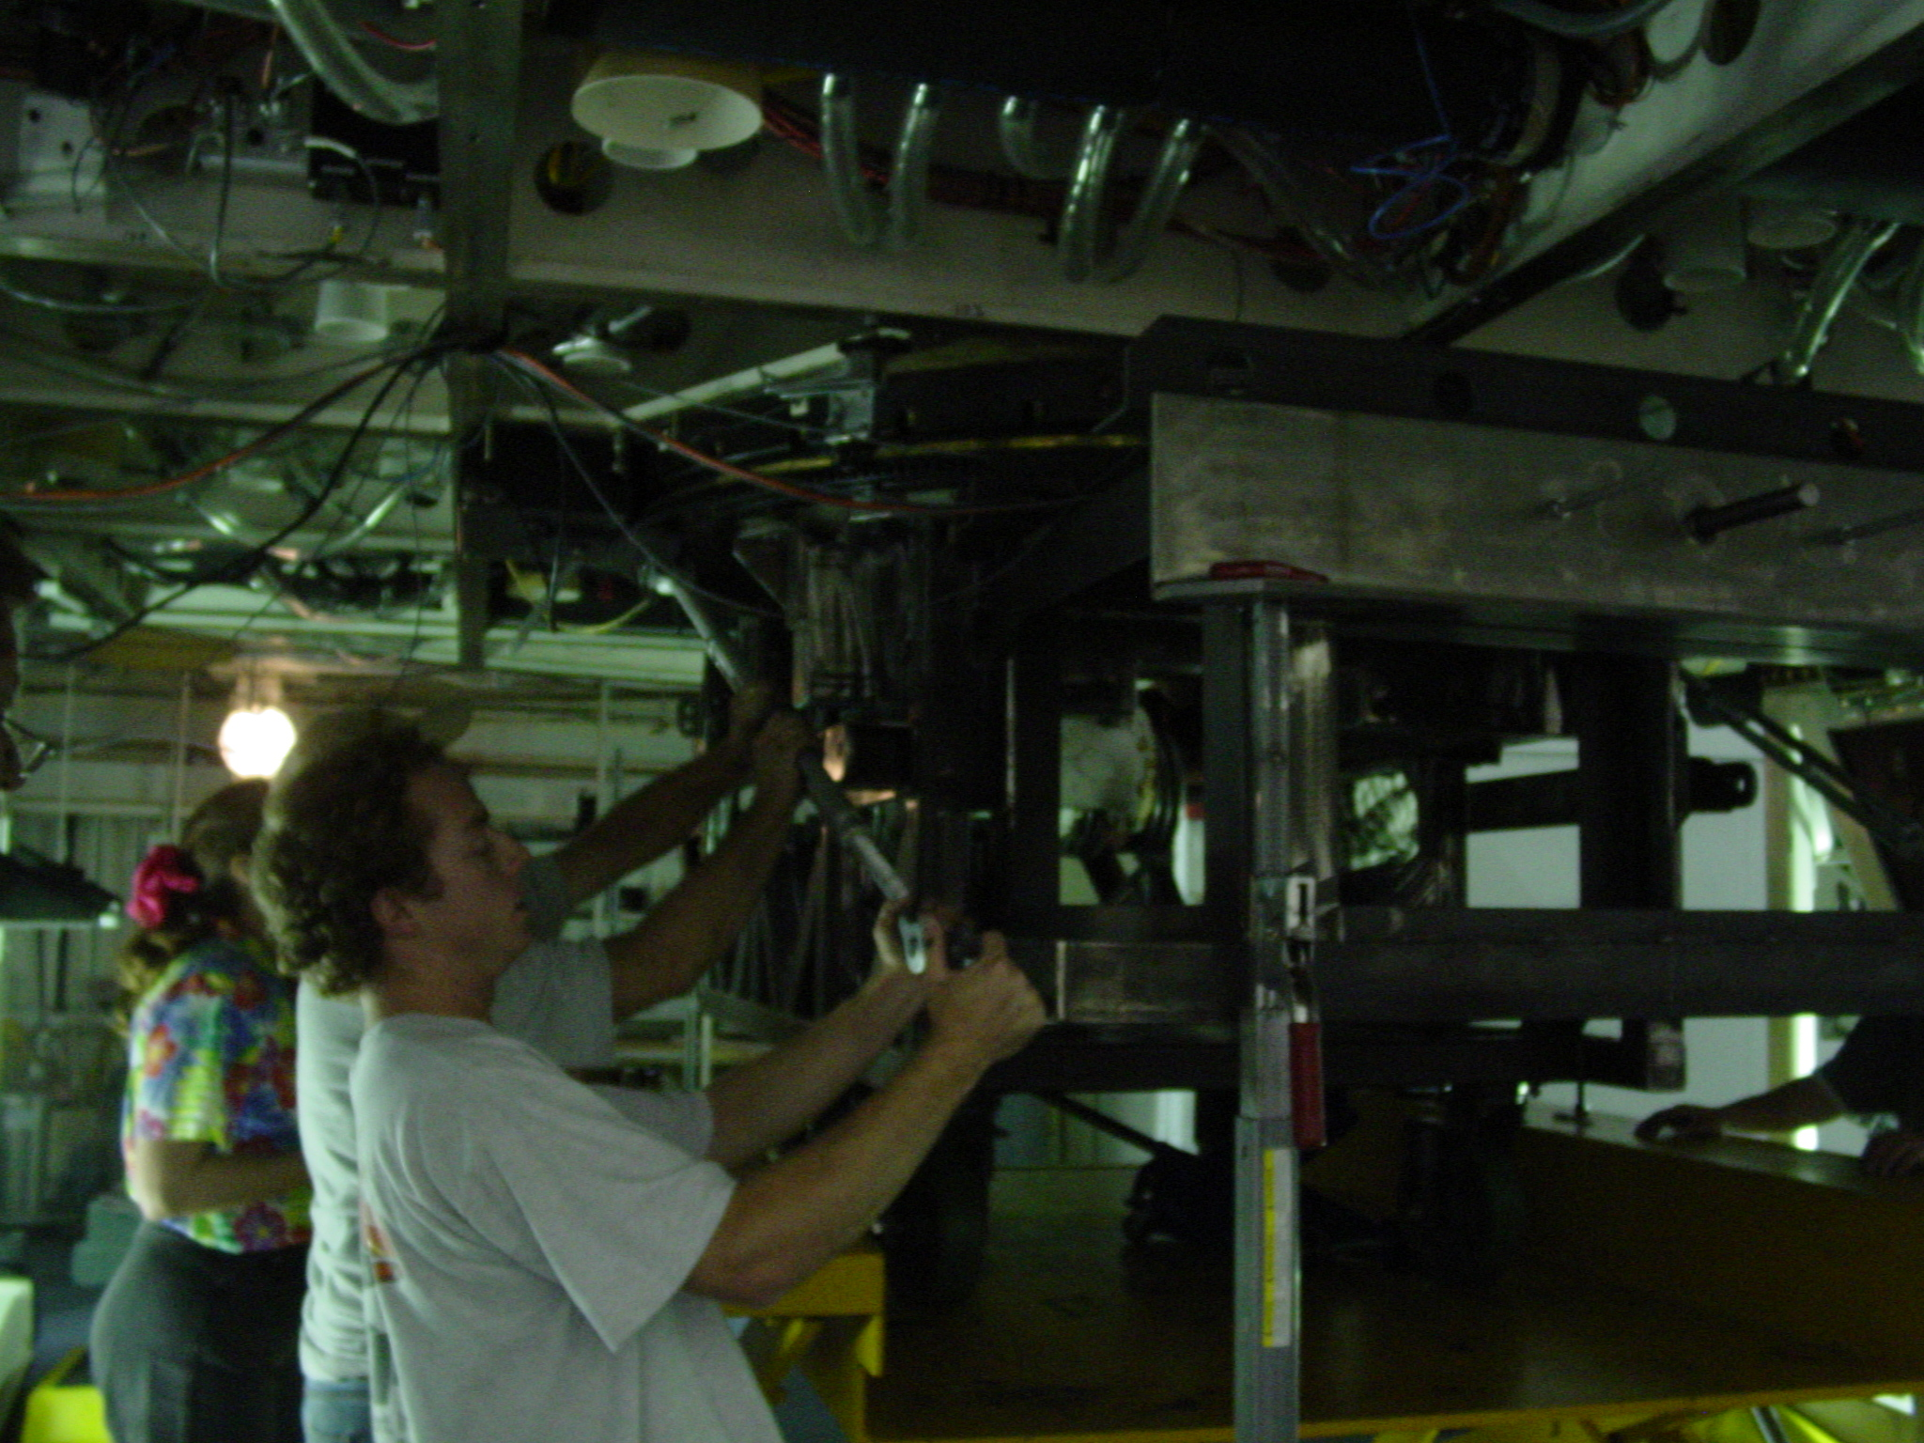
Figure 9

- Unbolt counterweight from the cart assembly.
- Bolt the instrument to the derotator ring. See Figure 10.

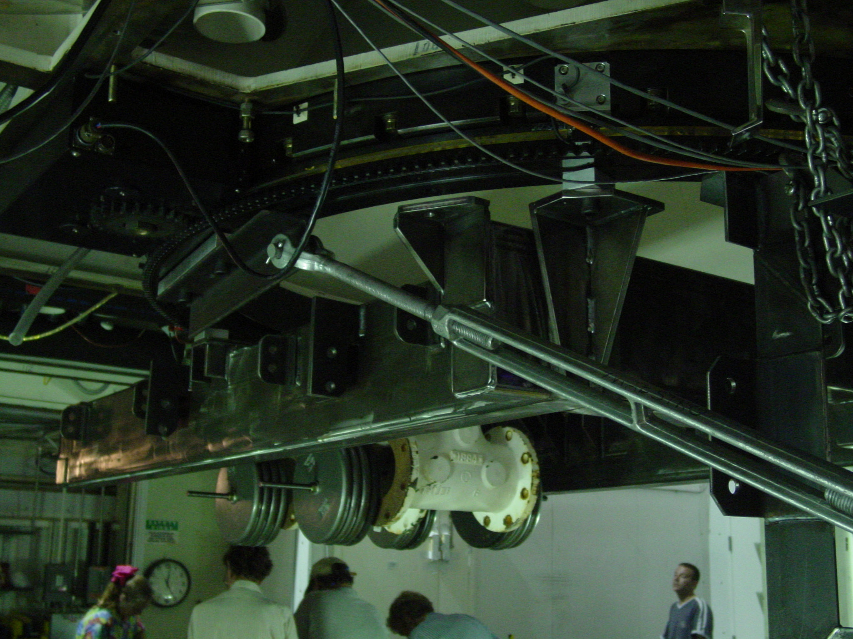
Figure 10

- Unbolt the instrument from the cart assembly.
- Lower the cart assembly. See figure 11. Wheel to temporary storage location.

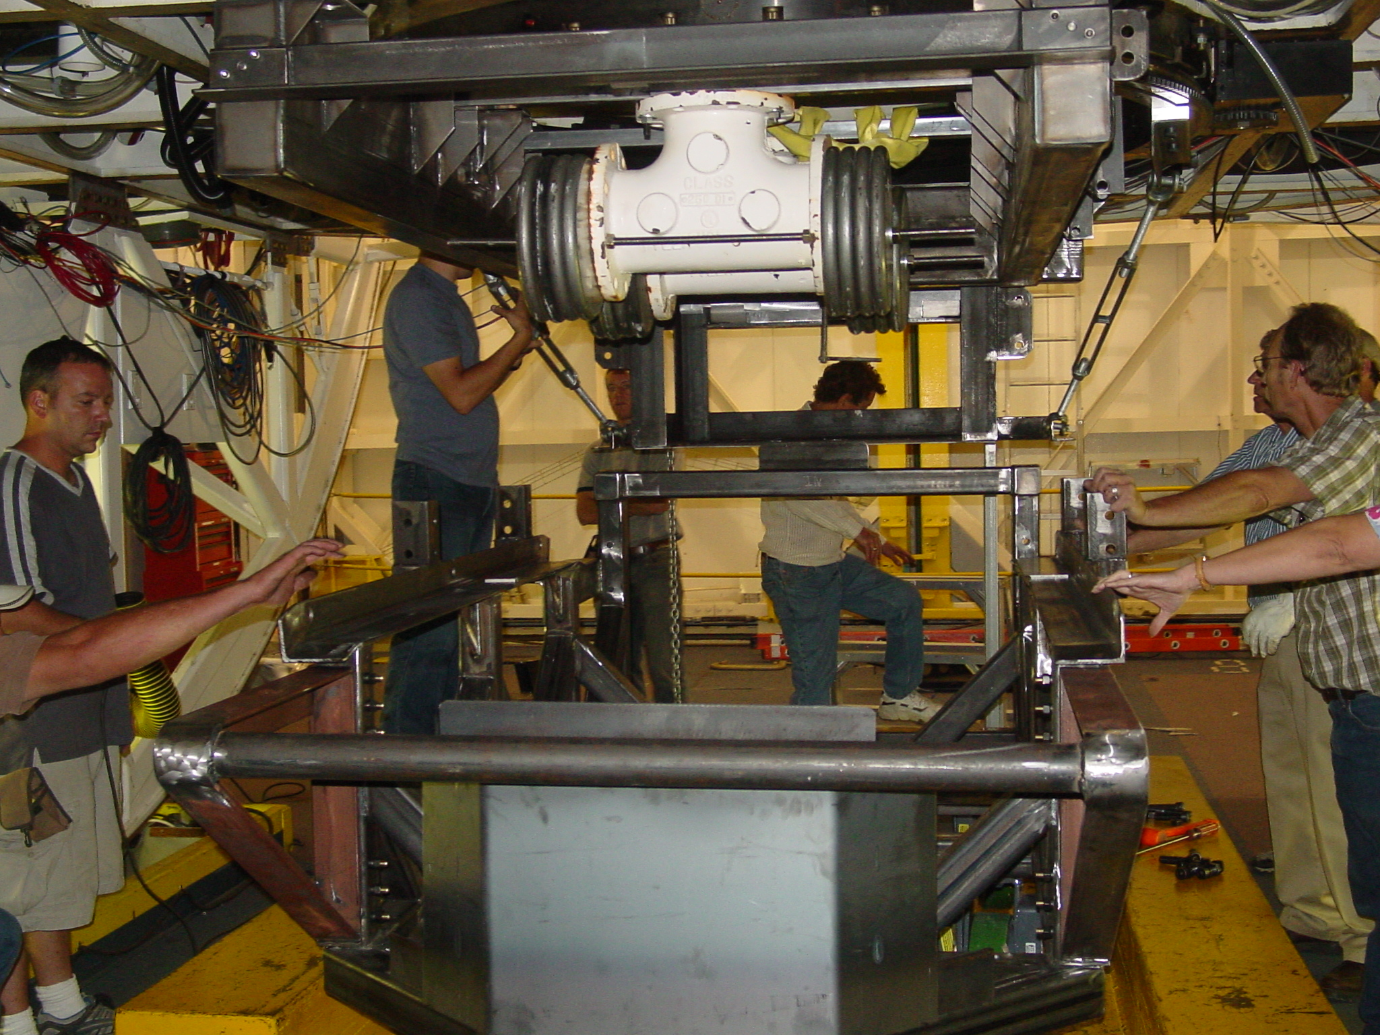
Figure 11

- When Unmounting the instrument from the telescope, unmount the instrument first, bolt it to the cart, and then unmount the counterweight and bolt it onto the cart.
- Roll the instrument and cart assembly out from under the telescope, and to the corner over the hatch location.
- Remove the counterweight assembly from the cart, and place on the piano mover.
- Place blocks against wall as shown in figure 6.
- Rotate the building so that the lower hatch is over the MAESTRO storage location.
- Attach the straps to the instrument as shown in figure 3.
- Rotate the instrument vertically as shown in figure 6.
- Open the hatches.
- Lower the instrument using the reverse process as discussed in steps 7-16 to its storage location in the basement.

