MAESTRO Optical Design
Jan. 11, 2002
Jill Bechtold

This document describes the MAESTRO design, contained in “final.ZMX”, which is the design given to Bechtold by Sarlot on Jan. 4 (as “TEMP5.ZMX”). This design improves over the design presented at the PDR, and responds to issues brought up at the PDR, with help from Burge and Shectman.

The spectrograph is f/3, and will sit at the f/5 Cass focus. We investigated faster f-numbers for the spectrograph, in order to get a better plate sclae, but the resulting optimization made the CaFl element, which does much of the optical work,
unbuildable. We therefore returned to f/3.

The choice of f/5 instead of f/9 allows the use of the ADC, important given the small slit and large wavelength coverage. Also, it was clear during the exploratory design of the f/9 to f/3 optics that the existing f/9 top box is too crowded to allow before-slit optics, and after-slit optics are difficult to design.

Although putting the spectrograph at f/5 means we must replicate the topbox functions, we have chosen f/5 over f/9. Some sharing with Binospec may be possible. I am visiting
CFA next week for a meeting, and will discuss f/5 issues with Fabricant and McLeod.

Wavelength coverage has been improved. By chosing a custom ruled echelle grating, rather than replicating a stock grating, we can improve the format. The down-side is that we won’t know how efficient the grating will be, whereas before we were designing around a grating with known performance. The extra cost is minor – 25K.

We also improved the UV throughput significantly by picking a fused silica prism, and returning to I-line glasses, which were in the design of 10/00.

Our new plan is to nod-and-shuffle (see Glazebrook & Bland-Hawthorn 2001 PASP 113, 197) to attain red spectra with acceptable sky subtraction in a small slit. This can be accomplished initially with a 4kx4k CCD in the red only, and eventually over the whole spectral range with an anticipated upgrade to a 4kx8K device. Observers interested in blue spectra only can use a long slit for conventional observing. With non-and-shuffle, the echelle format can be much more compact – thus a fused silica prism can give adequate order separation. Making the echelle format more compact also enabled us to get superior imagery over a wide wavelength range.

We also rotated the pickoff mirror, so that it is located above the reddest order – previously it was to one side of the echelle format, in the dispersion direction. This eased the requirements to image over a very large field, so the design now has imagery which is far superior to the previous design.

LAYOUT AND OPTICAL ELEMENTS:

The echelle grating is a custom ruled Richardson Labs grating, with 60 l/mm and blaze of 63 degrees. Richardson Lab stock gratings include others with this blaze angle, and similar l/mm.

The cross-disperser is a 40 degree prism, made of fused silica.

The CCD will have 15 micron pixels. Initially we will have a 4kx4k device, but will upgrade to 4kx8k with shuffle-and-nod to enable spectroscopy in the red. The format of this design was chosen anticipating this upgrade in the near future.

Figure 1 shows the layout. The light passes through 3 singlets (BSM51Y, fused silica, PBM18Y) and then a glued triplet of BSM51Y-CaFl-BSM51Y. The light then passes through the fused silica prism, the echelle grating, then back through the triplet and 3 singlets, and through a field flattener which is the dewar window, made of fused silica. The CCD is tilted slightly.
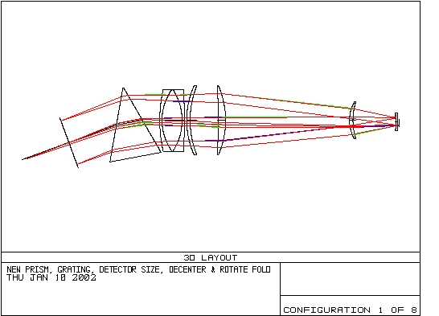

The elements are all UV transmitting: I-line classes, CaFl or fused silica.
The size and shape of the CaFl element is pushing feasibility – it calls for 87mm thickness, and typical blanks are 90mm thick. It may be necessary to get two blanks and glue them together.

A blowup of the pickoff mirror/field flattener and CCD is attached.

ECHELLE FORMAT AND SPECTRAL RESOLUTION:

The format is illustrated in Fig. 2, based on first order calculations by Bechtold.

Fig. 2: Rectangle indicates 4096x2048 pixels. A more legible copy is attached.
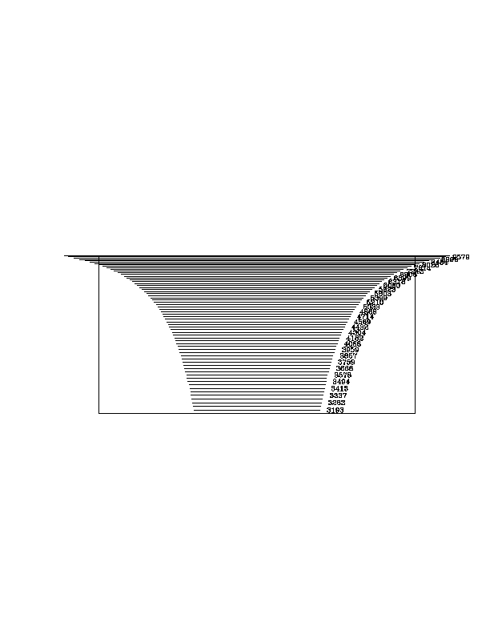
The single exposure wavelength coverage is 3150 – 10063 A. The coverage is continuous until 8000 A. Gaps thereafter to the red are minimal.

The 2 pixel resolution, with a 0.3” slit, is R=83,000 or 3.6 km/sec. The optics should deliver imagery better than 0.3 arcsec for most of the format, but just barely. Spot diagrams, with a 3 pixel box drawn, are attached.

The standard use will be with a 0.5 “ slit, yielding R=51K or 5.8 km/sec.
With a 0.7 “ slit, which would be used with the faintest sources, the resolution is 8 km/sec, still significantly better than Blue Channel with the cross-disperser.

TOLERANCING:

Preliminary tolerancing calculations by Bechtold indicate that there are no show-stopping issues. Tolerancing was carried out in ZMAX, for nominal starting tolerances in all variables, as supplied by Roland (attached). The grating was not toleranced, because ZMAX was unhappy with the coordinate breaks, etc. Also the tolerance was carried out at one wavelength only – I can’t figure out how to make it do tolerancing at other wavelengths.

Allowing for refocusing only, acceptable merit functions were attained for the reddest and bluest orders (configurations 1 and 8) run separately, and for all configurations together. The change in backfocus was in the range of +/10 mm. Similar results were obtained in fast-tolerance mode, and regular mode.

A similar result was attained with all the tolerances multiplied by a factor of 2. That is, acceptable imagery was obtained with one change in focus only.

This indicates that tolerances on fabrication for the major optics will be nominal.

The largest contributor to the focus budget was the uncertainty in index of the CaFl piece. This element contains a lot of the optical power.

THROUGHPUT:

The throughput will be very high, and limited by the performance of AR coatings in the middle of the range, and the QE of silicon on the red end.

A total end-to-end throughput of around 20% should be attained. Here I have assumed:
- 95% hit for transmission of all glasses. This is an estimate only.
- 2 elements in focal reducer
- 26 air/glass interfaces with 97% AR coatings. This is what plain MgFl should deliver. Sol-gel would be much better.
- 50% QE for the grating
- 90% QE for the CCD

REMAINING ISSUES:
- Focal reducer: Before more work on tolerancing is done, the optics which change f/5 to f/3 should be added. The CD Roland left with his design work contained some of his files with designs for the f/9 to f/3 focal reducer, and are a good starting point. Harmer needs to be contacted to see what he has on this, since I thought Roland said he included Harmer’s focal reducers but they aren’t on the CDrom. We need to find out how much room there is at the f/5 Cass, and what Binospec has decided to do about guiding and calibration lamps. Fabricant has not published the necessary information, so I’ll talk with him next week.

- Move pickoff mirror: When the focal reducer is added, the pickoff mirror should be moved a little farther from the field flattener (which is the CCD dewar window), so that the pickoff mirror can be supported mechanically. Bechtold tried this, with dire results to the imagery, for reasons that are not clear. The field flatenner is larger than it needs to be, but the dewar envelope must be included as well, and there is no room in the current design for a slit assembly.

- Are elements 2 and 3 oversized? They appear to be a little larger than they need to be.
- Tolerancing of the final design, including the grating, multiple wavelengths, etc. needs to be carried out.
- Tolerancing for thermal effects should be carried out. The “environment” command in ZMAX does this, but is only available in the EE version. McCarthy advises this be done with care, but he may be biased by his experience with cryogenic optics. Change of focus for thermal expansion of the structure, not included in ZMAX is expected to dominate. This will have to be looked at.
- Long slit issues. Single order long slit should be possible with an order separating filter. Whether this should be included will need to be zmaxed.
- ALIGNMENT procedure needs to be thought about.
- Scattered light, ghosts – it may not be worth spending much money on a scattered light analysis, given the STIS echelle experience. However, a quick analysis should be done.

Matthew Chang has accepted Steward’s offer to join the technical devision and work on optical design and testing. He will begin work as soon as his visa issues are resolved, probably in 2 months. I have an appointment with Powell to see what can be done so that he can “hit the ground running”, e.g. ordering his computer, etc before he arrives. However, this leaves ~3 months before he can spend serious time on MAESTRO. I’ll continue crawling up the ZEMAX learning curve to deal with these issues until then.

DEFAULT TOLERANCES:
Thickness 0.200 mm
Radius: 5 fringes
Spacing 0.2 mm
Wedge 0.100 mm over part diameter
Tilt 0.100 mm over part diameter
Flatness: 5 fringes
Decentration: 0.100 mm
Irregularity: 3 fringes
Index on glass: 0.0003
Index variation over part: 0.00010

