
MMT OBSERVATORY
6.5 m TELESCOPE
Doc.No. :
Issue : a
Date : May 11, 2007

MMT Observatory

6.5m TELESCOPE

MMT Rotator Analysis
Maestro load case

 | Signature | Date
Prepared
Reviewed
Approved

- Revision History

Issue | Date | Changes | Responsible
a | May 11, 2007 | Start analysis | Shawn Callahan

- Table Of Contents

1. Revision History 3
2. Table Of Contents 4
3. About this document 5
3.1. Purpose 5
3.2. Reference Documents 5
4. FEA model results 6
4.1. Loads 6
4.2. Boundary conditions 6
4.3. Model generation. 7
4.4. Equivalent stress- Von Mises 8
4.5. Strength of materials 11
4.6. Stripping strength of flange 11
4.7. Conclusion 11

- About this document

  - Purpose

This document contains the analysis of the stress in the MMT rotator bearing due to an overhung load from Maestro’s counterweight.

  - Reference Documents

See the MMT SiteScape for all documents.

- FEA model results
The following results show the Von-Mises stress in the races and rollers of the MMT instrument rotator. All loads have been applied to a plate bolted to 5 of the ¾-16 tapped holes in the instrument mounting surface of the inner race.

  - Loads
According to David Dean on 5/8/07, the counterweight weighs 850 lbs [390 kg.]. Measurements of the cart indicate that the load ranges from 2 to 3 feet from the bolt circle on the rotator. To be conservative I applied 850 lbs 33 inches from the bolt circle using a 1-inch steel plate.

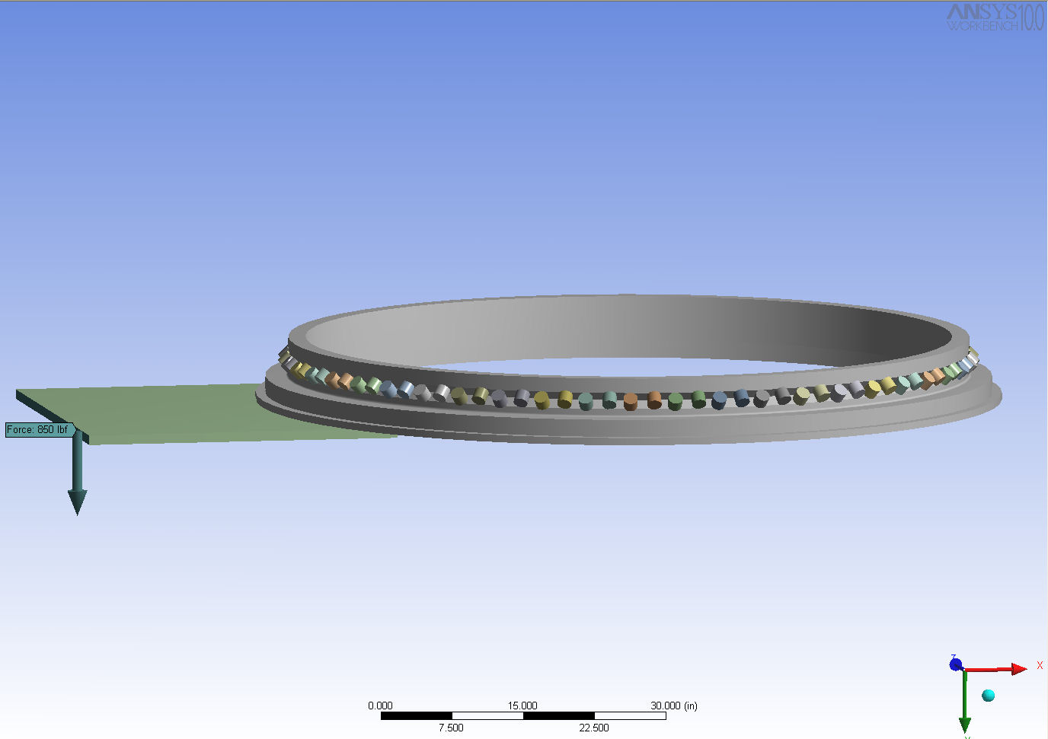
  - Boundary conditions
Fixed supports were applied to the outer race surface that mounts to the telescope. Since the central cone provides approximately 30 inches of section this constraint should be a good approximation of the stiffening from the telescope cell.
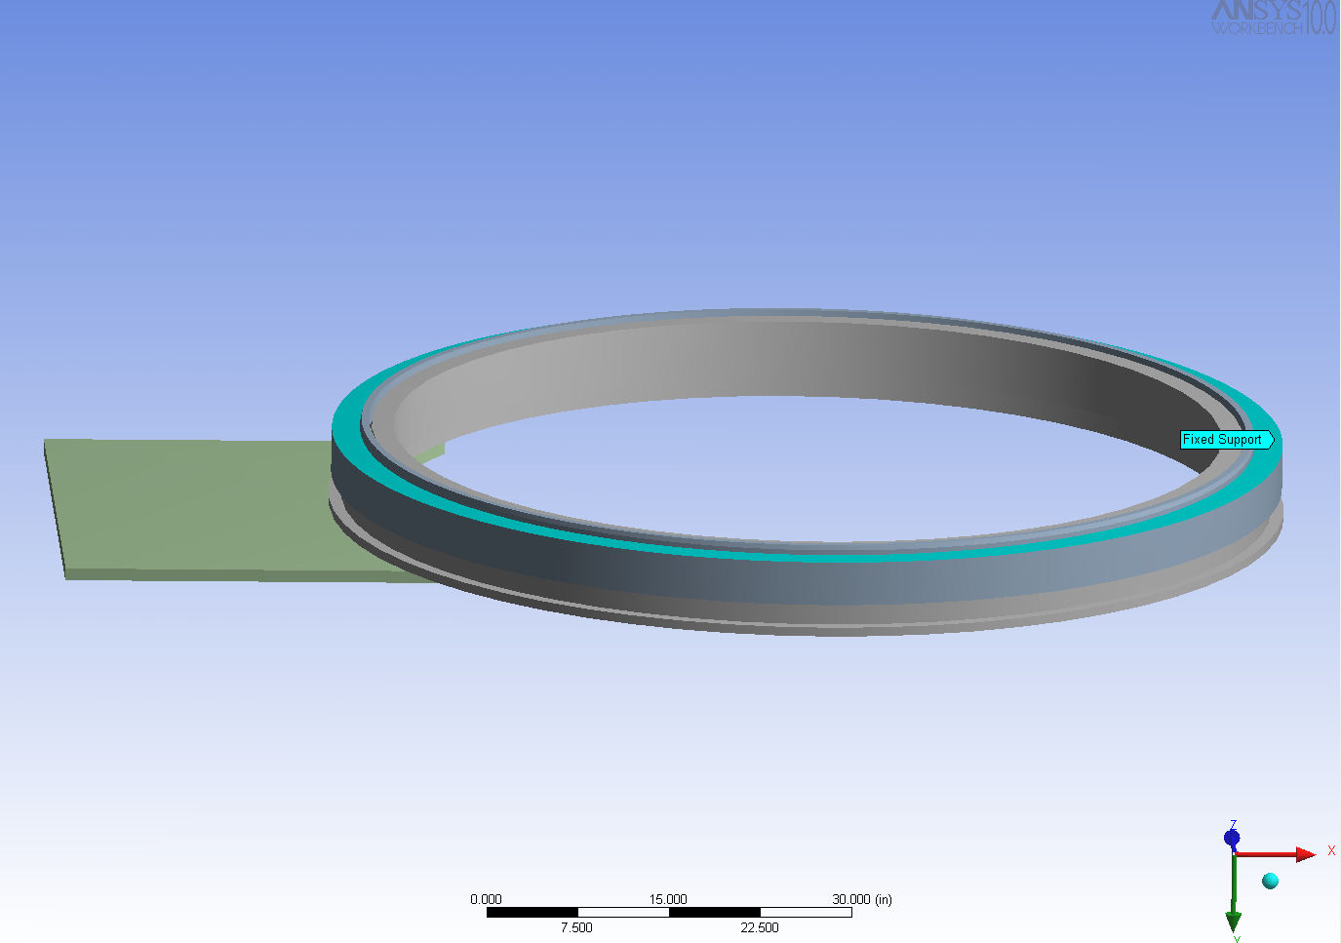
  - Model generation.
Since the highest stress lies in the rollers, the mesh was refined for the threes rollers showing the highest stress.

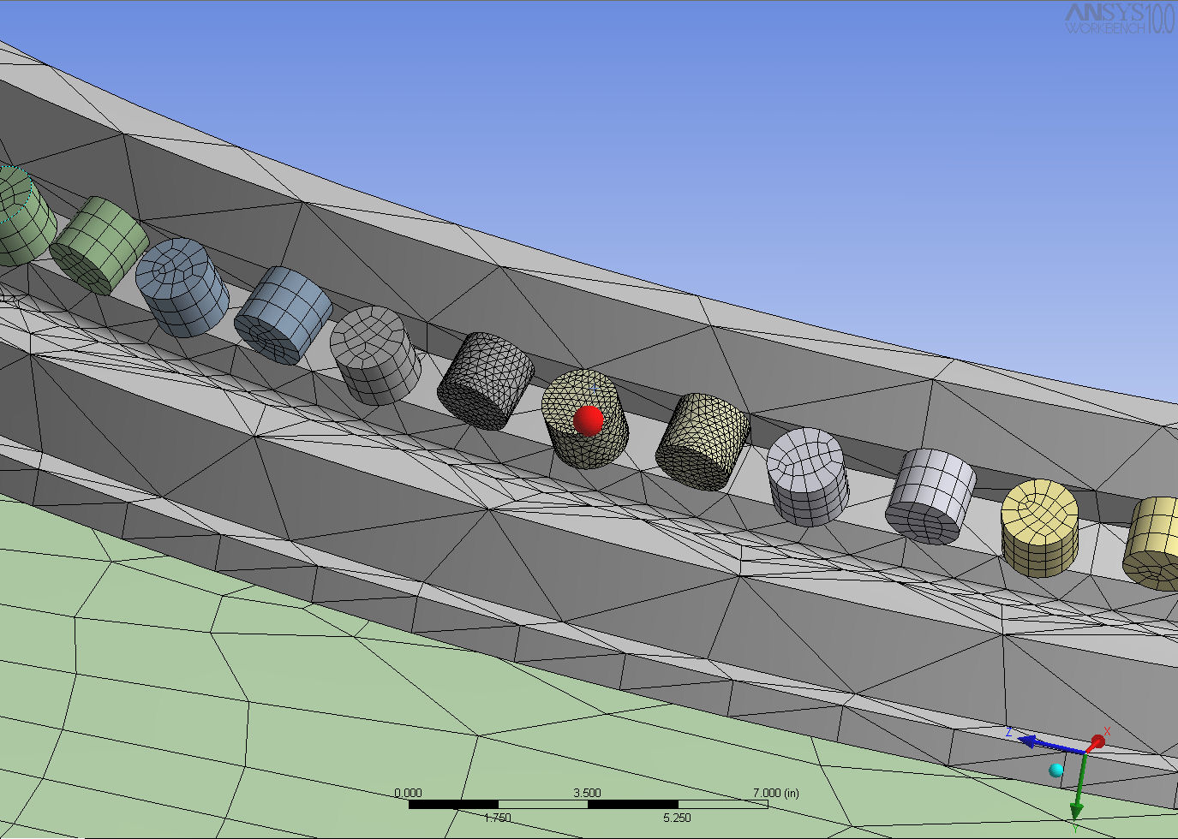

  - Equivalent stress- Von Mises
The maximum stress is in the rollers. With the above load case the maximum stress is around 700 psi. 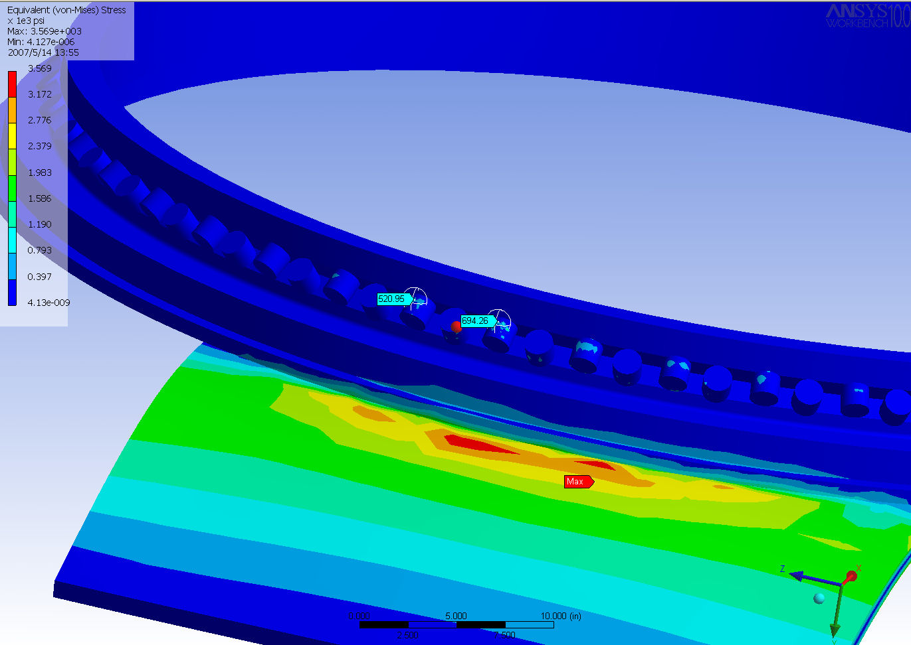

I also looked at two additional load cases where the load was applied over a 12-inch wide plate .

The stress from 850 lbs applied to a 12-inch wide plate is still below 2000 psi.

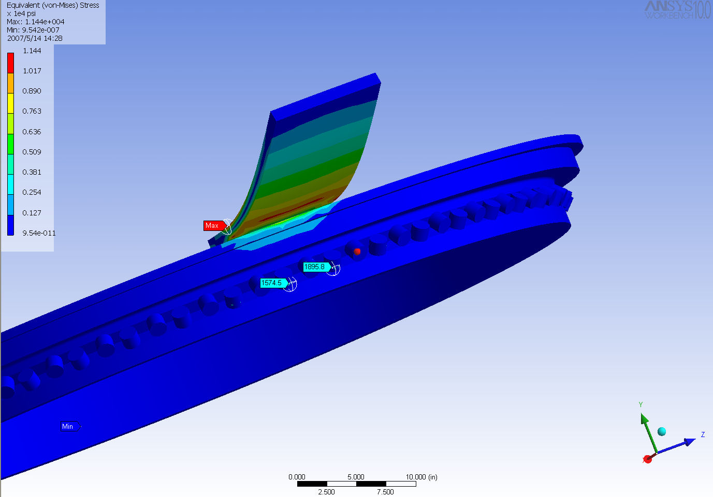

Finally, I looked at the “monkey wrench” load of the entire counterweight supported on a 1” wide “wrench” applying 850 lbs over a 33-inch moment arm. This is obviously a worst case load to the rotator.

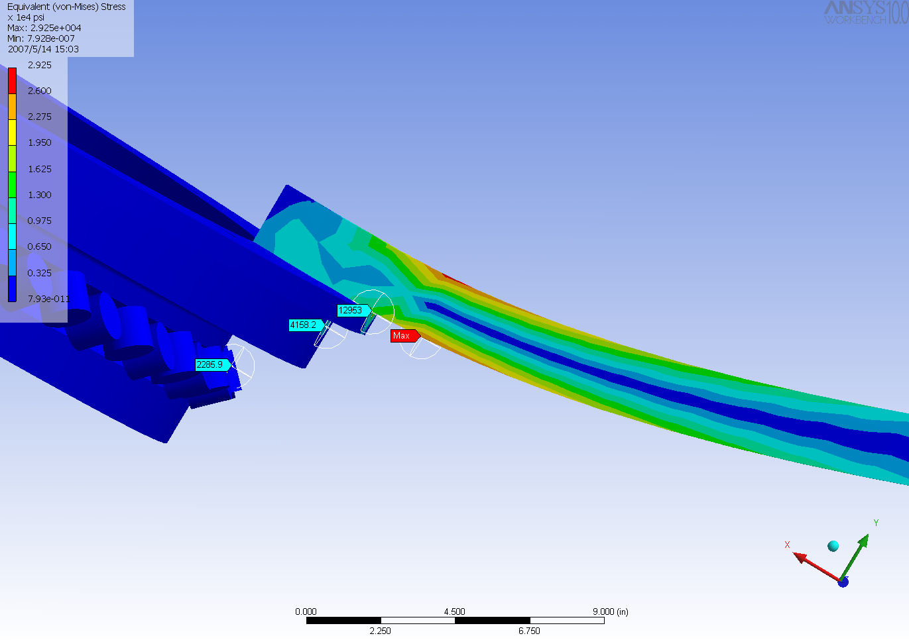

The maximum stress was still less then 13,000 psi under the “wrench”. The bearing stress was less than 2300 psi.

  - Strength of materials
The rollers are AISI 52100 Steel heat treated to 58-62 RC. This high strength material has a yield strength of 295,000 psi.

The material of the race is AISI 4150 steel heat treated to 250 BHN (minimum). The yield strength of this material is around 120,000 psi.

  - Stripping strength of flange
The flange has 24 ¾-16 UNF tapped holes 1.5 inches deep. Using a conservative stripping strength of 90 ksi, each bolt should support 40,000 lbs.

  - Conclusion
If we applied all of the weight of Maestro’s counterweight to a single bolt on the rotator flange (NO, I DO NOT RECOMMEND THIS!) we would not damage the inner and outer race, bearing rollers, or tapped holes.

--oOo--

Doc_info_start
Title: Fill in title here
Document Type: Report
Source: Steward Observatory
Issued by: Joar Brynnel
Date_of_Issue: Fill in date here
Revised by:
Date_of_Revision:
Checked by:
Date_of_Check:
Accepted by:
Date_of_Acceptance:
Released by:
Date_of_Release:
File Type: MS Word
Local Name: Repeat title here
Category: Fill in category here (3 digits)
Sub-Category: Fill in sub category here (3 digits)
Assembly: Fill in Assembly name here
Sub-Assembly:
Part Name:
CAN Designation: Fill in full doc number here
Revision: Fill in revision letter here
Doc_info_end

